KRION 6D Help document

KRION Consulting Pvt Ltd

5/6/2024

Help Document

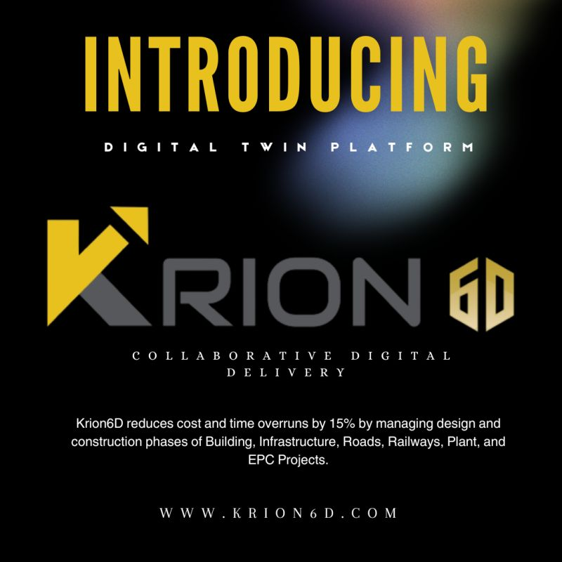

Table of Contents

**About Krion 6D** 4

**Getting Started** 4

**Main Dashboard** 5

**User Creation** 7

Create Users 7

Edit or Delete a User 9

Create User Groups 10

**Roles and Teams** 11

View, Edit, Delete Roles 12

Assigning Roles 13

Assigning Roles for Group 14

Assign Watcher 15

**Workflow** 17

Creating a Workflow 17

Edit/ Delete a Workflow 20

Creating Teams 20

**Add Project** 22

**Design Dashboard** 24

**Project Dashboard** 24

**Uploading Files in the Project** 25

Add/Move/Remove Folders 26

Understanding the Document View 26

Assigning Document to Workflow 28

Working with the document files 28

**Review** 29

Add a Review 30

Actions on Review 31

Timeline 31

**RFIs** 33

Create RFI 33

Actions on RFI 35

Creating RFI from the 3D viewer 35

Create Issue 41

Actions on Issue 43

Creating Issue from the 3D Viewer 43

**Transmittal** 46

Create Transmittals 47

Actions on Transmittals 48

**Submittal** 49

Create Submittals 50

Actions on Submittals 51

**Tickets** 52

Create Ticket 52

Actions on Tickets 54

**Meetings** 55

Add Meeting 55

Actions on Meetings 57

**BOM/BOQ** 58

Add BOM/BOQ 58

**Checklist** 60

Creating a New Check List 60

Actions on a Check list 61

**Forms** 62

Create Form Templates 63

Add, fill out, and submit Forms 63

**Reports** 68

Create a Custom Report Template 71

**3D Viewer Interactive tools** 74

**Changing Views** 84

**Clash** 85

Prepare documents for Clash Detection 85

Clash List 86

View Clash 87

**Multi Model View** 90

Prepare documents for Multi-Model View 90

View Multi-Model 91

**Compare** 92

Prepare documents to Compare 92

View Model Compare 93

Change List Toolbar 94

**Simulation** 95

Prepare documents to run simulation 95

View Simulation 96

**IoT Data Connection** 97

Setting up the Data Connection 97

Data Visualization Chart 99

Child chart 100

# **About Krion 6D**

Krion 6D is a Digital Twin Platform to improve timeliness and reduce cost overruns in construction projects. Krion 6D is a complete IT solution for the Construction/Infrastructure industry based on the concept of “Digital Twin.” The Krion 6D module is an integrated cloud platform to manage data models, people, processes, and assets throughout the lifecycle of a construction project. The Krion 6D module has predictive analytic features to anticipate and forecast in all the stages of Construction/Infra. It works on public, private, and virtual cloud infrastructure and uses Artificial Intelligence for operational insights and efficiency.

# **Getting Started**

To Login to Your Krion6D Account

* Open the Krion 6D application URL.
* Enter your email ID and password to log in.

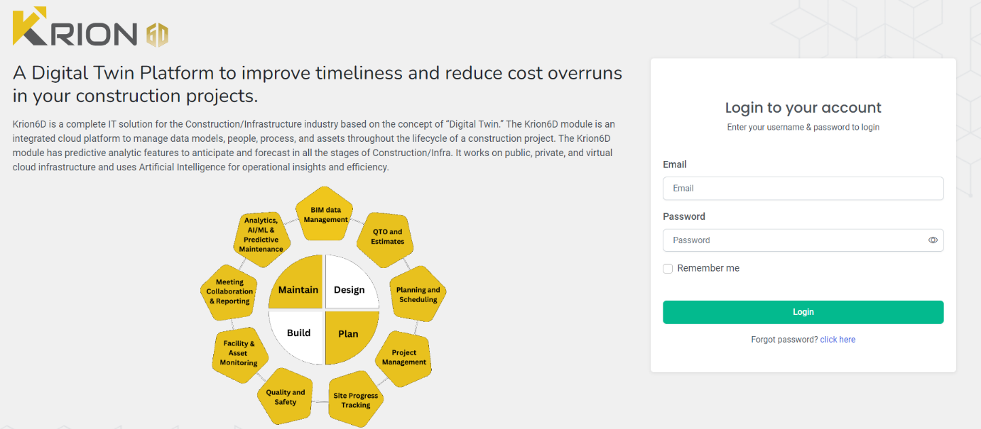

**Note:** Once the user "Click Here' button on the Forgot Password, the user will receive the OTP in his provided email.

After entering the OTP the user will navigate to set password screen where the user is to enter the New password & Confirm password.

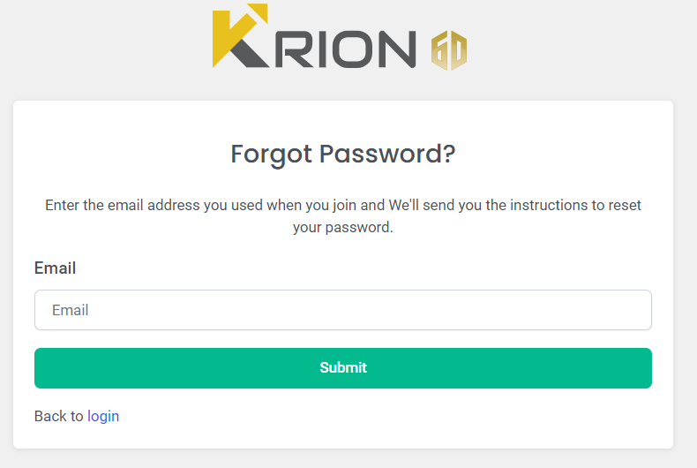

**Note**: Once the user login is successful the user will navigate to the Main Dashboard screen and user will able to access the Multiple options in the sidebar menu

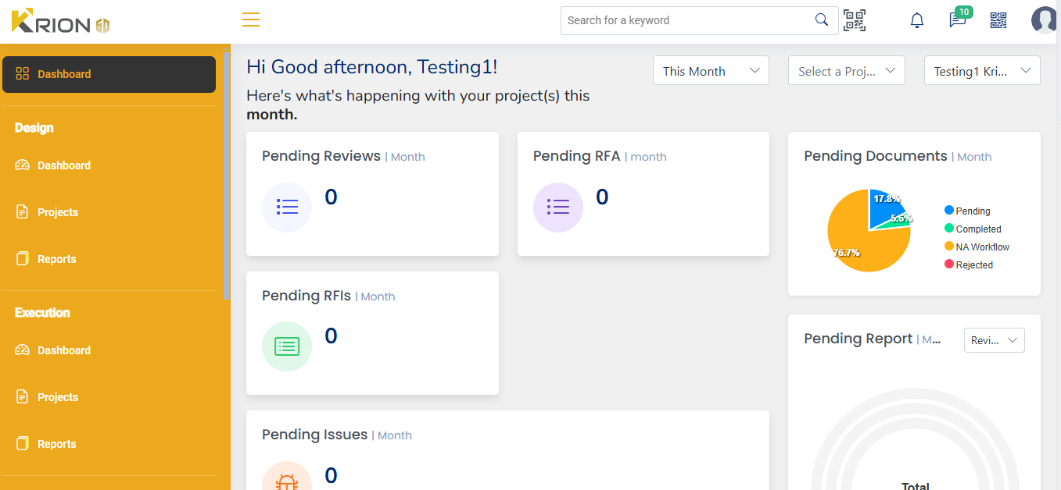

# **Main Dashboard**

The main dashboard of Krion 6D serves as the central hub offering a comprehensive overview of key project aspects and displaying a single view of all your projects.

The dashboard shows Important, relevant, and actionable information from all the modules in Krion 6D. You can quickly evaluate areas that require the attention of you or your team, and easily navigate to the other modules to continue your work.



**Note:** Use to hide the navigation pane and to get a complete view of the dashboard

1. The dashboard shows a consolidated view of pending items **Reviews**, **RFIs, Issues, Documents and Reports.**
2. The **Recent Project Analytic** card gives an overview of pending reviews, RFIs, Issues, Transmittal, and Submittal. The project analytics can be downloaded as an SVG, PNG or CSV file.
3. **Recent Project** card shows the recent projects currently in progress.
4. **Recent Updates** show updates done on any of the items in a project.

**Note:** The analytics and all the other cards can be viewed for This week, This Month, and This Year, or all the details can also be displayed at once based on your selection. Also, the dashboard details can be viewed for individual projects or selected Users.

1. The top right corner of the Dashboard offers the following features:



Search can be done from the main dashboard by two ways:

* **Search bar** to type and search any items like RFIs, Issues, transmittal or submittal, or any other details of a project.
* ****The **QR code search option** can be used to search a BOM/BOQ by uploading the QR code

 Other tools:

* 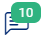 **Notifications** related to the projects of the user can be viewed by clicking the Bell Icon
*  **Activity log** shows the updates made on any item in the project.
*  **Page URL** can be downloaded as a QR code to be scanned through mobile and redirected to a particular page

**User Icon** shows the details of the user who is currently logged in.

# **User Creation**

Once a project has been created you have to create users, user groups, assign roles and teams for project members who will be working in the project

The options to create **Users**, **Role** and **Teams** is available under Administration in the navigation pane

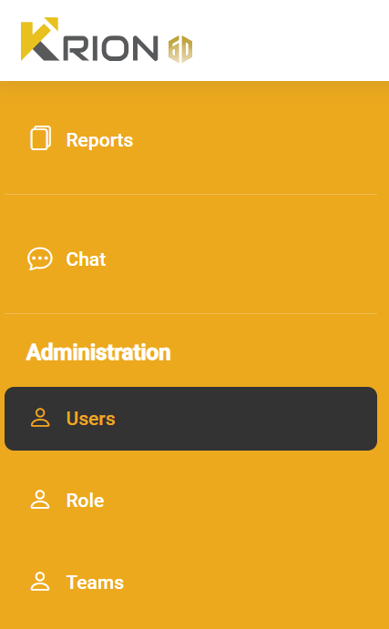

## **Create Users**

To create a new user, navigate to **Users** under administration

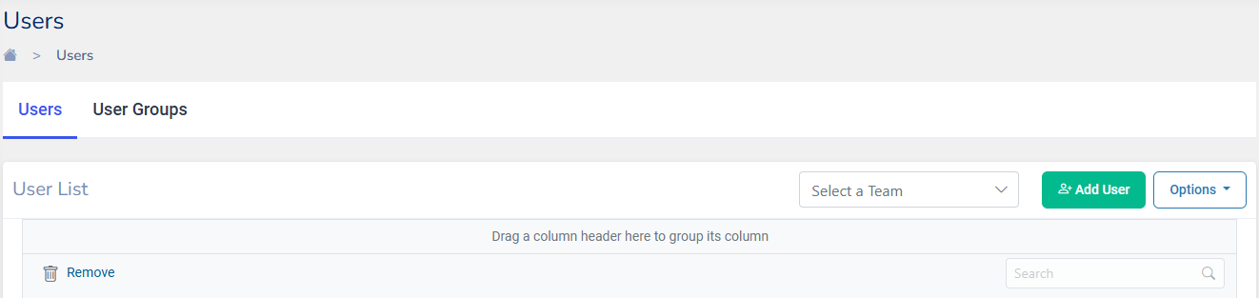

* Select Bar to selecting a particular team
* Options include to create a User includes clicking on **Download Template** which will download an Excel file containing a Sample User template that can be filled and Import back again using **Import Excel** and also export using **Export User**.
* Search Bar helps in searching a particular user
* 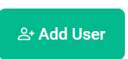You can remove a particular user from the list by selecting the user and clicking on remove button

Click on to add a new user account. Add user dialog will show up. Fill in the details as required.

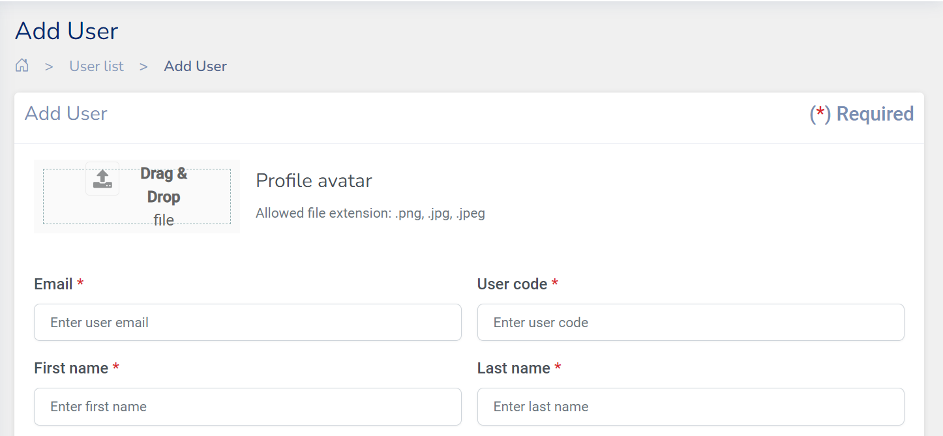

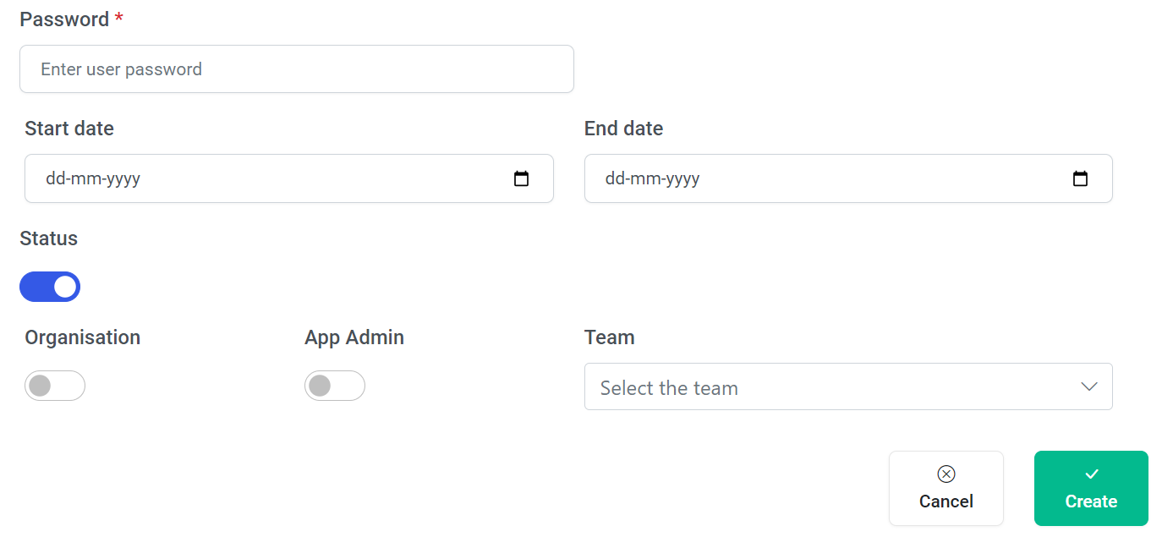

1. Drag and drop a file for the **Profile avatar** of the user.
2. Enter the **Email ID** and **User Code** unique to the user.
3. Enter the **First name** and the **Last name** of the user
4. The Admin of your organisation sets **Password** during user creation, which can be changed later by the individual user.
5. Enter the **Start date** and **End date** for the user account.
6. The **Status** button of the user is switched on to indicate permission into the project.
7. Toggling on **Organization** will give access to all the modules of the organization except user creation.
8. **App Admin** if toggled on will make the user an Admin and will have access to all the modules including User creation
9. Finally select the **Team** in which the user will be mapped from the teams listed in the drop-down menu.
10. Click on **Create** to finish creating a user

**Note:**

* **Options** will download Template, Import Excel, Export User containing the list of users created under your organisation.
* **Search Bar** helps in searching a particular user

## **Edit or Delete a User**

Click on against a role to edit or remove a User.

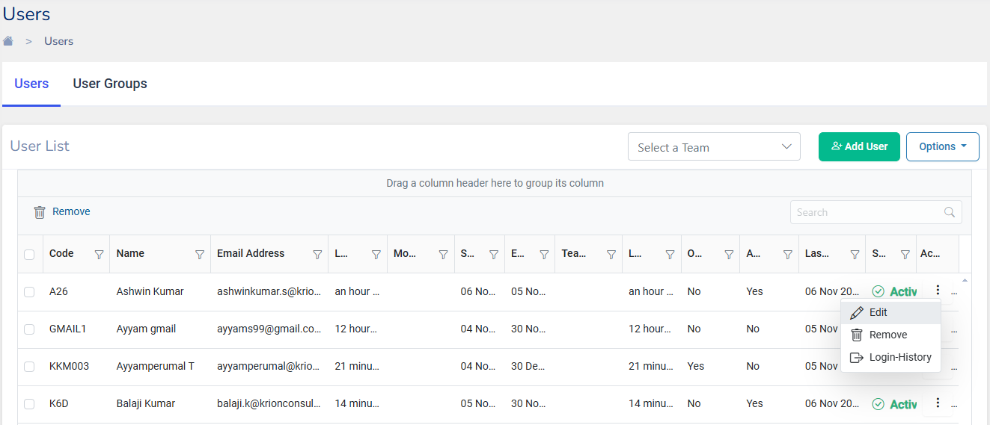

* Editing User Details: To edit a user's details, click on the **Edit** button.
* Removing a User: To remove a user from the list, select the user and click on the **Remove** button.
* Viewing Login History: To view a user's login history, select the user and navigate to the **Login Histor**y section, which lists the entire login history of the selected user.

## **Create User Groups**

Once users of the organization are created, you Create **User groups** that can be used for workflows etc. 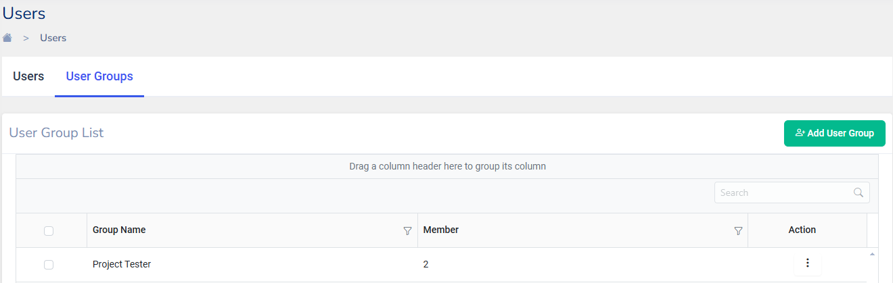

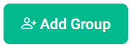

Click on **User Groups** tab under user and click on, Add User Group dialogue will open up

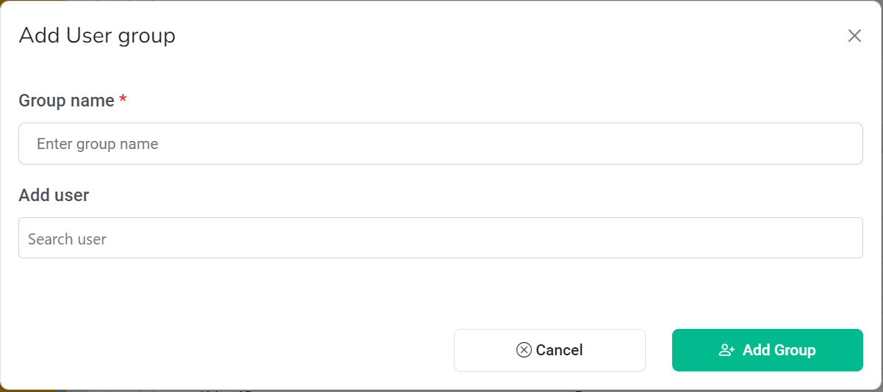

Enter a new or existing **Group Name** and **Add users** from your organization by searching and click **Add Group** to finish creating a new group.

# **Roles and Teams**

Once a project has been created you can Assign roles to users of the Project. Also, project Teams can be created.

The options to create **Role** and **Teams** are available under Administration in the navigation pane

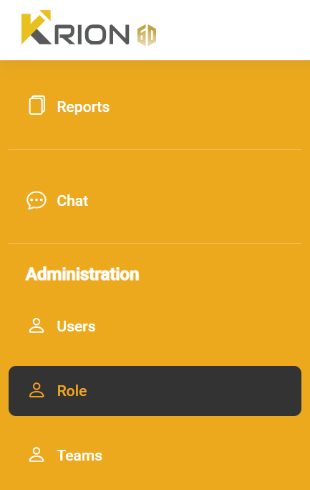

By default user can view the list of roles in the Role screen which the user may use it later.

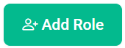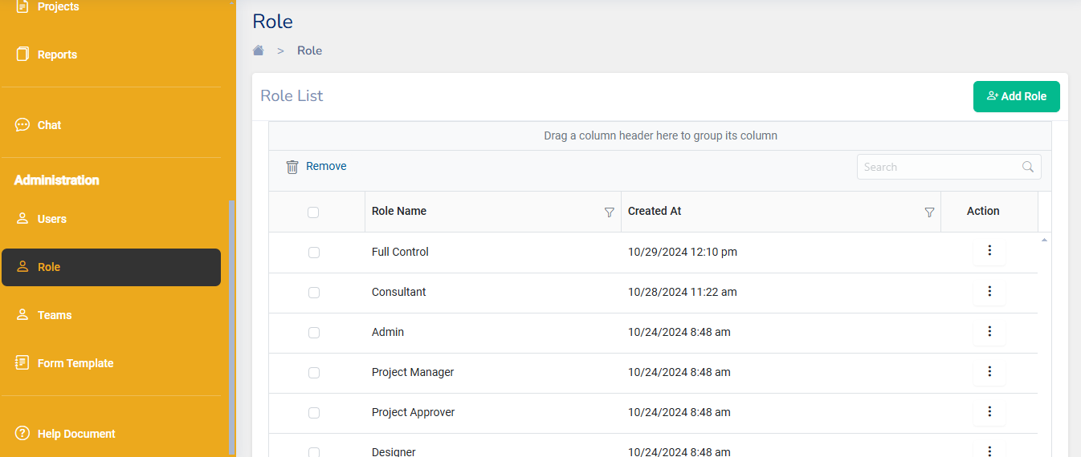

Click on and **Add Roles** dialog will open.

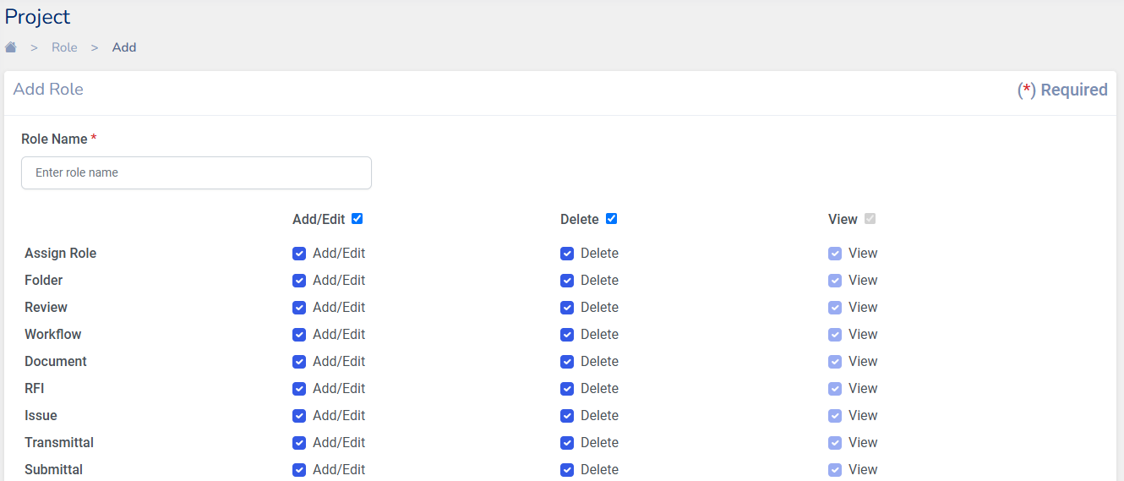

Enter the role name and click on to create a new role.

**Note:**

1. Role Assignment can be done only by the Admin/Project Manager.
2. Access to each module is controlled as per the role in the organisation
3. If only view access is to be given to a particular role, uncheck the **Add/Edit** and **Delete** options

## **View, Edit, Delete Roles**

Click on from the roles list to edit, view or remove roles.

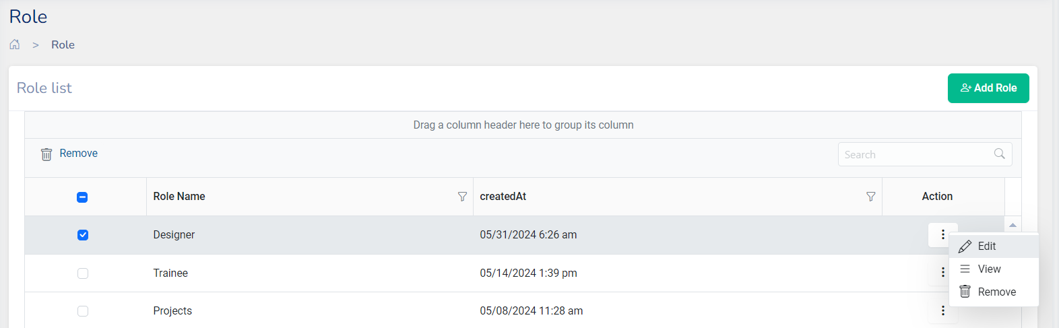

* **Edit**: Details of the role can be edited
* **View**: To view the details of a particular role
* **Delete**: The roles created here can also be deleted by using this option

## **Assigning Roles**

For assigning role to the user, The prerequisite of the Project should be created and in that particular project users are allowed to assign the role against it.

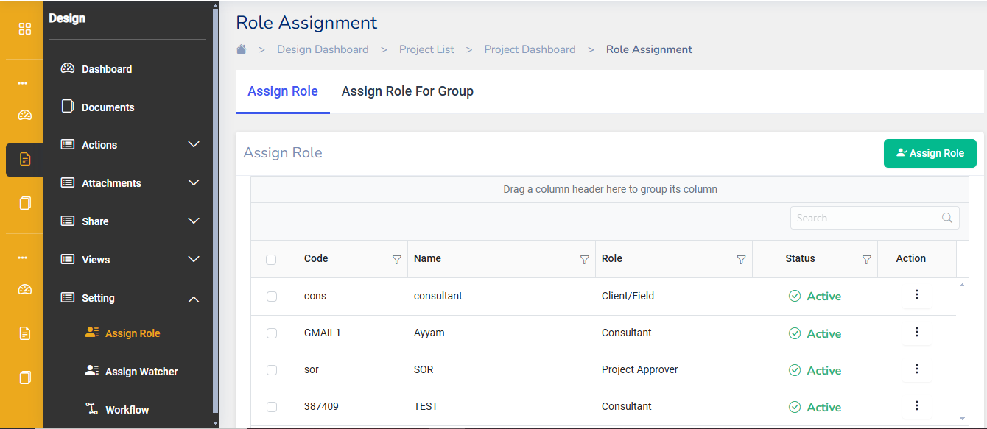

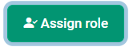

Click on the assign role dialog will open. Select the role from the drop down, where the list of roles created will be displayed. To Add a User to that role , search/select a user from the list of users under your project.

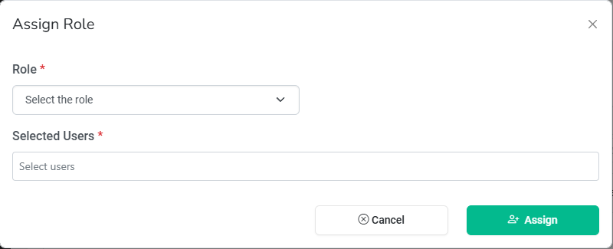

Click on to finish assigning a role to a user.

## **Assigning Roles for Group**

We can also assign roles to a Group of users.

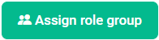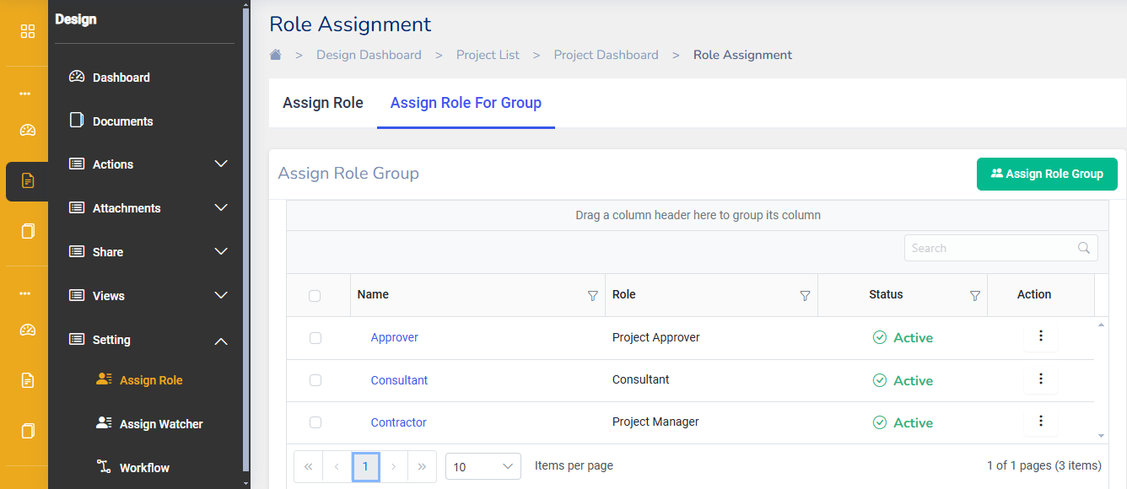

Click on, assign role for a group dialog will open, where we can select a role and then add a User Group.

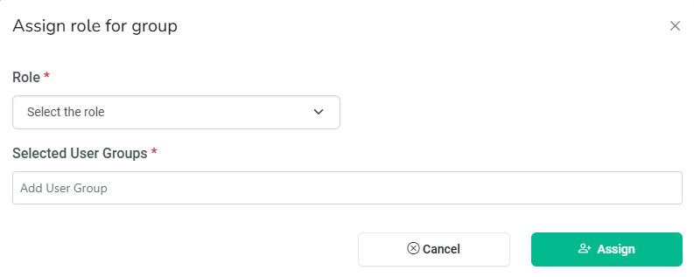

Click on to finish assigning a role to a User Group.

**Note:**

****The assigned roles can also be Edited or Deleted. Click on against a role to edit or remove roles.

## **Assign Watcher**

Go to the main menu on the left side.

Click on **Assign Watcher** under the **Setting** section to open the watcher assignment interface.

# 

**Assigning Watcher**

In the **Assign Watcher** tab, you’ll see a list of available watchers with fields like Code, Name, Status, and Action.

Locate the watcher you want to assign by either scrolling through the list or using the search bar.

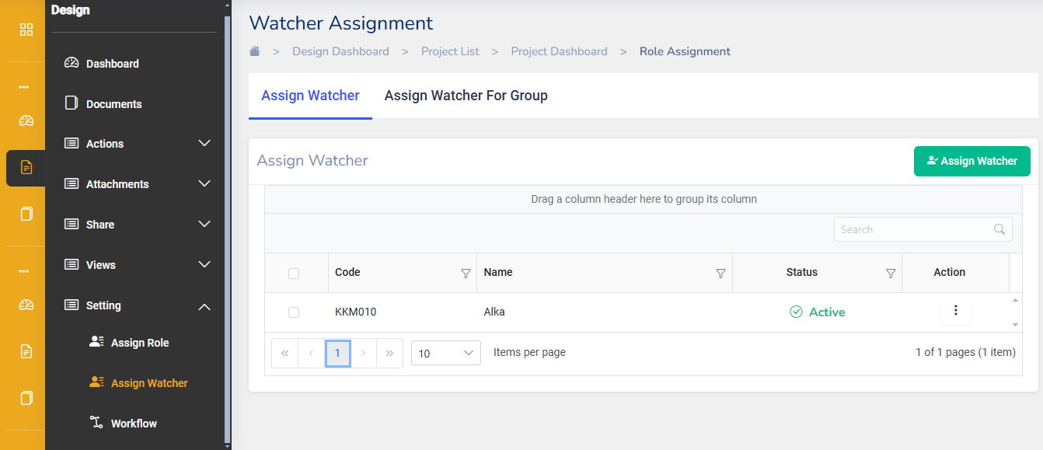

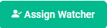

Click on the assign watcher dialog will open. Select the watcher from the drop down, where the list of watcher created will be displayed.

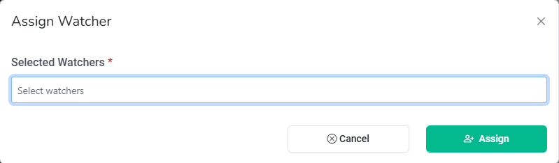

Click on to finish assigning a watcher to a user.

**Assigning Watcher for Group**

If you need to assign watchers to a group, switch to the **Assign Watcher For Group** tab.

Follow similar steps as for an assign watcher assignment.

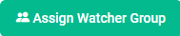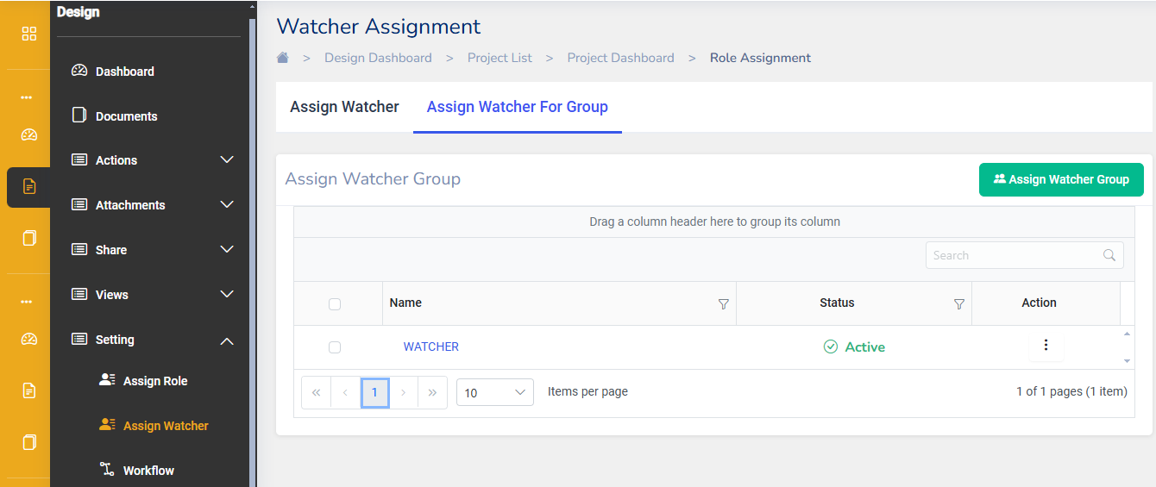

Click on, assign watcher for a group dialog will open, where we can select a watcher and then add a User Group.

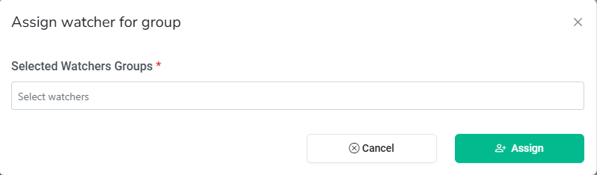

Click on to finish assigning a watcher to a User Group.

# **Workflow**

Workflows are an important feature that helps in streamlining the approval process for Documents, RFIS, Issues, BOMs/BOQs etc.

Workflows tool in Krion6D is available under Settings in



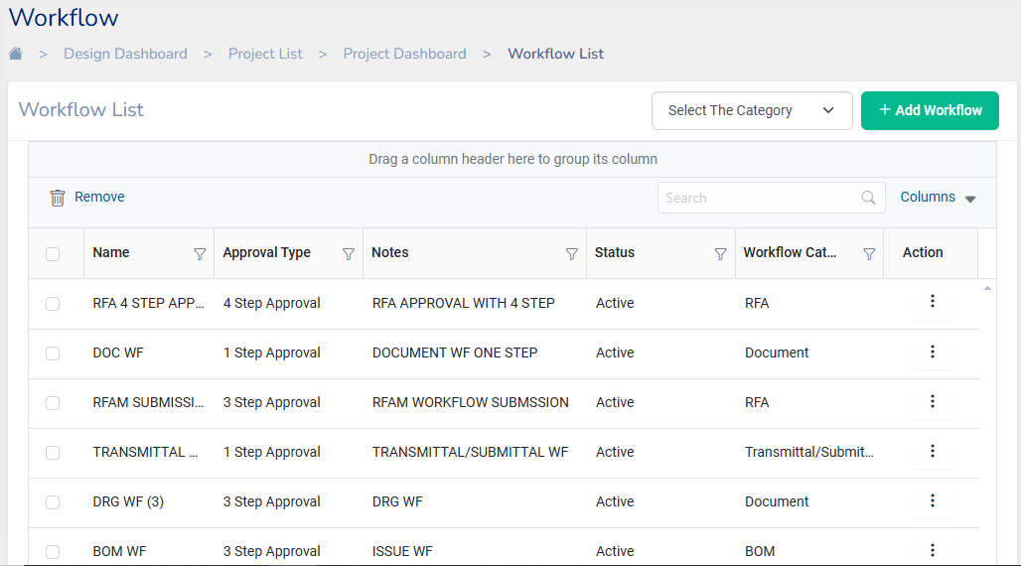

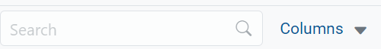**Note:** The items displayed in the Workflow list can also be changed by selecting the columns drop-down menu. Search bar allows to search for a particular workflow.

## **Creating a Workflow**

To create a new workflow, click on . Add workflow dialog opens where we must fill in the details.

**Note:**

* Before creating any workflow, the workflow should be assigned to any one of the categories viz., Process or Document.
* User can create the workflow by selecting the category. Based on the category user can create the document, Review & RFI etc...
* User create the workflow with Every member must review in that process all the reviewers in the step should be approve to forward it to next step .
* For minimum no of required workflow approval is based on the workflow is limited by the reviewers.
* for example:-from Four reviewer approval limit is set 2 then that workflow is approved by 2 of the reviewers only.

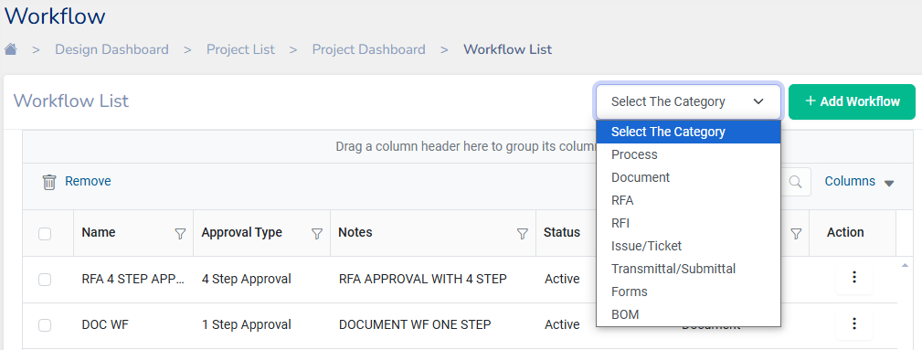

**General Info**

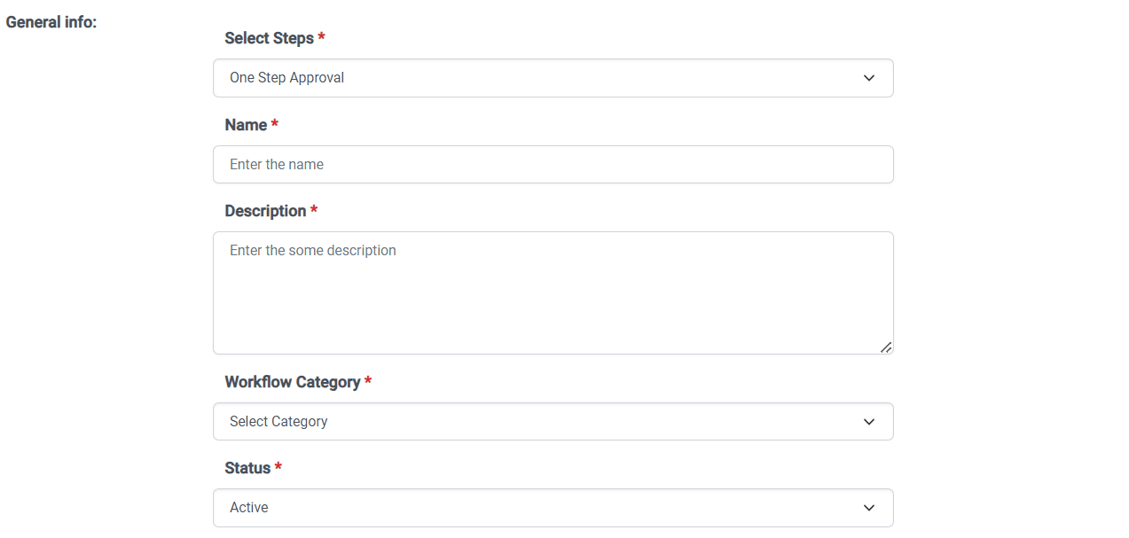

* **Select steps** of approval to be setup in the workflow. The following options are available
  + One Step Approval: A single approval step.
  + Two Step Approval: A review step and an approval step.
  + Three Step Approval: Two review steps and an approval step.
  + Four Step Approval: Three review steps and an approval step.
  + Five Step Approval: Four review steps and an approval step.
* **Name:** Enter a name for your workflow.
* **Description**: Enter some description of your workflow.
* **Workflow Category:** This can be set to document workflow or process workflow.
* **Status:** Select status as Active/Inactive for the Workflow.

**Steps**

The **Steps** section specifies the details for each step in the workflow:

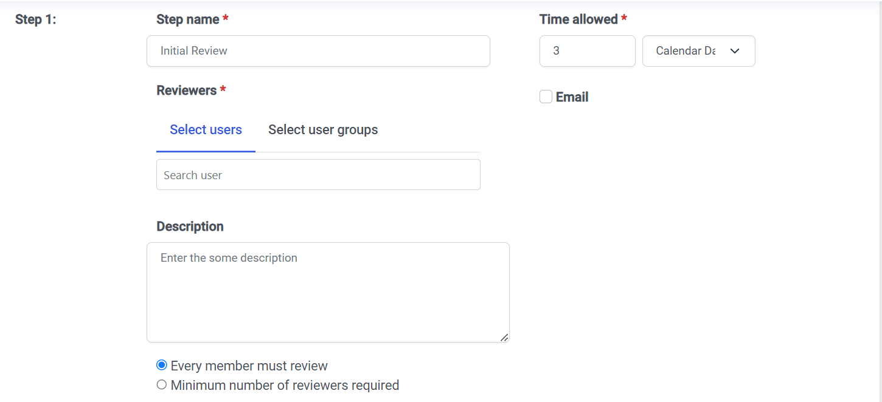

* **Step Name:** Enter a name for the step E.g.: Initiator, Approver etc.
* **Reviewers:** Add the reviewers for the step by selecting a user or a user groups
* **Time allowed:** Specify the time allowed for each step. You can also select either calendar days or work days (fixed at Monday to Friday).
* **Description:** Enter some description related to the step
* Select one of the options between **Ever member must review** or **Minimum number of reviewers required**
* Click on **Email** if the reviewers of the workflow have to be notified via Email.

**Note:**

* Based on the Number of steps selected in the General Info each step, you must enter the **Step name**, **Reviewer Type** and **Time allowed** and other details.

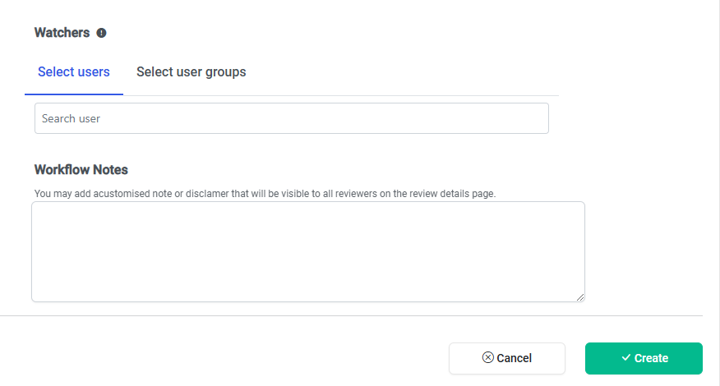

**Watcher:**

* Users can select users or user groups to be added as watchers.
* There is a search bar to help find specific users.

**Workflow notes**: Optionally, add a custom note, such as a disclaimer, which will be visible to all reviewers.

Finally, click on to finish creating a workflow.

## **Edit/ Delete a Workflow**

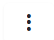From the workflow list Select a workflow my clicking on the check box and then Clicking on under **Action** to Edit or Delete a workflow.

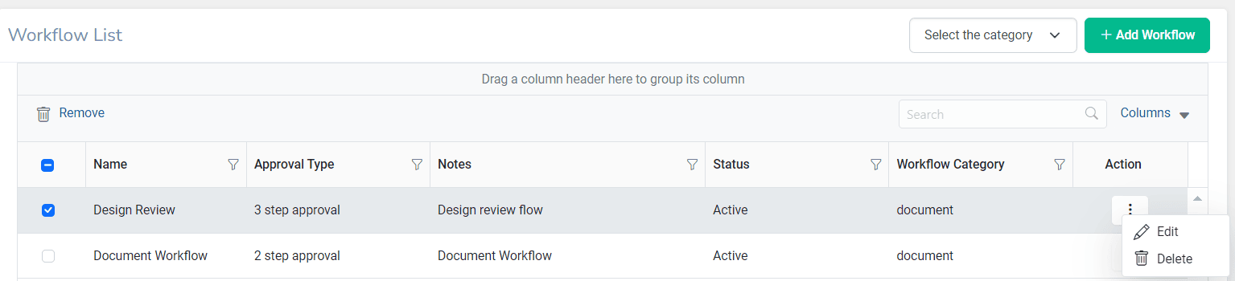

## **Creating Teams**

Teams help in grouping users based on their area of work. Krion6D enables you to create Teams and assign Team Codes to identify the team uniquely.

Navigate to Teams Under Administration from the navigation pane

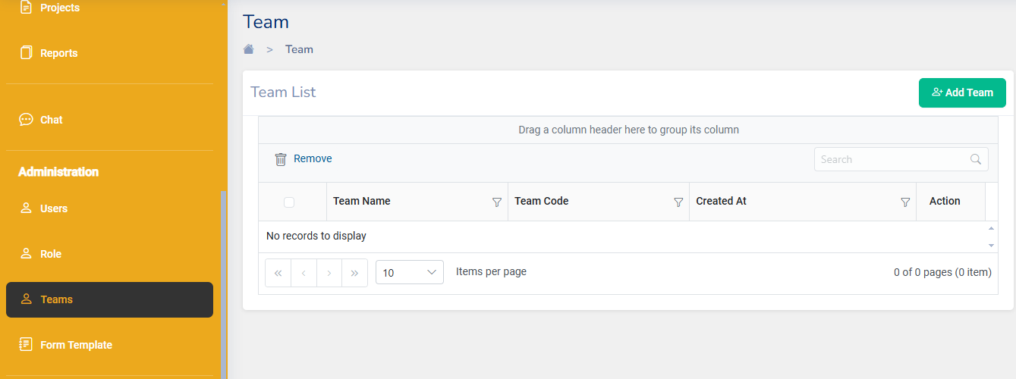

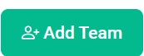Teams created in organisation will be displayed.

To add a new team, click on . Add team dialog will open where we can enter a **Team Name** and **Team code**

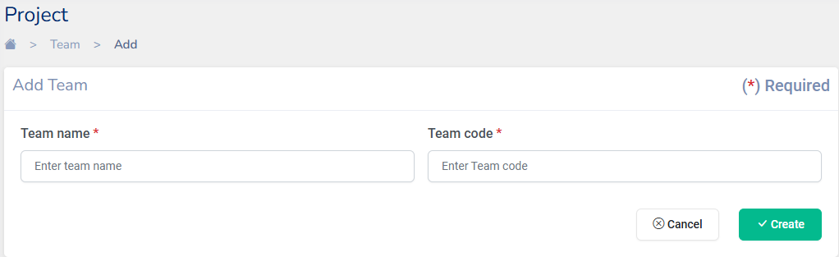

After entering Team Name and Team Code click on Create to finish creating a team.

# **Add Project**

The Krion 6D application lets you add a new Project using an available template or by creating a new template.

From the navigation pane click on Projects under Design. A list of existing projects will show up.

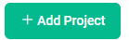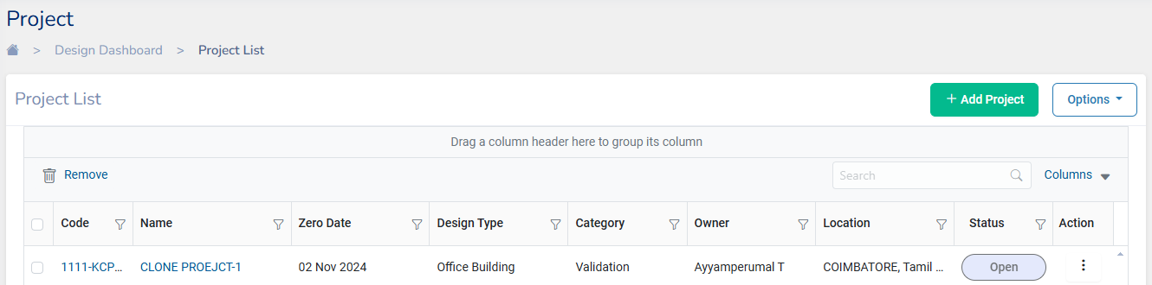

1. To create a new project, click on
2. Other options include to create a project includes clicking on **Download Template** which will download an Excel file containing a Sample Project template that can be filled and uploaded back again using **Upload Excel**. A Microsoft Project file can also be uploaded to add a new project through **Upload MSP**.
3. ****User can clone the project using the clone option in the action menu button with the options of Including users & workflow.
4. Add project will prompt with the following form:

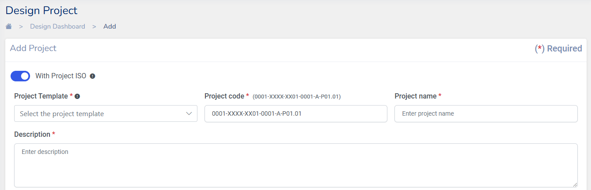

**Note:**

* A project can be added with Project ISO by toggling the button on.
* User can create a project without ISO option where the code is not mandatory for through out all the workflow process, Which includes the Add, Edit & Delete operation.

1. Complete the required fields:

* **Project Template**: This field lists a choice of basic templates that you can choose to create a project.
* **Project Code**: To be entered in the ISO 19650 format. The Project code to be entered is structured as follows:

(0001-XXXX-XX01-0001-A-P01.01), which breaks down into these components:

* 0001: A unique identifier for the project being created
* XXXX: The code representing the organization.
* XX01: Alpha Numeric Code for the current phase of the project.
* 0001: The code for the department.
* A: The department revision identifier Viz., A - Architectural, C-Civil, S-Structural, M-Mechanical, P-Plumbing, E-Environmental etc.,
* P01: Revision Number
* 01: A suffix indicating that the issue is currently a work in progress.
* **Project Name**: Specify the name of the project
* Give a brief **description** of the project

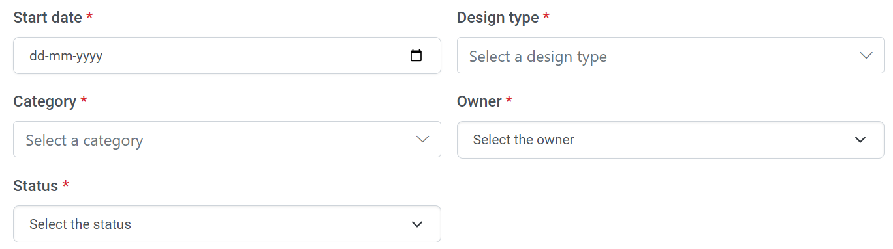

* Specify the **start date** of the project
* Select a **Design Type** from the drop-down menu
* Select the **category** of the building from the listed options
* Select the **Owner** of the project
* Select the **Status** of the project (Create, Close, InProgress)
* Enter the **location information** of the project as mentioned

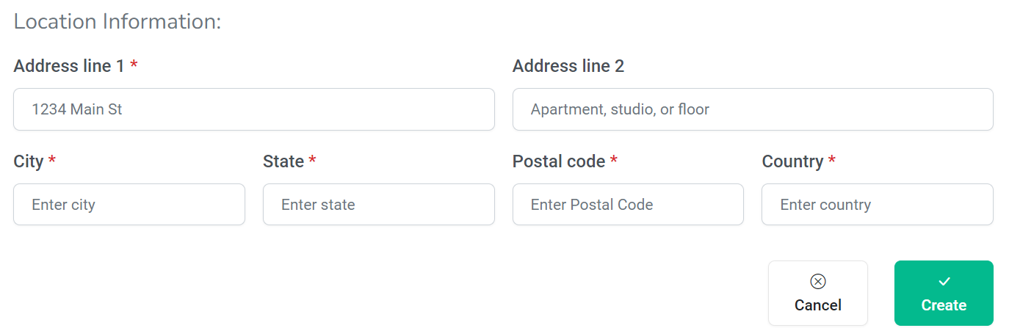

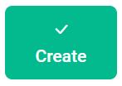

1. Click on to finish creating a Project.

**Note:**

When a new project is created by default 3 folders are available to store files. Design, Document and Other.

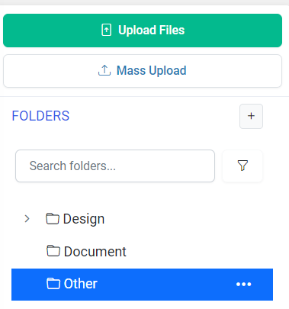

Once a new project is created, the tool will automatically guide the user through additional setup steps when the project is opened. These steps include **adding users**, **creating user groups**, and setting up **workflows**.

# **Design Dashboard**

Project Design Dashboard in Krion 6D application gives a quick overview of the data related to all projects in your organization. The Number of Projects, the total project hours, and the project costs. All these data can be viewed for a week, Month, a year, or all in total.

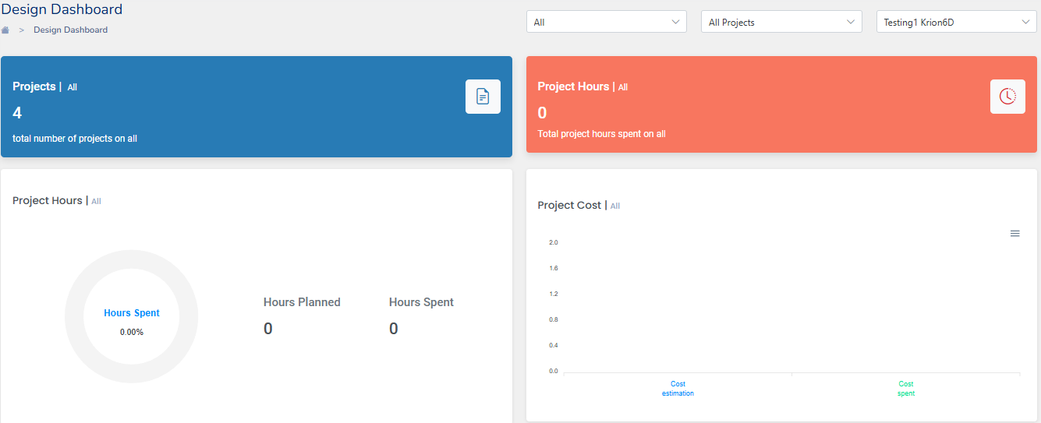

# **Project Dashboard**

The project dashboard shows a comprehensive view of important, relevant, and actionable information from a particular project. A Project’s dashboard can be viewed by selecting the Project name from the projects listed in the project design dashboard or direct from the Navigation Pane.



The project dashboard gives a snapshot of the **Project hours** spent and the **Project cost.** The details in the project dashboard can be viewed for a Week,Month, Year, or total**.** In additionto that it gives an overview of all elements related to a Project like the total **Reviews**, **Documents** (Both Pending and Completed), **RFIs**, **Submittal**, **Issues,** and **Transmittals**. Any item that needs attention can be accessed directly from the dashboard by clicking on the respective card.

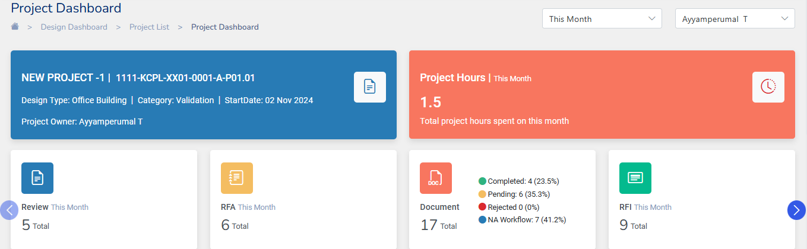

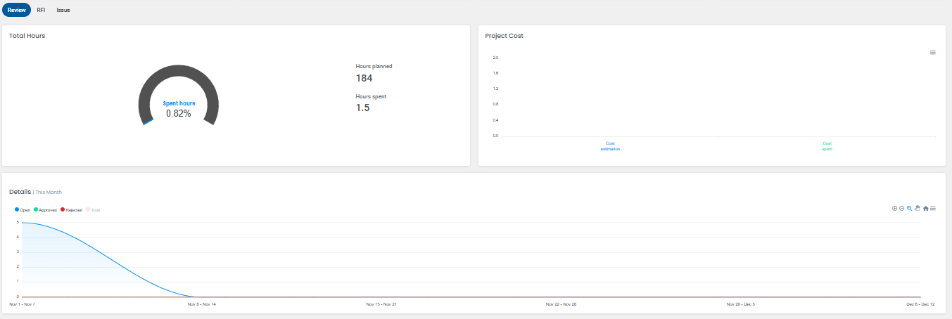

The dashboard provides comprehensive analytics related to Reviews, RFIs, and Issues within the Project. It includes detailed information on the total hours planned versus hours spent on these items, as well as the estimated and actual project costs

Data related to the count of Reviews, RFIs, and Issues that are open, Approved, or rejected are displayed for the project.

All the details displayed as analytics can be downloaded as a SVG, PNG or CSV file.

# **Uploading Files in the Project**

All files related to a project can be uploaded under the documents tab in projects in the Krion6D application



The Krion 6D application lets you upload files from Revit, Autocad, NavisWorks, and all the other important file formats. The file formats supported by Krion 6D are xls, xlsx, csv, pdf, png, doc, docx, rvt, dwg, dwf, nwc, nwf, nwd, bcf, ifc, pptx, ppt, las, spx, xml, dxf, zip, rar, ipt, ipj, iam, jpg, jpeg, txt, svf, cad.

**Note**: The maximum file size of a document that can be uploaded is 1GB.

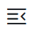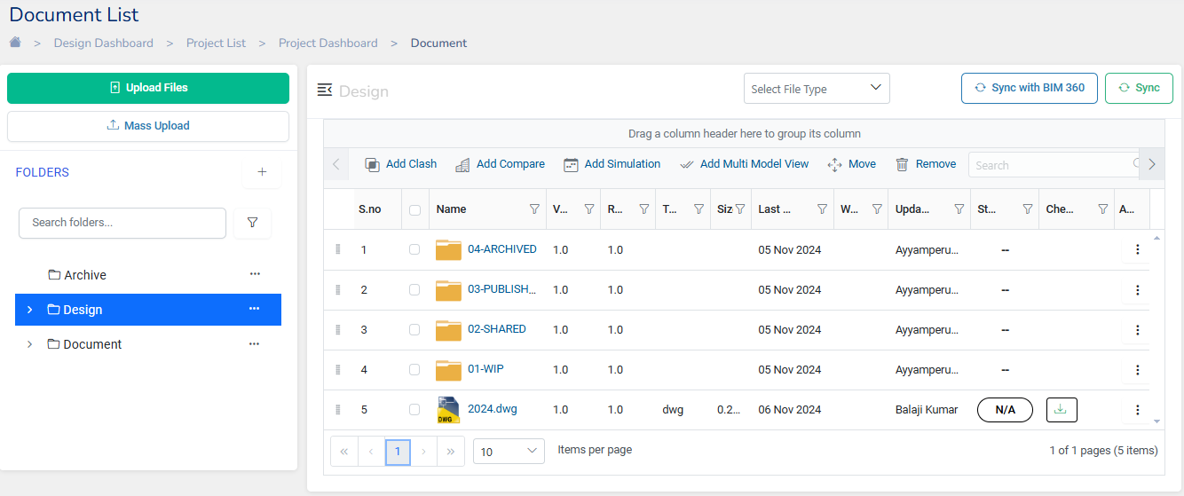

**Note:** This can used to hide the left pane showing the list of all the folders.

## **Add/Move/Remove Folders**

* To Upload a file or Add a new file click on

****This option lets you upload one document at a time.

* To upload a entire folder containing multiple documents, Click on
* To create a New Folder, click on , and enter a folder Name and click Save

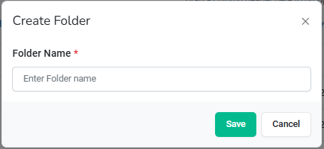

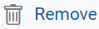

* Can be used to remove a file from the document list.
* 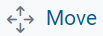 Option lets you change the order of the files/folders list by clicking and dragging them to a new location.
* 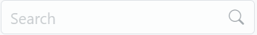 Search bar helps in searching a Document File/Folder from the list.
* Sync with BIM360 helps in syncing the drawings with BIM360 application

## **Understanding the Document View**

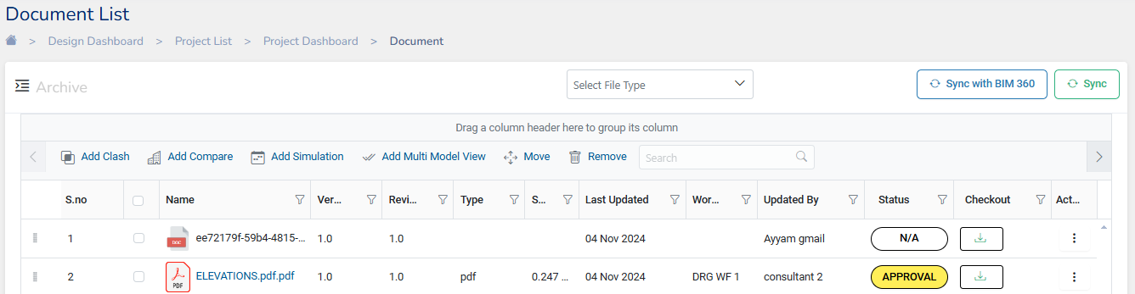

* + **Version**: Displays the document version.
  + **Name**: Shows the document name.
  + **Type**: Displays the file type.
  + **Size**: Shows the document size.
  + **Revision**: Displays the revision number of the document.
  + **Date**: Indicates the date of the last update of the document.
  + **Updated By**: Displays the user who last updated the document.
  + **Status**: Shows the current status of the document (e.g., Create, In Progress, Review, Release).
  + **Check Out**: Provides the option to download the document.
  + **Action**: Clicking on the options under this column enables the following actions:

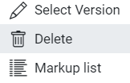

* + - **Select Version**: Allows selection of a particular version of the document.
    - **Delete**: Enables the user to delete the document.
    - **Markup List**: Displays the list of markups annotated on the drawing/3D model

**Note:** Document list can be grouped by dragging and dropping columns

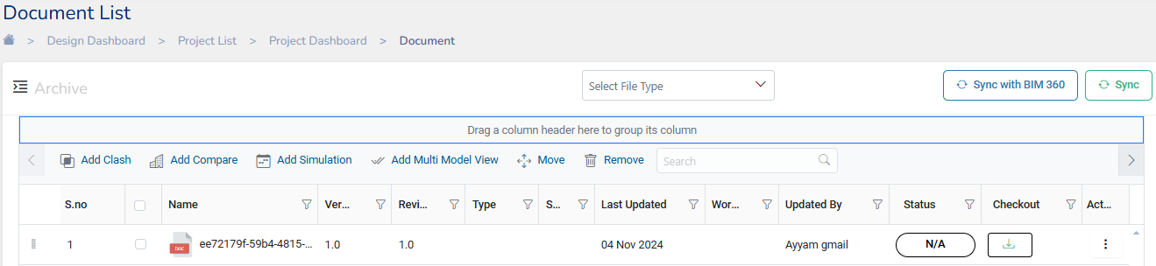

Here the list has been regrouped by the **File** **Type** Column

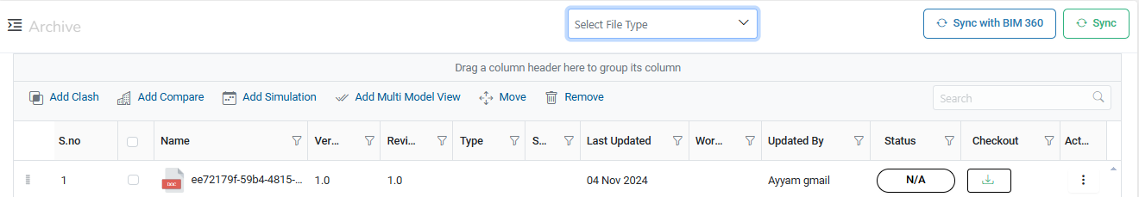

## **Assigning Document to Workflow**

Once a new document is uploaded the **Status** of the document can be to set to the document workflow.

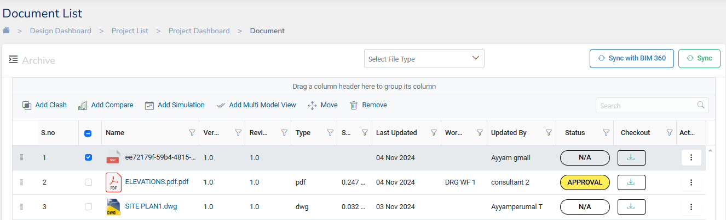

In the Status Column click on N/A and connect to a workflow by choosing a workflow listed from the drop-down menu.

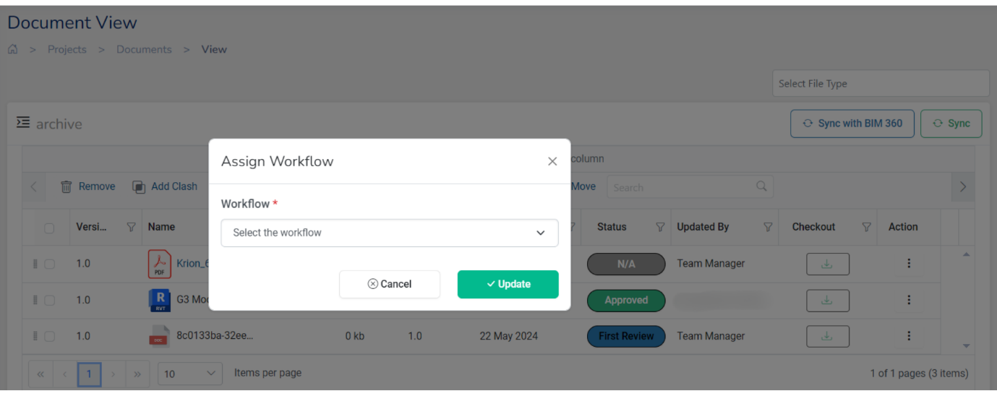

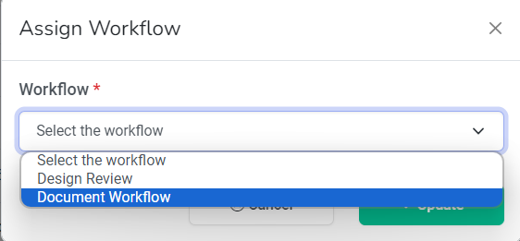

## **Working with the document files**

Krion6D application provides various options on work on the construction project drawings, various options to work with the documents like comparing them, identifying clashes, simulation, and multi-model view.

* 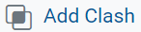To detect any clash in drawings select 2 documents (.xml+.nwd) and

click on . Clash visualization of any design elements between the two documents gets highlighted.

* 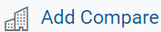To compare to designs select to two documents (.rvt+.rvt) or (.dwg+.dwg) and click on
* 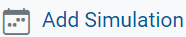To check the simulation of drawings select two documents (.xml+.nwd) and click on

 . Simulation gives a view of the drawing with a timeline of the project. You can drag the timeline cursor to see various aspects of the project at the desired time.

* To federate drawings in a muiltimodel view , select two or more documents (.rvt+.rvt) or (.dwf + .dwf) or (.rvt + .dwf + .dwf) etc and click on

# **Review**

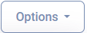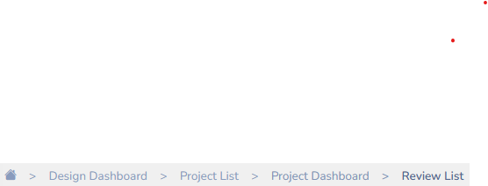The review list in Krion 6D application displays the complete list of tasks that you have across the project. You can go to the reviews list from The review list has a complete list of tasks/subtasks in a project and follows a WBS structure.

The review tasks list can be uploaded by clicking on . The Krion 6D application lets you upload task list from an excel sheet, or MS project file or can be synchronized with an MS project server.

The list shows the **Name** of the task, **Start** **Date** and **Due Date** of the task, **work hours** spent, **owner**, and **status** of the task.

Tasks are color-coded to show the different status of each task.

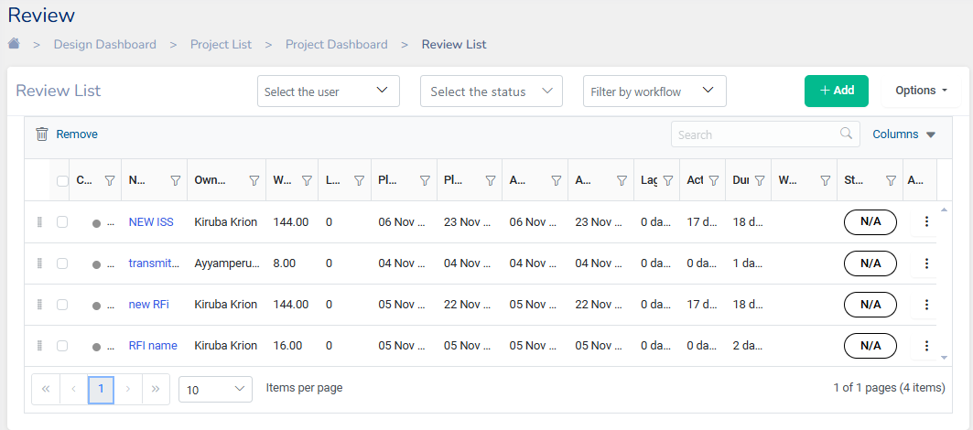

**Note:** The review list can be filtered by the status of the task whether the task is Open, Approved, Review or Responded. The list can be filtered by User or User Group.

**Tip:** The task list can be viewed with a timeline like a Gantt Chart in a side-by-side view by clicking on the Timeline from the navigation pane.

## **Add a Review**

To add a new task to review click on and fill in the necessary details

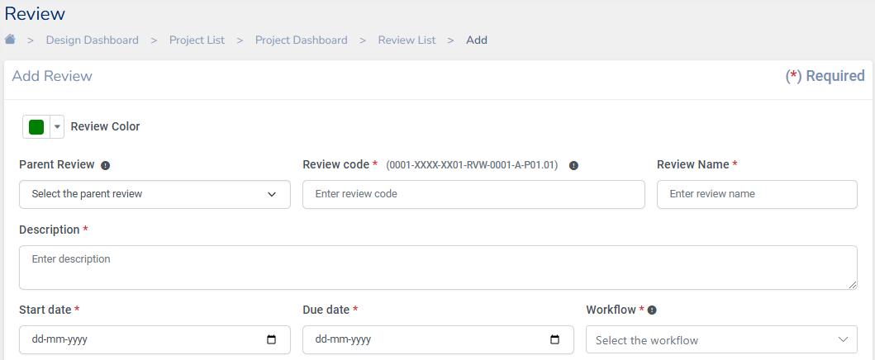

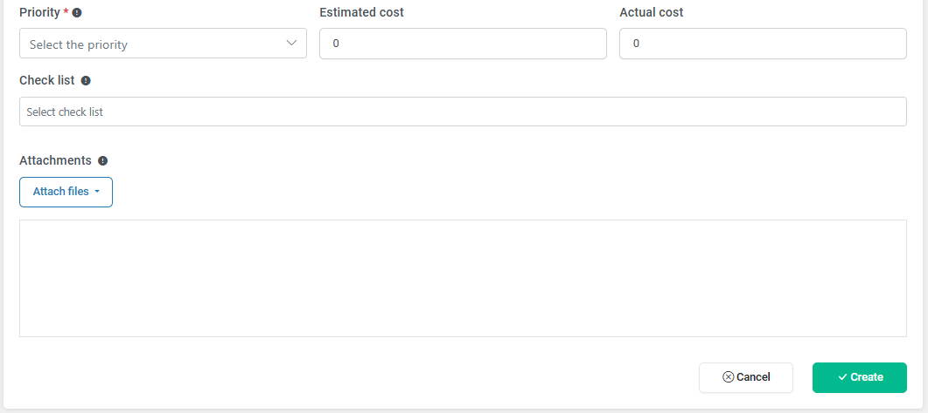

* Select the **Parent review** of the new review being created
* Enter the **review code** as per the ISO format

0001-XXXX-XX01-RVW-0001-A-P01.01.

It is structured as below:

* + 0001: A unique identifier for the Review being created
  + XXXX: The code representing the organization.
  + XX01: Alpha Numeric Code for the current phase of the project.
  + RVW : Indicating that it is a review.
  + 0001: The code for the department.
  + A: The department revision identifier Viz., A - Architectural, C-Civil, S-Structural, M-Mechanical, P-Plumbing, E-Environmental etc.,
  + P01: Revision Number
  + 01: A suffix indicating that the issue is currently a work in progress
* Enter the **review name**, add a **description**, **start date**, and **end date**, and select the **Workflow** to which the review will be attached.
* **Priority** can be set for the review as High, medium, low, or critical.
* Optionally the **Estimate of cost** and **actual cost** can be entered.
* **Attach** **Files** lets you upload any files related to the review task. You can attach any file from the drive, RFIs, Issues, Transmittals, Submittals, BOM/BOQ or Form. Any combination of these files can also be uploaded.
* Finish entering the all required fields and then click **Create** to successfully create a review.

## **Actions on Review**

Click on from the Review list to view various actions that can be performed on a Review

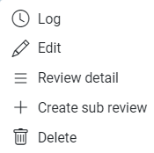

* **Log:** This option lets the user log the hours spent on a review. Users can update the Log Date, Total Hours Spent, Actual Hours spent
* **Edit**: To make any changes to the details in the created Review, users can use this option to edit the Review
* **Review Detail:** This option can be used to view the details of a Review from the review list.
* **Create Sub Review**: Redirects the user to add a sub review to the current Parent Review.
* **Delete**: A review can be deleted by using this option

## **Timeline**

The timeline feature in Krion 6D application displays all the projects in a Gantt Chart format. This visual tool helps in planning scheduling and tracking specific tasks with a project. It gives a clear visual representation of a project’s timeline and the duration of individual tasks making it easier to understand the project’s flow and overall scope.

It also shows how tasks are interrelated and depend on the completion of proceeding tasks. Adjustments and updates can be made as the project advances, providing a dynamic way to manage and adapt to changes

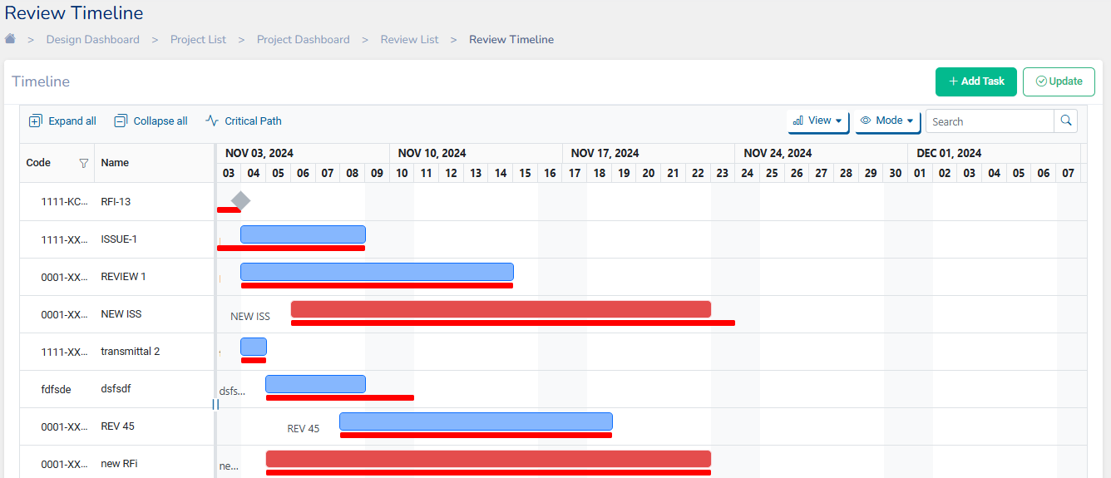

The timeline view features:

**Detailed task Information**: Simply hover over any taskbar to see details such as the task name, start and end dates, and current progress

**Task Relationships**: Easily create dependencies by dragging and dropping between tasks

**Adjustable Durations**: Directly update the duration of tasks by adjusting the ends of the taskbars.

**Progress Updates**: Modify the progress status of tasks directly from the timeline.

**Flexible Views**: Switch seamlessly between timeline, grid, or chart views to best suit your project tracking needs

**Time Scale Customization**: Customize the task view to display information by date, month, or year, enhancing long-term planning and review

**Expand All**: Quickly unfold all subtasks within a task to view detailed breakdowns and individual components of larger tasks.

**Collapse All**: Simplify your view by collapsing all subtasks, allowing you to focus on the overall tasks and reduce visual clutter.

**Task Search**: Use the search bar to quickly locate specific tasks within your project

# **RFIs**

RFI **(Request for Information)** is used to formally document questions or queries or responses to design in construction-related topics that may come up during the lifecycle of a construction project.

RFIs can be viewed from . The **columns** that are displayed in the list can be customized as per the requirement by selecting the required fields. RFIs can be searched from the list from the search bar.

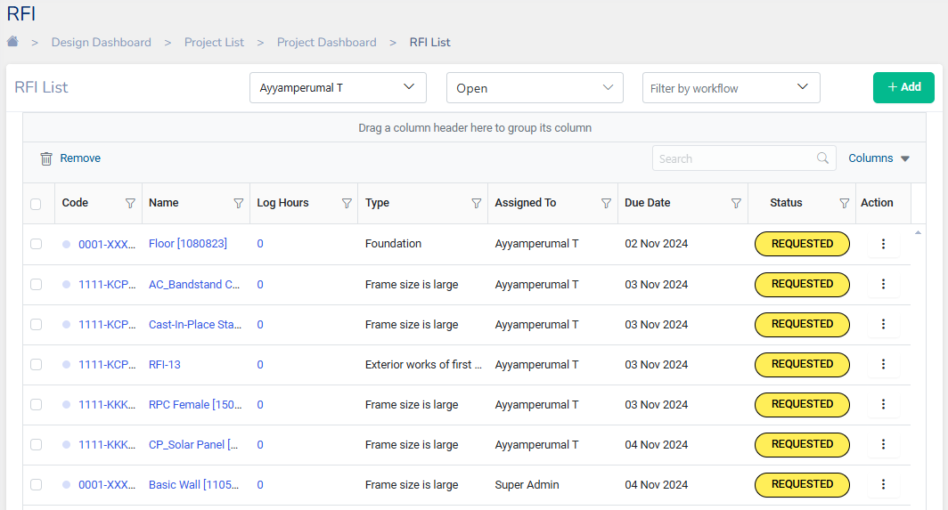

## **Create RFI**

To create an RFI you can click on

1. The RFI is created by entering a unique **RFI code** as per ISO 19650 format. The code is customizable. The RFI code is structured as **0001-XXXX-XX01-RFI-0001-A-P01.01**, which breaks down into these components:
   * 0001: A unique identifier for the RFI being created
   * XXXX: The code representing the organization.
   * XX01: Alpha Numeric Code for the current phase of the project.
   * RFI: Indicating that it is a RFI
   * 0001: The code for the department.
   * A: The department revision identifier Viz., A - Architectural, C-Civil, S-Structural, M-Mechanical, P-Plumbing, E-Environmental etc.,
   * P01: Revision Number
   * 01: A suffix indicating that the issue is currently a work in progress

This format ensures that each issue can be tracked and referenced efficiently throughout its workflow process.

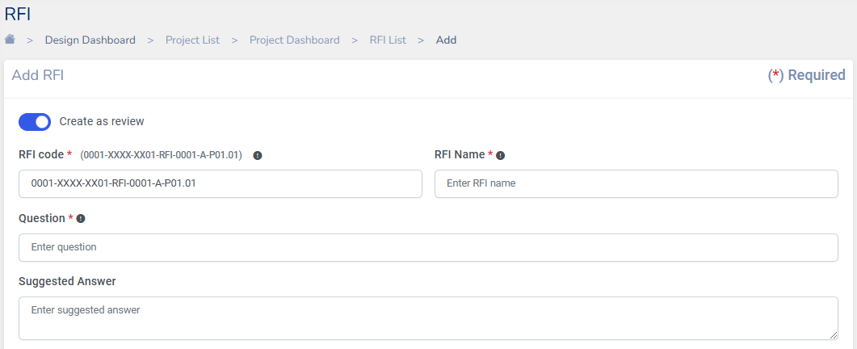

***Note****: The* ***Create as Review*** *button can be toggled on if you want to create an RFI as a review task. If no review is required for the RFI being raised it can be toggled off. However, the RFIs can also be individually tracked down by attaching it to a workflow*

1. In the **Title** field enter the RFI name
2. Enter the **question** requesting information for which the RFI is being created

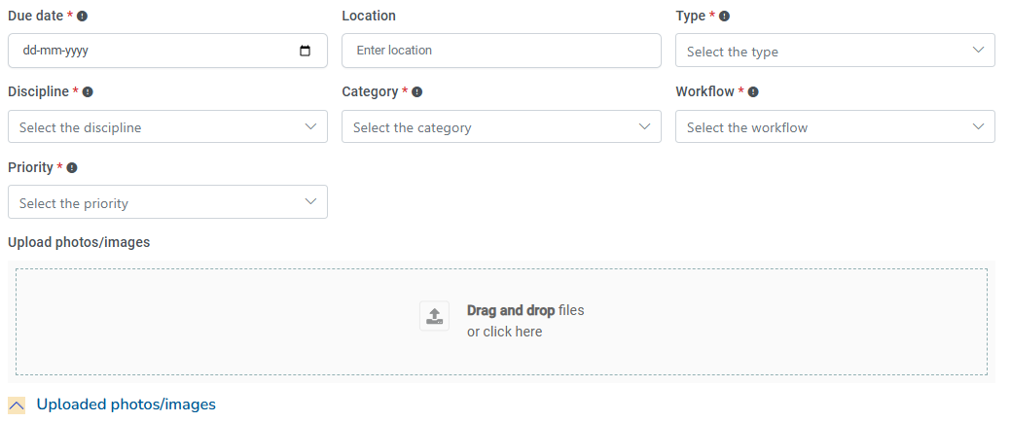

1. Enter the **Due Date** for the RFI
2. Choose the **Location** of the RFI, **Type**, **Discipline**, **Category,** and **Priority** for the RFI
3. **Workflow** is a mandatory field which needs to be assigned to a RFI for various stages of approval and processes
4. Optionally **estimate of Cost** and **Actual cost** can be specified
5. Select if there is a **Cost Impact** or **Schedule Impact** on the RFI being raised.
6. 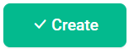**Upload** relevant supporting documents if necessary
7. Finally click to successfully create an RFI

## **Actions on RFI**

Click on from the RFI list to view various actions that can be performed on an RFI

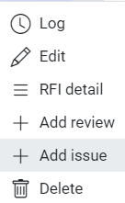

* **Log:** This option lets the user log the hours spent on an RFI. Users can update the Log Date, Total Hours Spent, Actual Hours spent
* **Edit**: To make any changes to the details in the created RFI, users can use this option to edit the RFI
* **RFI Detail:** To view the details of a RFI from the RFI list this option can be used.
* **Add Review**: Redirects the user to the Add Review page where the users can add the RFI as a review task.
* **Add Issue:** Enables the user to create an Issue.
* **Delete**: An RFI can be deleted by using this option

## **Creating RFI from the 3D viewer**

RFI can also be created on the 3D model while viewing the drawing in the 3D viewer.

1. Open a drawing file from the document list. Once the 3D viewer page is loaded, Find the icon from the tools displayed on the screen.

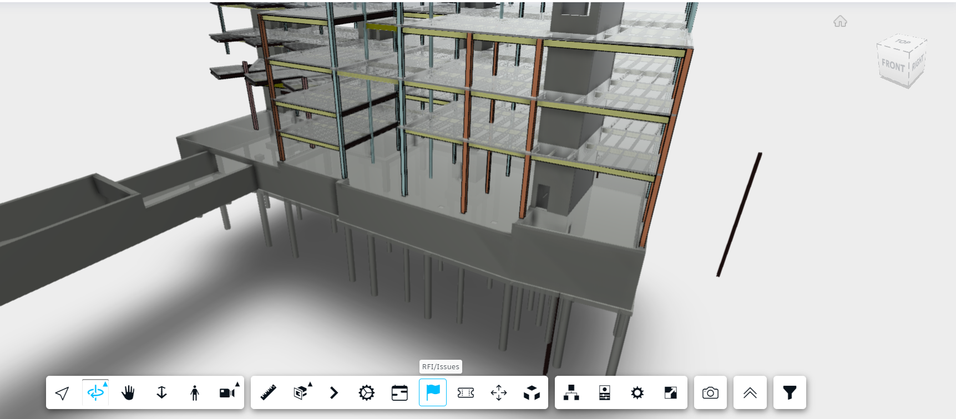

1. Clicking on the tool opens the dialog to raise an RFI

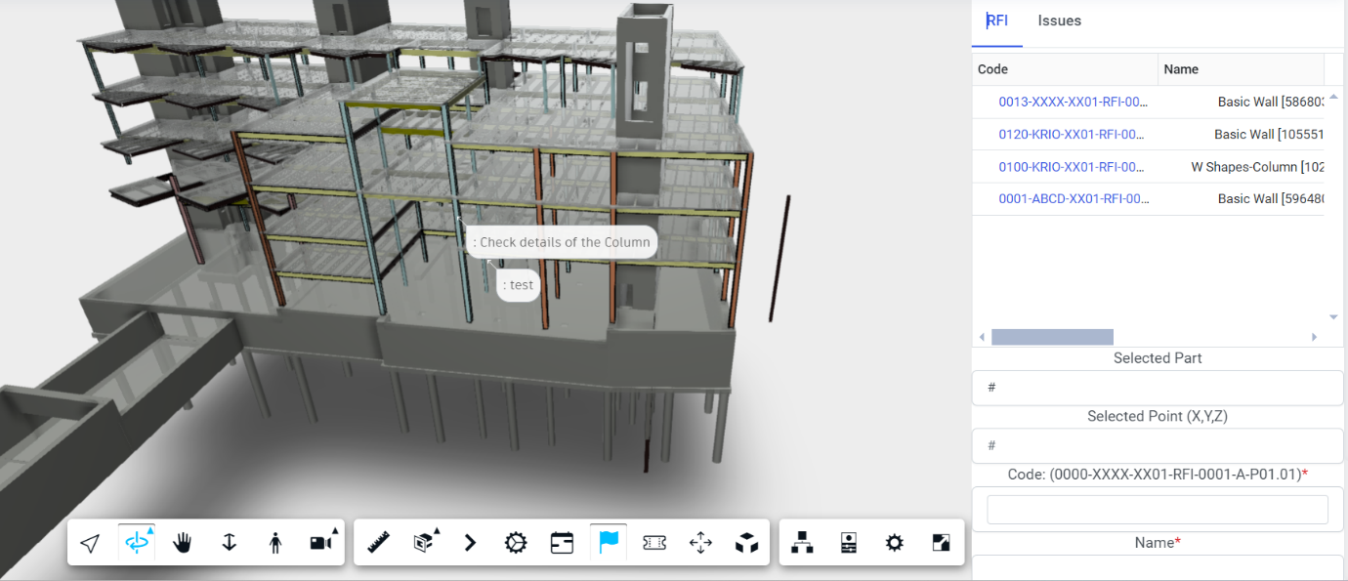

1. Once the item in the model is marked the **Selected Part**, **Selected Point,** and **Name** fields get automatically populated.

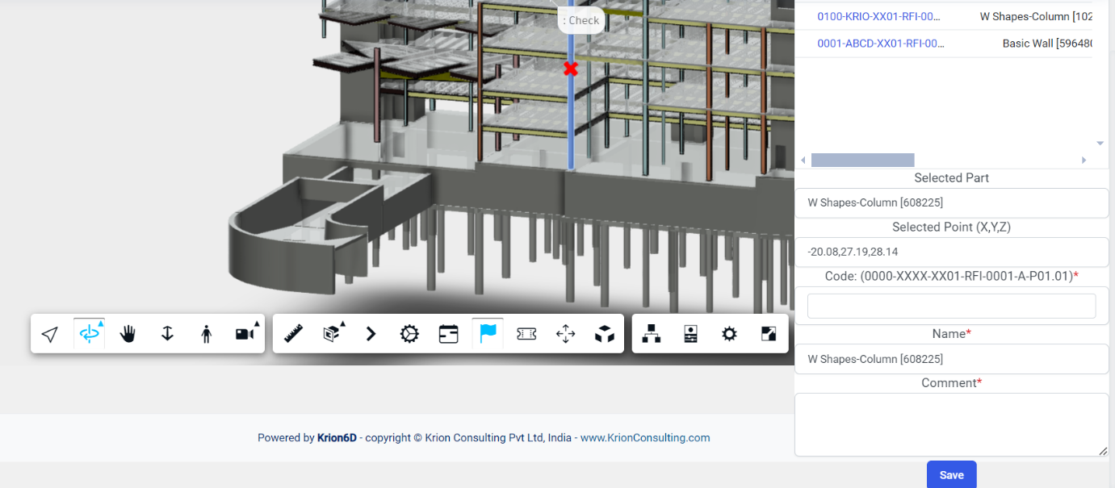

Enter the other details like the **RFI code** (based on the specified format) and enter **comment**s if any and click save.

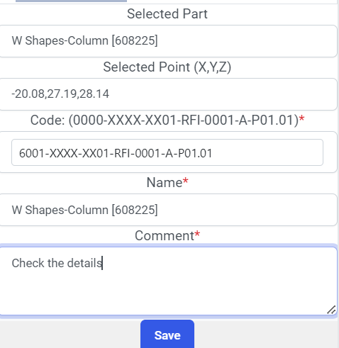 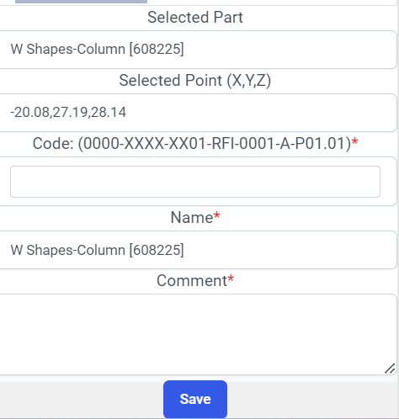

1. The created RFI’s details can be attached to a workflow directly from the 3d viewer and if required, can be edited by clicking on the RFI Code displayed in the dialog box, which will redirect to the edit RFI Detail module

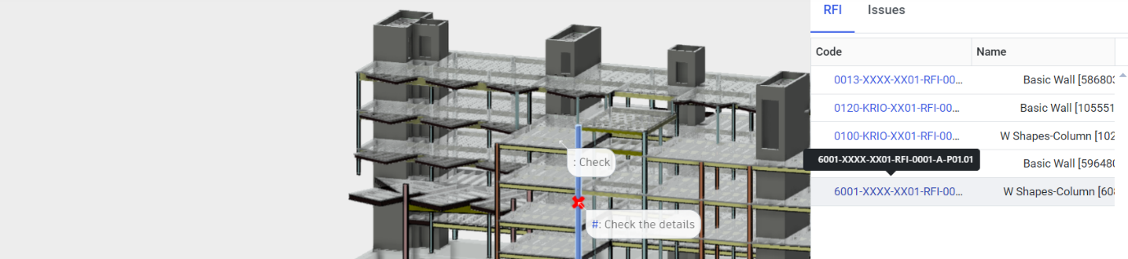

By Clicking on **Edit** we can further select a Assignee and other necessary details can be added to the Issue.

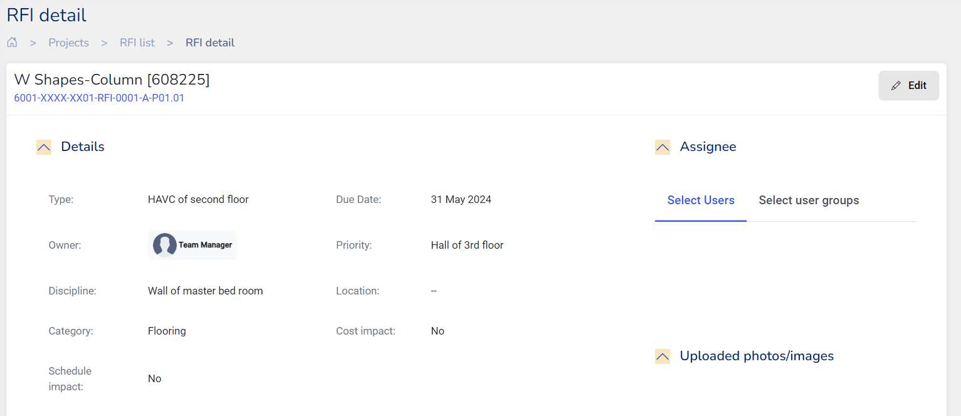

**RFAs**

**RFA (Request for Approval)** is a formal process used to submit documents, drawings, or other items for approval throughout the lifecycle of a construction project. RFAs ensure that all necessary approvals are documented and tracked, helping to maintain quality and compliance with project standards.

RFAs can be viewed from

The columns that are displayed in the list can be customized as per the requirement by selecting the

required fields. RFAs can be searched from the list from the search bar.

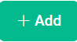Create RFA

To create an RFA you can click on

1. The RFA is created by Choosing RFA Colour(**Default Colour Green**). The code is customizable. The RFA code is structured as **0001-XXXX-XX01-RFA-0001- A-P01.01**, which breaks down into these components:

* **0001**: A unique identifier for the RFA being created
* **XXXX**: The code representing the organization.
* **XX01**: Alpha Numeric Code for the current phase of the project.
* RFA: Indicating that it is a RFA
* **0001**: The code for the department. KRION 6D HELP DOCUMENT 30
* **A**: The department revision identifier Viz., A - Architectural, C-Civil, S-Structural, M-Mechanical, P-Plumbing, E-Environmental etc.,
* **P01**: Revision Number
* **01**: A suffix indicating that the issue is currently a work in progress This format ensures that each issue can be tracked and referenced efficiently throughout its workflow process.

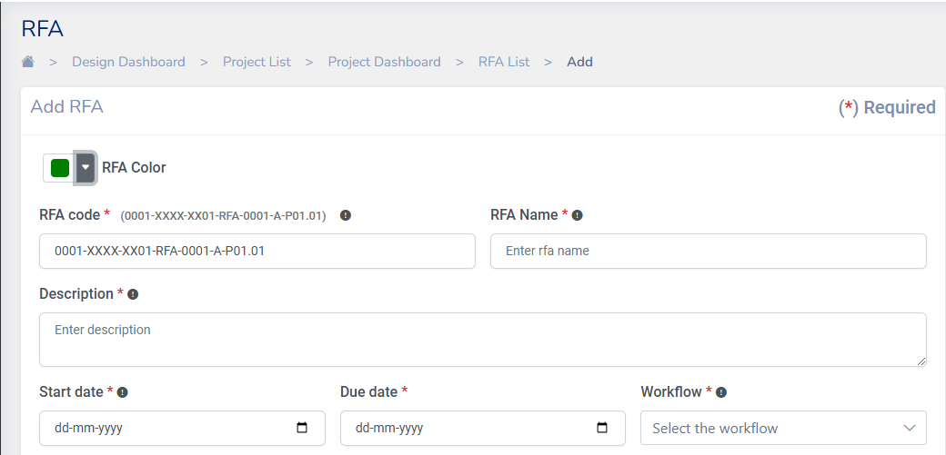

1. In the **Title** field enter the RFA name
2. Enter the **Description** information for which the RFA is being created

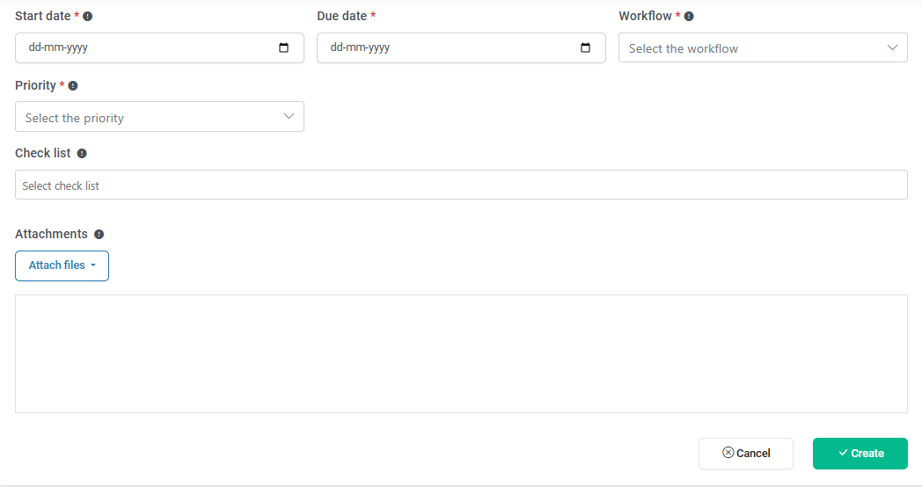

1. Enter the **Start Date** for the RFA
2. Enter the **Due Date** for the RFA
3. **Workflow** is a mandatory field which needs to be assigned to a RFA for various stages of approval and processes
4. Choose **Priority** for the RFA
5. Select the **Check list**
6. **Attach** relevant supporting file document if necessary
7. Finally click to successfully create an RFA

Actions on RFI

Click on from the RFA list to view various actions that can be performed on an RFA

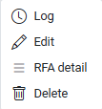

* **Log**: This option lets the user log the hours spent on an RFA. Users can update the Log Date, Total Hours Spent, Actual Hours spent
* **Edit**: To make any changes to the details in the created RFA, users can use this option to edit the RFA
* **RFA Detail**: To view the details of a RFA from the RFA list this option can be used.
* **Delete**: An RFI can be deleted by using this option

**Issues**

Issues tool is used to track work, communicate areas for improvement, resolve problems, and prevent delays by tracking the work through a workflow. You can create issues under Projects, assign them to team members, and track the progress.

In Krion 6D application Issues tool can be located under Design Dashboard > Project List > Project Dashboard > Issue List

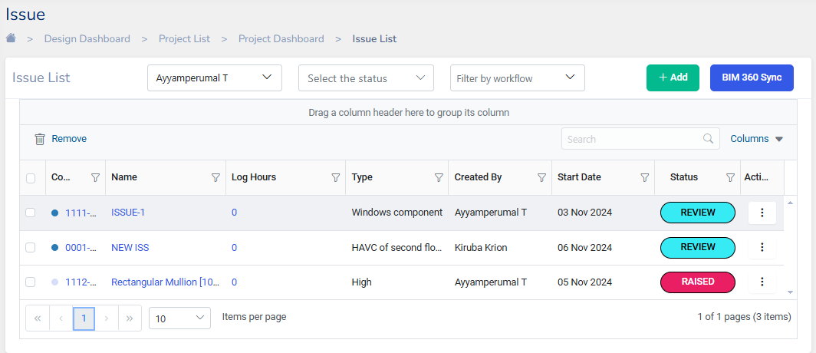

**Note:** The Status of the Issue will be updated based on the approval process defined in the Workflow.

## **Create Issue**

To Add a New issue, Click on the button. The Add Issue form will show up

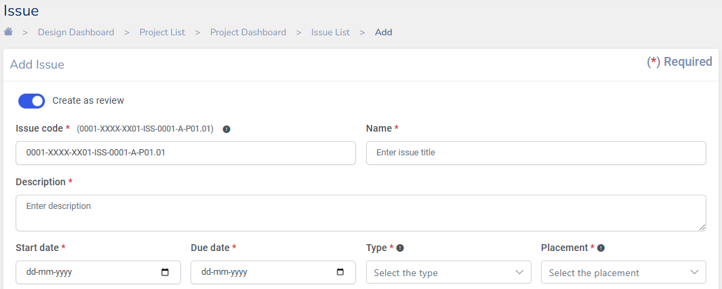

**Note**: The **Create as Review** button can be toggled on if you want to create the Issue as a review task. If no review is required for the Issue being raised it can be off. However, the Issues can also be individually tracked down by attaching it to a workflow

1. The Issue code to be entered is structured as follows:

**(0001-XXXX-XX01-ISS-0001-A-P01.01)**, which breaks down into these components:

* + 0001: A unique identifier for the Issue being created
  + XXXX: The code representing the organization.
  + XX01: Alpha Numeric Code for the current phase of the project.
  + ISS: Implies that it is an Issue
  + 0001: The code for the department.
  + A: The department revision identifier Viz., A - Architectural, C-Civil, S-Structural, M-Mechanical, P-Plumbing, E-Environmental, etc.,
  + P01: Revision Number
  + 01: A suffix indicating that the issue is currently a work in progress

This format ensures that each issue can be tracked and referenced efficiently throughout its workflow process.

1. Enter a brief **Title** for the issue in the Title field (E.g.: Beam Column junction)
2. Provide a brief **Description** of the issue in the designated field
3. Specify the **Start date** for addressing the issue
4. Specify the **Due date** for addressing the issue
5. 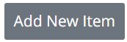Enter the issue **Type** in this field. If the issue is already listed choose it from the list. If the issue you are raising is not listed under the issue type, you can Enter the issue and click
6. Enter the **Placement** Type in this field. If the issue is already listed choose from the list. If the issue you are raising is not listed under the issue type, you can Enter the issue and click

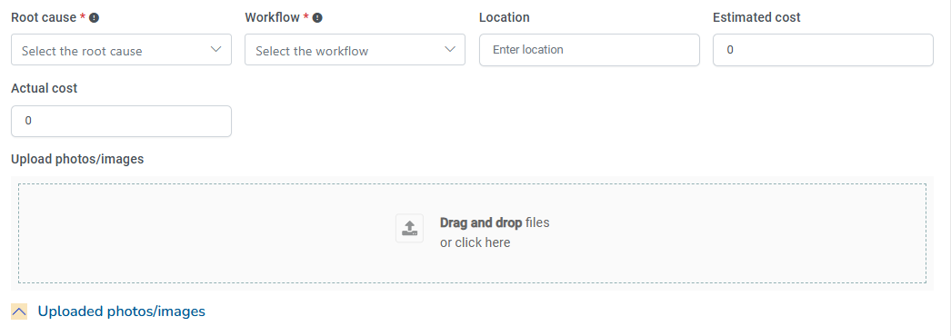

1. Indicate the **Root cause** of the issue from the available options, If not available a new entry can be created.
2. Assign the **Workflow** type from the listed options.Workflow is a mandatory field which needs to be assigned to an Issue for various stages of approval and processes
3. Enter the **Location** of the issue in the associated file
4. Optionally, Provide the **Estimated cost** of addressing the issue
5. Optionally, input the **Actual cost** incurred for resolving the issue
6. 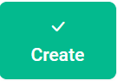**Upload photos/images** of the issue by dragging and dropping files into the designated field or attaching files from the drive. Attachments added will be displayed in this box Note: Steps 11 to 13 are optional to Create an Issue
7. Click on the button to finalize the creation of the Issue.

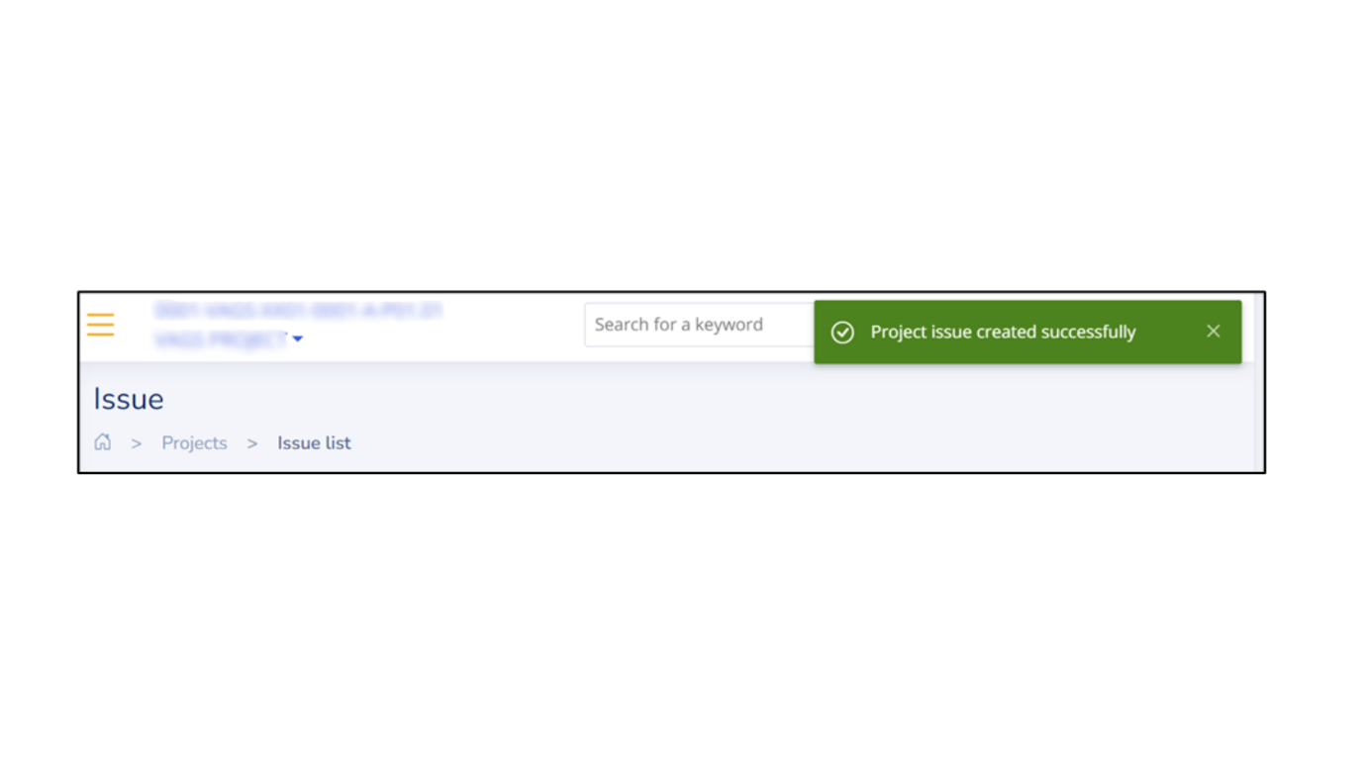**Project issue created successfully** message will pop up confirming the creation of the issue

## **Actions on Issue**

Click on from the issue list to view various actions to be performed on an Issue

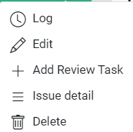

* **Log:** This option lets the user log the hours spent on an issue. Users can update the Log Date, Total Hours Spent, Actual Hours spent
* **Edit**: To make any changes to the details in the created issues, users can use this option to edit the issue
* **Add Review Task** : Redirects the user to the Add review page where the users can add the issue as an review task.
* **Issue Detail:** To view an issue from the issue list this option can be used.
* **Delete**: An issue can be deleted by using this option

## **Creating Issue from the 3D Viewer**

While analyzing structural or architectural drawings, Issues can be created by Marking the item on the 3D Model.

1. Open a drawing file from the document list. Once the 3D viewer page is loaded, find the icon from the tools displayed on the screen.

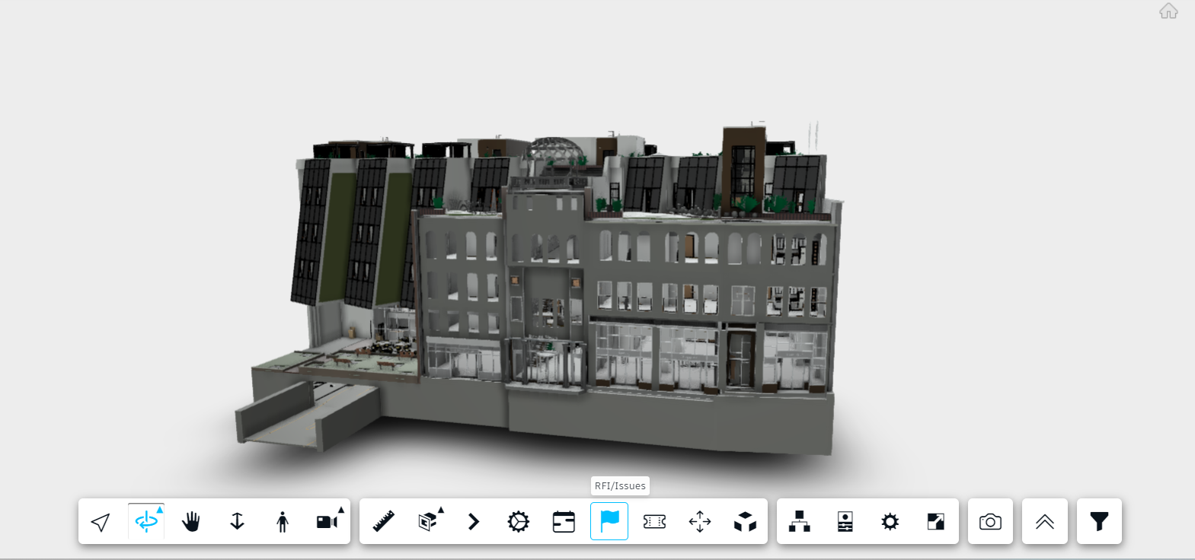

2. Clicking on the tool opens the dialog to raise an Issue.

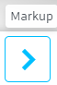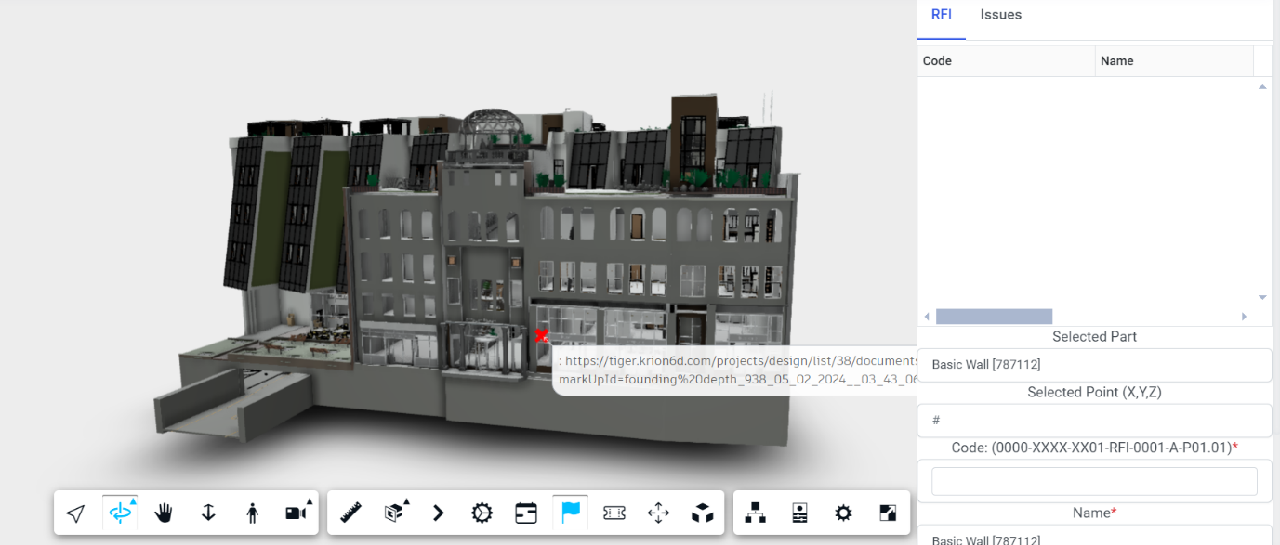

3. Select the item on the building, and create a Markup on the model using the markup tool.

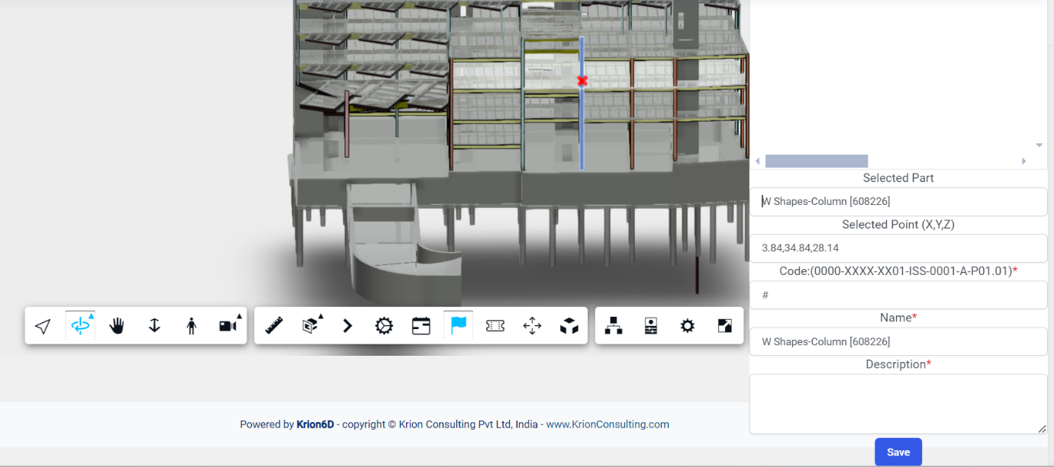

Once the item in the model is marked the **Selected Part**, **Selected Point** and **Name** fields get automatically populated.

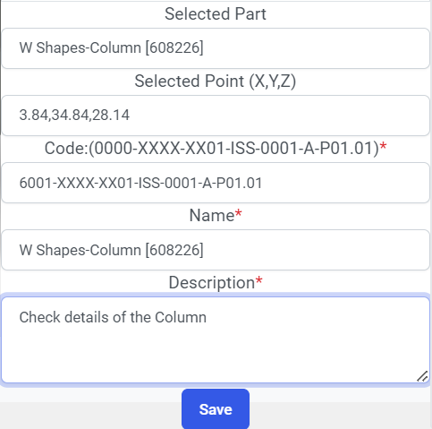 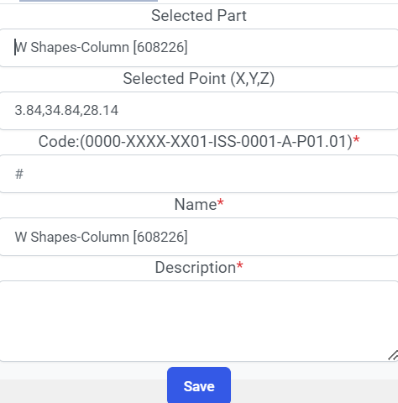

Enter the **Issue Code** as per the specified format and add **description** if any and Click save.

4. The Issue details can be further can be attached to a workflow directly from the 3d viewer and if required, can be edited by clicking on the Issue Code displayed in the dialog box, which will redirect to the edit Issue Detail module.

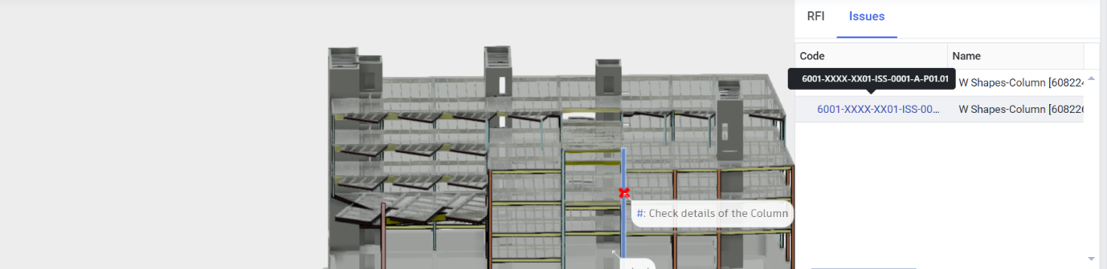

By Clicking on **Edit** we can further select a Assignee and other necessary details can be added to the Issue.

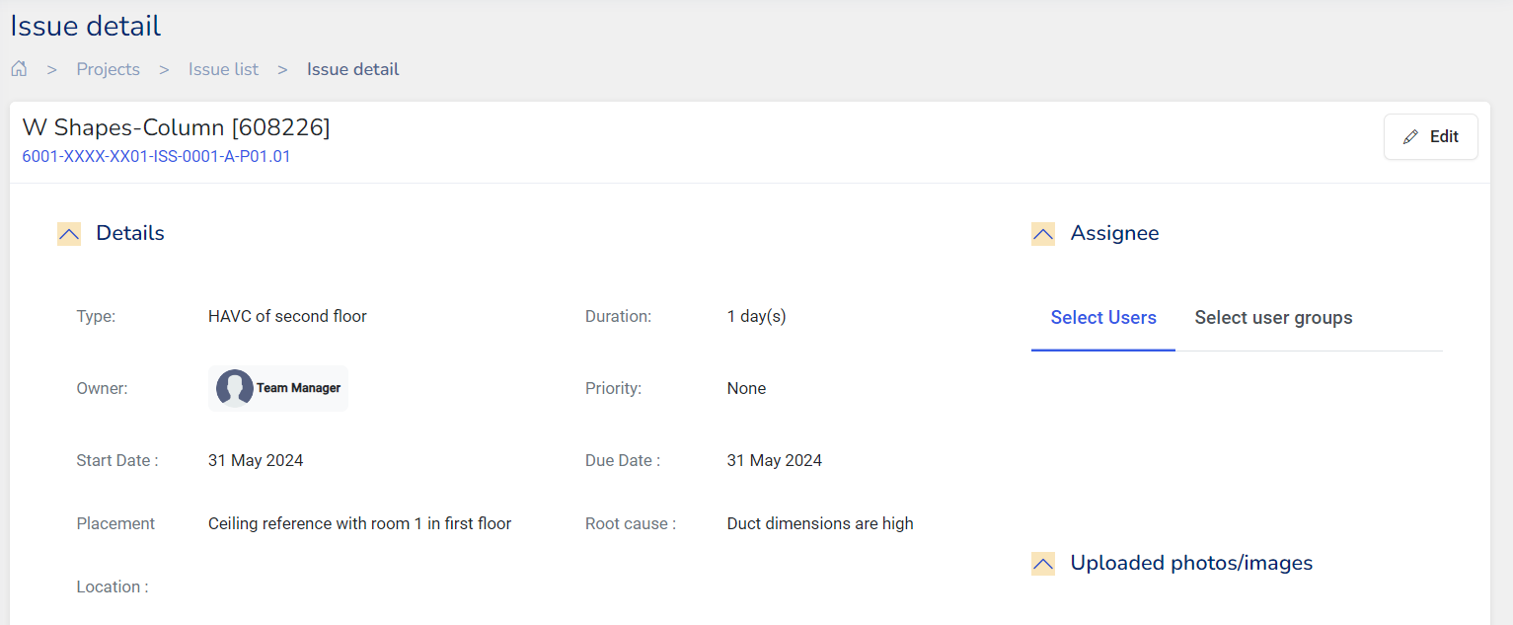

# **Transmittal**

A transmittal is a document accompanying other documents, files, or samples, serving as a record of when these items were sent and providing proof of their transmission. In construction projects, transmittals are especially important as they track the dispatch of project documents and identify the recipients.

The transmittal tool can be accessed under the Share option under the projects from the navigation pane.

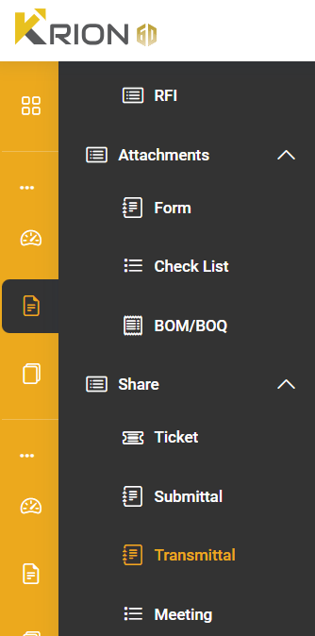

The **Transmittals** tool in Krion 6D allows you to see a list of all transmittals along with details like the:

* Transmittal code
* Title
* Created by
* No of Documents
* Status

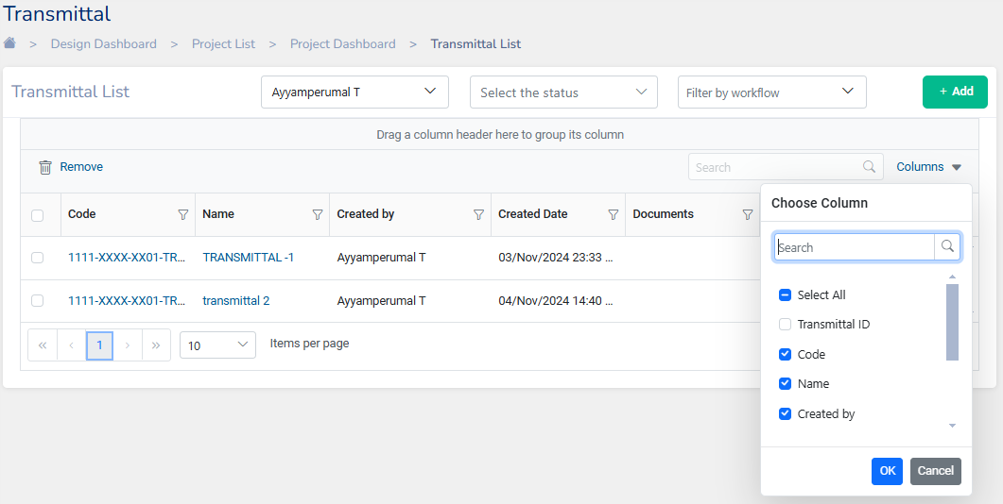

**Note:** The transmittals list can be filtered by the status and by user/user groups. The items to be displayed in the list can also be customized by selecting the columns drop-down menu.

## **Create Transmittals**

1. Click on to create a Transmittal

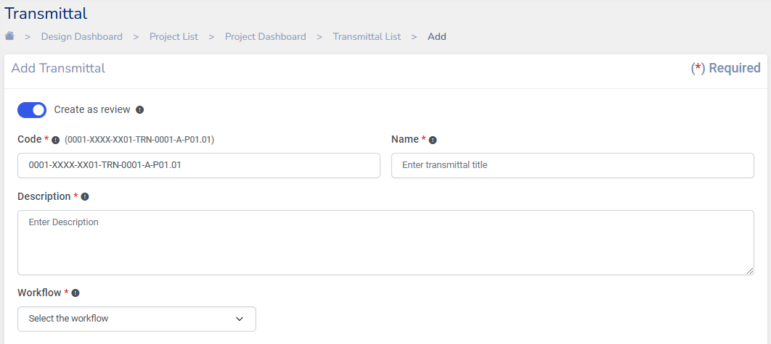

In the create transmittal dialog, enter the **Transmittal Code** in the format

0001-XXXX-XX01-TRN-0001-A-P01.01 as specified, which breaks down into these components:

* + 0001: A unique identifier for the Transmittal being created
  + XXXX: The code representing the organization.
  + XX01: Alpha Numeric Code for the current phase of the project.
  + TRN: Indicates that this is a transmittal code
  + 0001: The code for the department.
  + A: The department revision identifier Viz., A - Architectural, C-Civil, S-Structural, M-Mechanical, P-Plumbing, E-Environmental etc.,
  + P01: Revision Number
  + 01: A suffix indicating that the issue is currently a work in progress

This format ensures that each issue can be tracked and referenced efficiently throughout its workflow process.

1. Enter the **description** about the transmittal
2. Select and assign a **workflow** for the transmittal that needs final clearance for execution/Procurement etc.
3. 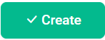**Attach files** or related documents enables to upload files from Krion6D Drive.
4. Finally Click on to successfully create a transmittal

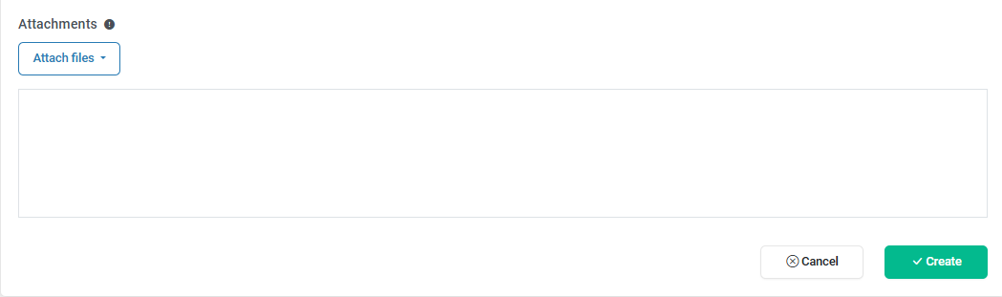

**Note:**

1. When a transmittal is created all members in the workflow will get notified about the same.
2. A transmittal can be created as a review by toggling

button if required

## **Actions on Transmittals**

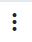Once a transmittal is created it can be viewed in the transmittal list. Various actions can be performed on a Transmittal by clicking on under the action’s column.

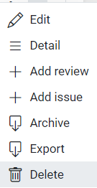

* **Edit**: Clicking on edit actions lets you edit a Transmittal
* **Detail**: To view the details in a transmittal
* **Add Task**: Enables you to go to Add Review tool where a related task can be created
* **Add Issue**: Enables you to go to Add Issue tool where a Issue can be created
* **Archive**: To archive the selected Transmittal
* **Export**: This lets you export a Transmittal as an Excel, PDF, or an email
* **Delete**: Delete a transmittal

# **Submittal**

Submittals are a formal process employed to submit documents, materials, and equipment for approval from architects, engineers, clients, or other stakeholders involved in a project. **Submittals** ensure that the documents and equipments utilized in the project adhere to the project's specifications and requirements.

The Submittal tool can be accessed under the Share option under the projects from the navigation pane.

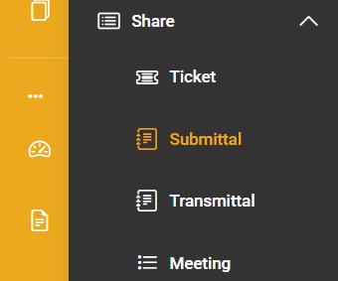

The **Submittals** tool in Krion 6D allows you to see a list of all Submittals along with details like the:

* Submittal code
* Title
* Type
* Recipients
* Due Date
* No of Documents
* Status

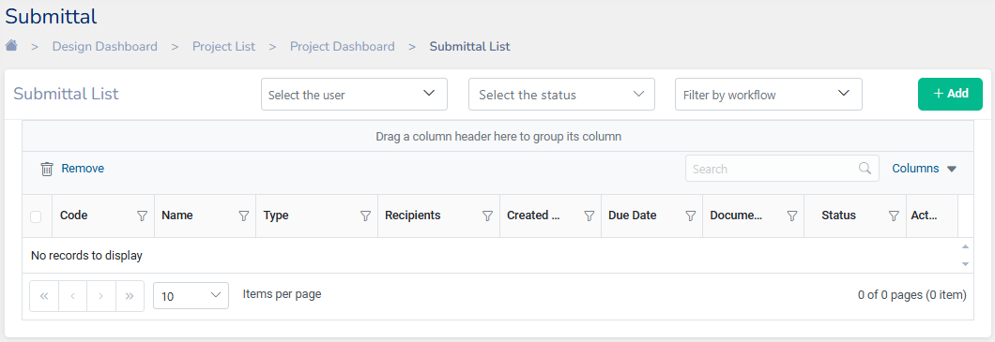

**Note:** The submittals list can be filtered by the status and by user/user groups. The items to be displayed in the list can also be customized by selecting the columns drop-down menu.

## **Create Submittals**

1. Click on to create a Submittal

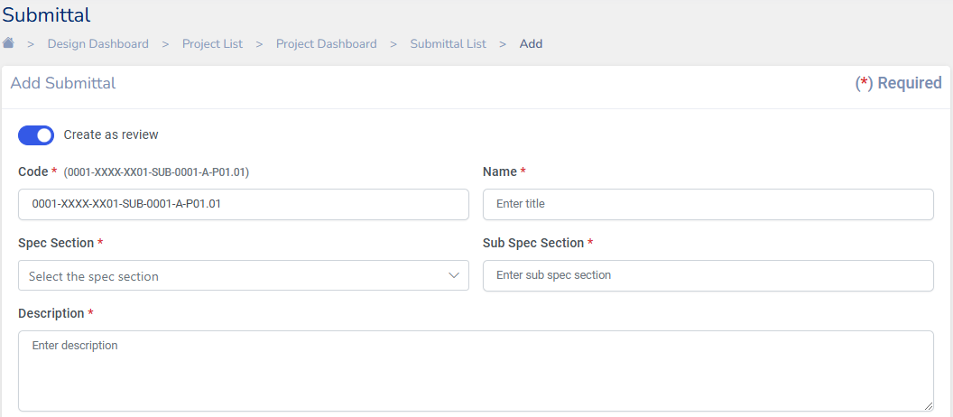

1. In the Create Submittal dialog, enter the **Submittal Code** in the format

0001-XXXX-XX01-SUB-0001-A-P01.01 as specified, which breaks down into these components:

* + 0001: A unique identifier for the Submittal being created
  + XXXX: The code representing the organization.
  + XX01: Alpha Numeric Code for the current phase of the project.
  + SUB: Indicates that this is a Submittal Code
  + 0001: The code for the department.
  + A: The department revision identifier Viz., A - Architectural, C-Civil, S-Structural, M-Mechanical, P-Plumbing, E-Environmental etc.,
  + P01: Revision Number
  + 01: A suffix indicating that the issue is currently a work in progress

This format ensures that each issue can be tracked and referenced efficiently throughout its workflow process.

1. Enter a **Title** name for the Submittal
2. Select the **Spec Section** and Sub Spec section from the drop-down menu
3. Enter the **description** of the Submittal

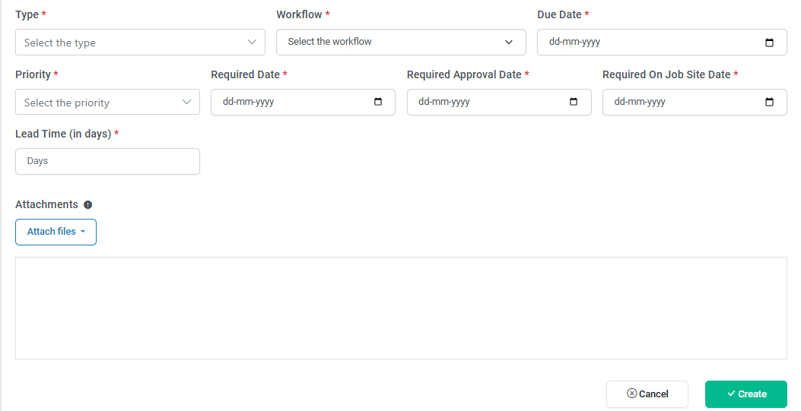

1. Select the **type**
2. Select and assign a **workflow** for the Submittal.
3. Enter the Due date, Priority, Required Date, Required Approval Date, Required on job site date and lead time (in days)
4. **Attach Packages** or related documents enable to upload files from Krion6D Drive.

After filling all the mandatory fields marked in red, click on to successfully create a Submittal

**Note:**

1. When a submittal is created all members in the workflow will get notified about the same.
2. A submittal can be created as a review by toggling

button if required

## **Actions on Submittals**

Once a submittal is created it can be viewed in the submittal list. Various actions can be performed on a Submittal by clicking on under the **Actions** column.

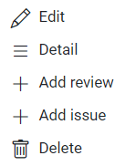

* **Edit**: Clicking on edit actions lets you edit a Submittal
* **Detail**: To view the details in a submittal
* **Add Task**: Add Tasks enables you to Add Review tool where a related task can be created
* **Add Issue**: Add Issue enables you to Add an Issue too where an Issue can be created
* **Delete**: Delete a submittal

# **Tickets**

Ticket tool in Krion 6D helps create a digital record to track and manage various tasks, issues, or requests raised during various stages in the project flow. Tickets tool in Krion 6D application can be accessed under Share from the navigation pane. .

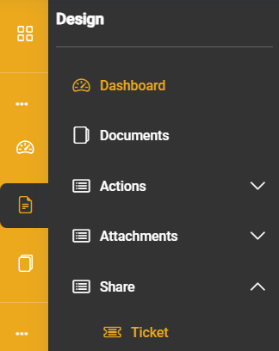

The tickets tool allows you to see a list of all tickets along with details like:

* Title
* Type
* Created by
* Start and Due date
* Status

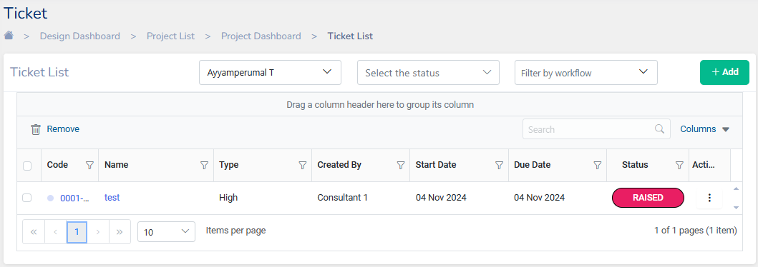

**Note:** The ticket list can be filtered by the status and user/user groups. The items to be displayed in the list can also be customized by selecting the columns drop-down menu.

## **Create Ticket**

1. Click on to create a ticket.
2. In the create ticket dialog, enter the **Ticket Code** in the format

0001-XXXX-XX01-TKT-0001-A-P01.01 as specified. which breaks down into these components:

* + 0001: A unique identifier for the Issue being created
  + XXXX: The code representing the organization.
  + XX01: Alpha Numeric Code for the current phase of the project.
  + TKT: Implies that it is a ticket
  + 0001: The code for the department.
  + A: The department revision identifier Viz., A - Architectural, C-Civil, S-Structural, M-Mechanical, P-Plumbing, E-Environmental etc.,
  + P01: Revision Number
  + 01: A suffix indicating that the issue is currently a work in progress

This format ensures that each issue can be tracked and referenced efficiently throughout its workflow process.

1. Enter a **Title** name for the Ticket
2. Enter the **description** of the Ticket
3. Select the **Start Date** and **Due date**
4. Enter the **Type, Placement,** and **Root Cause** of the ticket being raised
5. Select and assign a **workflow** for the Ticket.

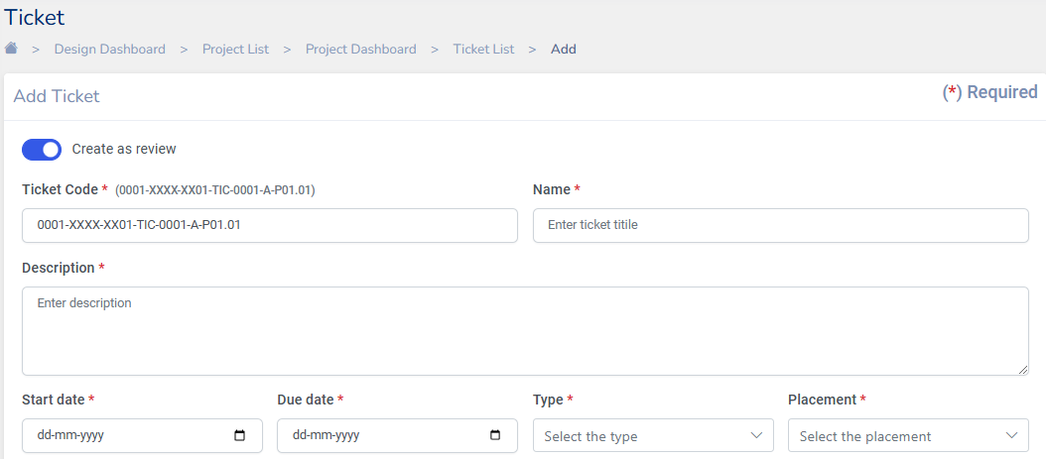

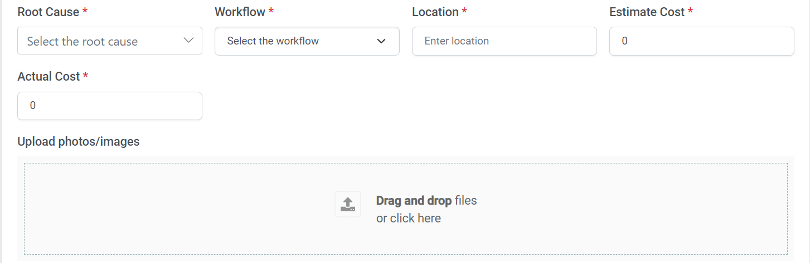

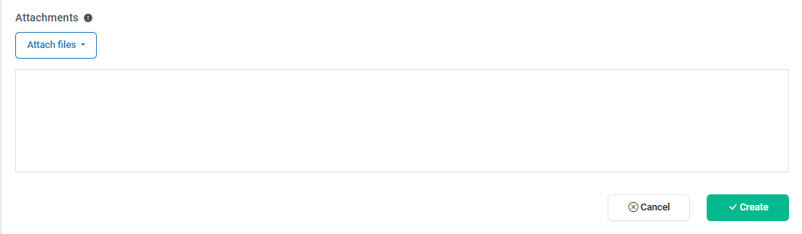

1. Optionally **estimate of Cost** and **Actual cost** can be specified
2. **Upload** relevant documents supporting the ticket being raised if necessary
3. **Attach Files** option lets you add any files from Krion Drive, review list, RFIs, Issues, Transmittals, Submittals, BOM/BOQ, Form

After filling all the mandatory fields marked in red, click on to successfully create a Ticket. Once a ticket is created people in the workflow will get notified through an email.

**Note:**

1. When a ticket is created all members in the workflow will get notified about the same.
2. A ticket can be created as a review by toggling

button if required

## **Actions on Tickets**

Once a ticket is created it can be viewed in the ticket list. Various actions can be performed on a Ticket by clicking on under the action’s column.

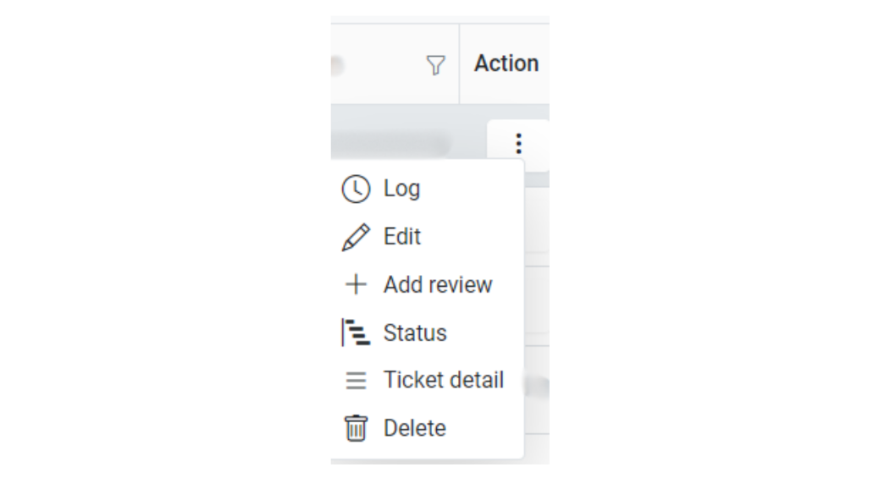

* **Log**: Clicking on the Log dialog lets you log the hours spent on a ticket.
* **Edit**: Clicking on edit actions lets you edit a Ticket
* **Add Task**: + Add Tasks takes you to the Add Review tool where a related task can be created
* **Status**: Shows the status of the tickets
* **Ticket Detail**: Lets you view all details of the ticket
* **Delete**: Delete a ticket

# **Meetings**

The meetings tool in Krion 6D helps in collaborating within project teams. The tool helps create meetings with required attendees and helps take notes/minutes of important points. It also allows necessary files to be added about the meeting

The meetings tool in Krion6D can be found under Share in



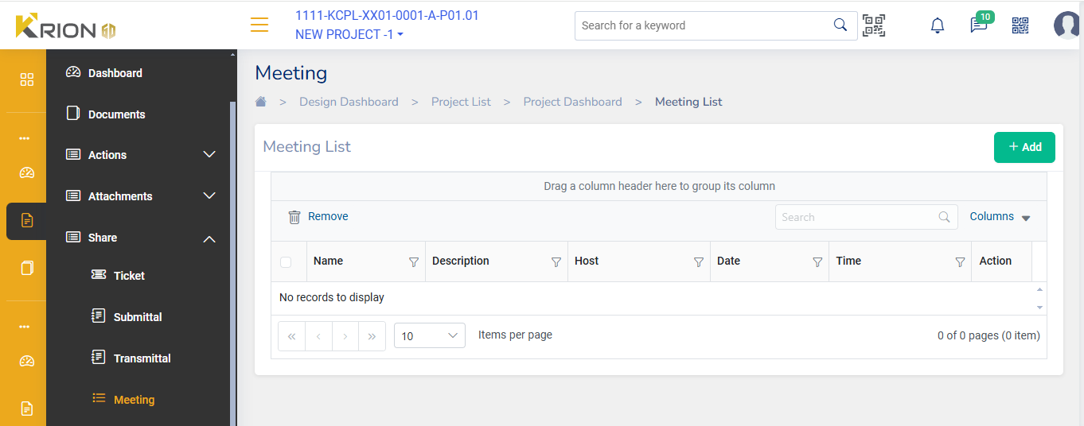

The Meeting list shows:

* Name of the meeting
* Description
* Date
* Time

## **Add Meeting**

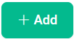To create a meeting, click on from the meeting list tool.

Enter the following details as mentioned in the dialog:

* **Name**: Enter the meeting name
* **Date**: Enter the date of the meeting or use the date tool
* **Time**: Enter the meeting time or use the tool to select the time
* **Duration**: Enter the duration in hours and minutes
* **Description**: Enter the meeting description like the agenda of the meeting or paste links for virtual meetings

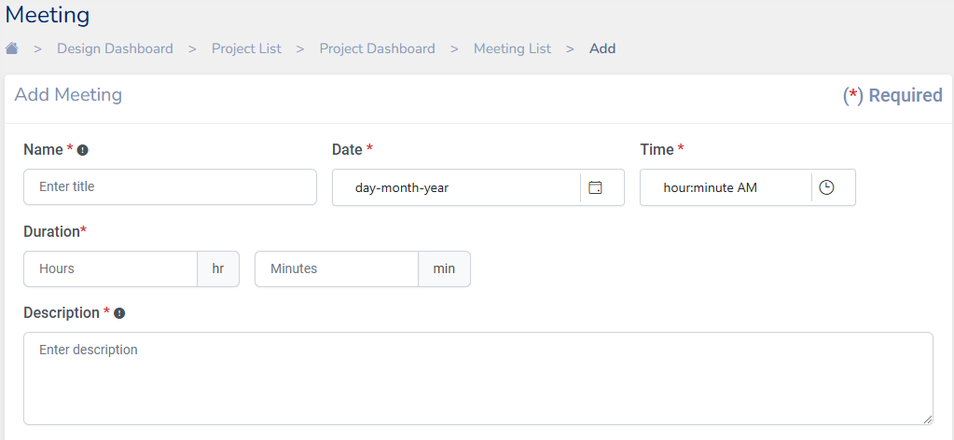

* **Notes**: Enter notes of the meeting and to add more notes click on Add Notes
* **Participants**: Enter the meeting Attendees by searching from **Select Users** or **Select User Groups** pertaining to the projects

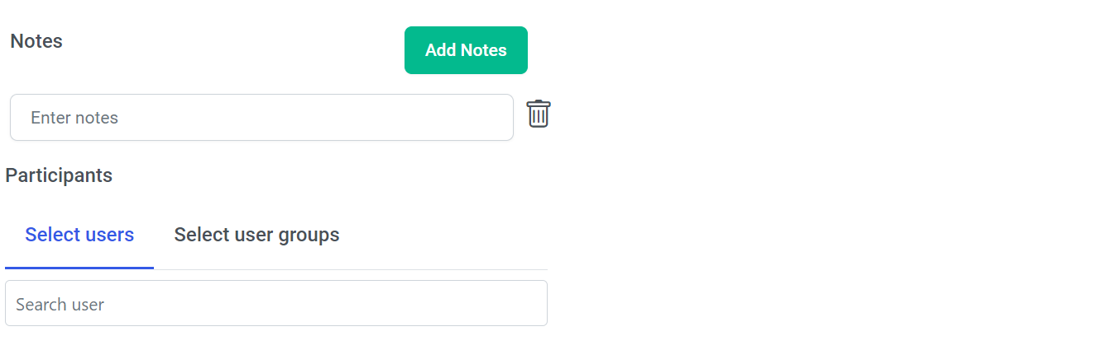

* **Upload Files Attachments**: Enables you to upload any files related to the meeting agenda

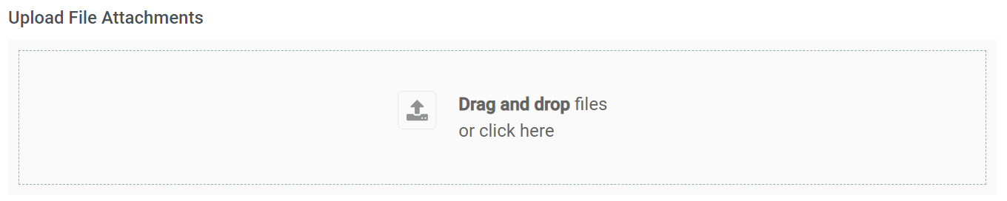

* **Attach Files:** Enables you to attach files from Krion6D, RFIs, Issues, Transmittals, Submittals, BOM/BOQ or Forms pertaining to the project

Finally click create to finish creating the meeting.

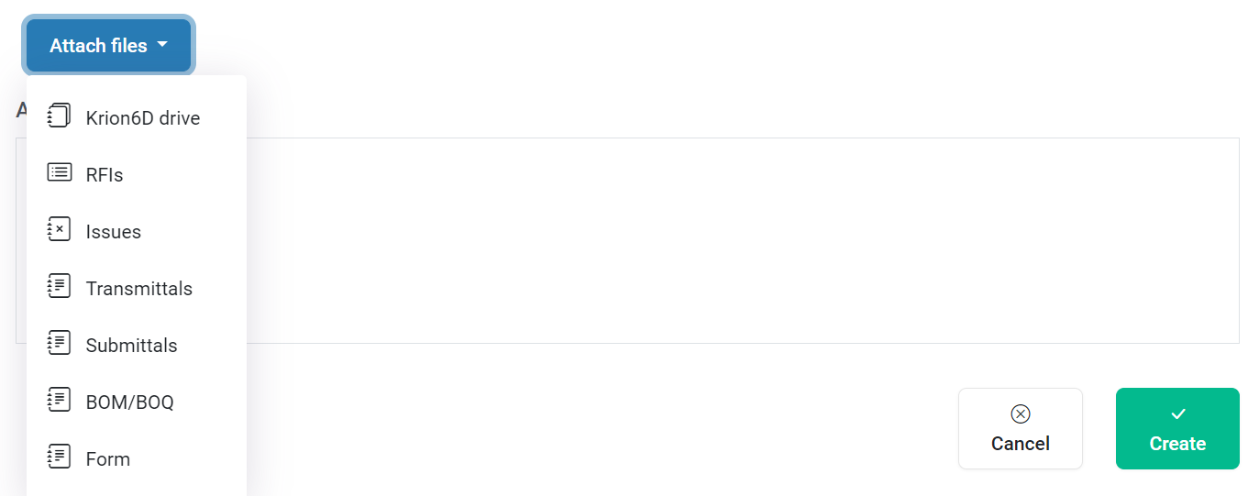

## **Actions on Meetings**

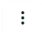Meetings can be retrieved by **searching** through the list and the columns displayed in the meeting list can be customized by selecting the required fields.

By clicking on under the action column we can **Edit**, view **detail**s, or **delete** a meeting

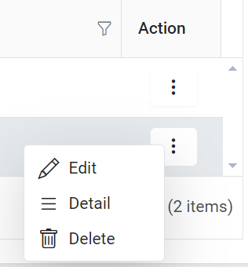

**Note**: The URL link of the meeting can also be attached to Review, Issue, RFI, etc., if required

# **BOM/BOQ**

BOM (Bill of Materials) and BOQ (Bill of Quantities) are essential documents in construction projects that help manage and track the materials, quantities, and costs associated with a construction project. Add BOM/BOQ tool in Krion 6D enables you add attach these documents related to a project. BOM/BOQ tool is available under the attachments in



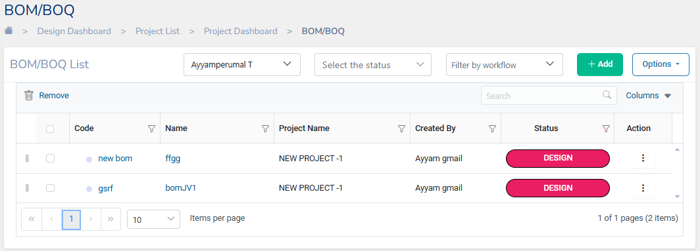

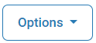**Note:** The items displayed in the BOM/BOQ list can also be customized by selecting the columns drop-down menu. Search bar allows to search for a particular BOM/BOQ.

Allows a BOM/BOQ list to be uploaded/downloaded as an Excel.

## **Add BOM/BOQ**

1. Click on to add a new BOM/BOQ
2. In the Add BOM/BOQ fill in the details as mentioned

* **Parent BOM** can be selected for review which is related to the current BOM being created. This field is optional
* BOM **Code** needs to be entered 0001-XXXX-XX01-BOM-0001-A-P01.01 in the required format which breaks down into these components:
  + 0001: A unique identifier for the BOM/BOQ being created
  + XXXX: The code representing the organization.
  + XX01: Alpha Numeric Code for the current phase of the project.
  + BOM: Implies that it is a BOM/BOQ
  + 0001: The code for the department.
  + A: The department revision identifier Viz., A - Architectural, C-Civil, S-Structural, M-Mechanical, P-Plumbing, E-Environmental etc.,
  + P01: Revision Number
  + 01: A suffix indicating that the issue is currently a work in progress

This format ensures that each BOM/BOQ can be tracked and referenced efficiently throughout its workflow process.

* Enter the BOM item **Name**
* Select and assign a **workflow** for the and set the **priority**.
* Select the **Unit** of the material and Enter the **Quantity** and **Price**
* Enter the **Rate per unit** In Figures and In Words and the **Total**
* Optionally enter **Remarks** and **GUID** if required
* Finally Attach the QR code file of the BOM/BOQ for reference.

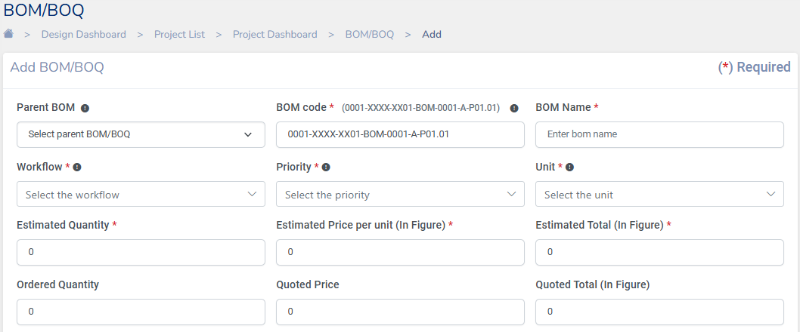

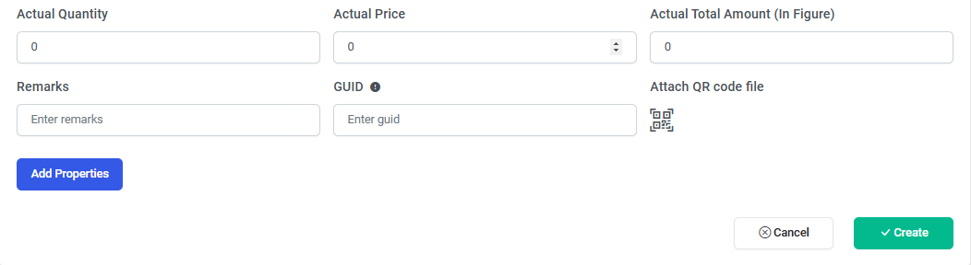



After filling all the mandatory fields marked in red, click on to successfully create a BOM/BOQ. Once a BOM/BOQ is created people in the workflow will get notified through an email.

# **Checklist**

Checklists are created to track a construction project's quality, safety, and commissioning progress. Checklists can be worked on the field to keep a project on track. In the Krion 6D application Checklist tool is available under the Attachments in



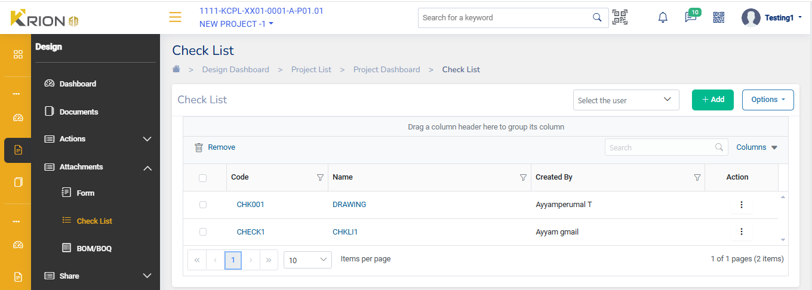

A **checklist** will have a

* **Code**: Unique ID given to a checklist
* **Title**: The name of the Checklist
* **Created by**: User who created the checklist

**Note:** The items to be displayed in the Checklist can also be customized by selecting the drop-down menu.

A checklist can be created by uploading it manually as an Excel sheet by entering all the details as per the sample Template. Clicking on allows you to download a sample checklist, and upload the Excel file once the items have been manually entered

Another way to create a checklist is by clicking the Add button and filling up the details directly on the Krion6D tool.

## **Creating a New Check List**

To create a new Checklist, click on and fill the details in the CheckList dialog

* Code: Enter Checklist Code
* Title: Enter the title name for the checklist
* Checklist Items:
  + Name: Enter the name of a Checklist Item
  + Category: Select the category to which the checklist belongs or create a new category item by typing in.
  + Priority: Priority of High, Medium, or Low can be set of the Item
  + 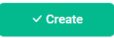Description: Describe the checklist item
* Finally, click to create a Checklist successfully

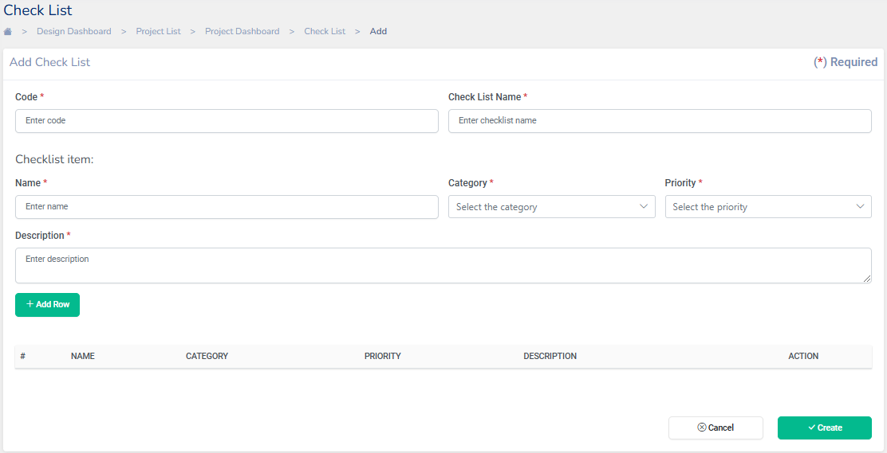

**Note:** *To add more checklist items in the same Checklist, click Add row.*

## **Actions on a Check list**

Once a Checklist is created it can be viewed in the list. Various actions can be performed on a Checklist by clicking on under the **Actions** column.

* **Edit**: Clicking on edit action lets you edit a Checklist
* **Add Task**: + Add Tasks opens to the Add review tool where a related task can be created
* **Add Issue**: +Add Issue opens to the Add an Issue tool where an Issue can be created
* **Delete**: Delete a Checklist

# **Forms**

The Forms tool in Krion6D enables anyone on the job to fill out, review, and manage project forms securely. This provides a single secure point of reference and a way to coordinate data collection, images, and follow-up documents.

Krion 6D comes with a set of preconfigured form templates. However, you can also import templates or create a brand-new template.

In the Krion 6D application Forms tool is available under the Attachments in



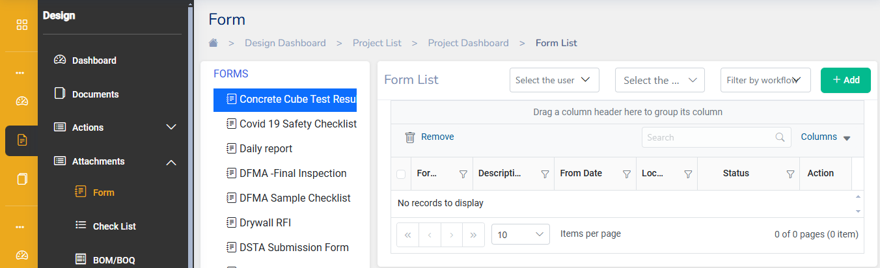

**Note:**

1. Forms can be Selected by user or user groups, by Status and filter by workflow from this tool placed on top of the Form List



1. Forms list can also be filtered using tool in each column

## **Create Form Templates**

The Krion 6D application lets you use the preconfigured templates in the Forms tools. However, setting up your own custom form templates will give you and your team more control over your forms.

You can create a form template by navigating to **Form Template** available under Administration

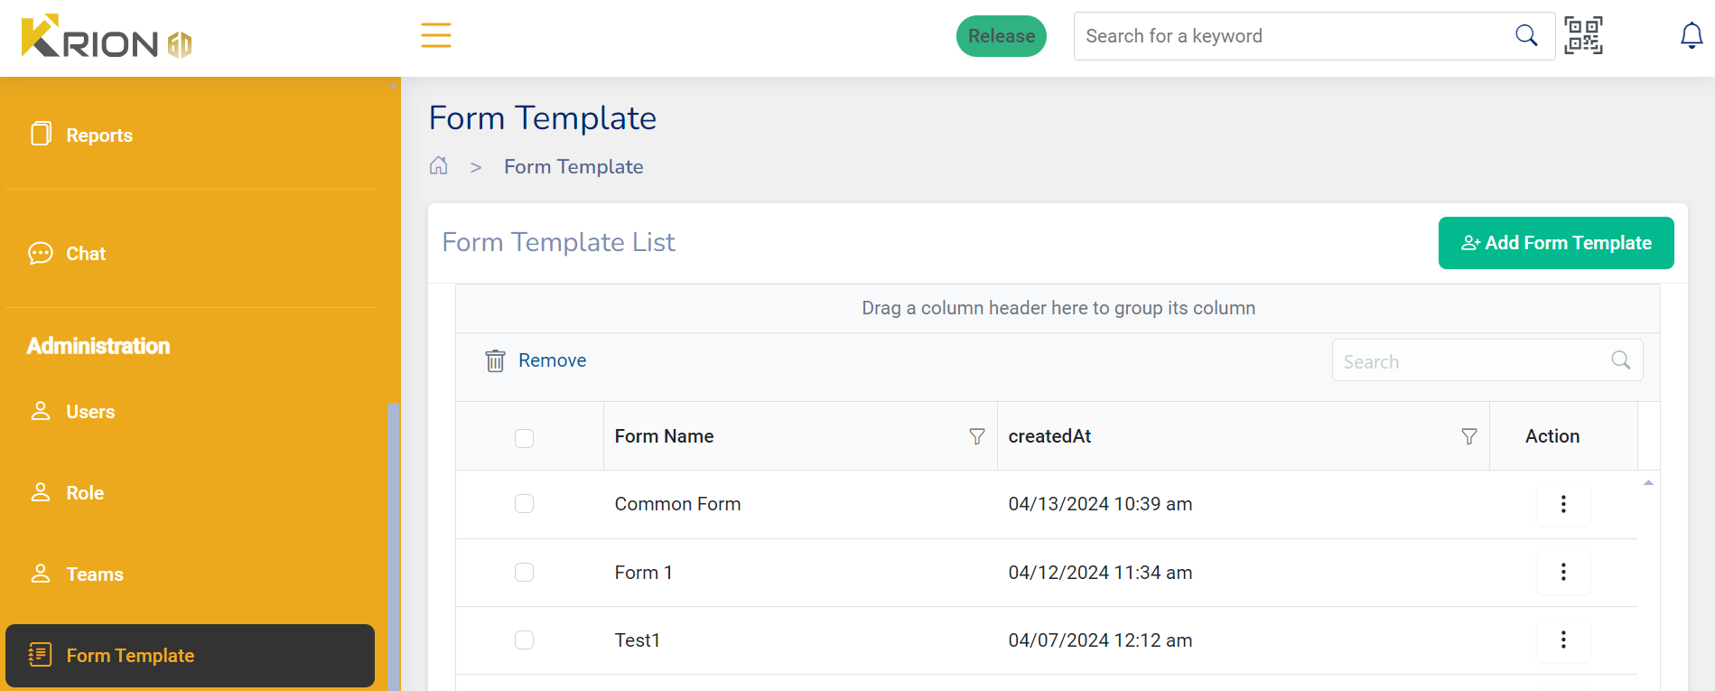

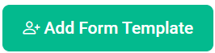

To Add a new form template, click on .**Add Form template** dialog will open where we can enter **Form Name** and the **PDF file** can be uploaded by clicking on Browse. Once the file is uploaded click on create.

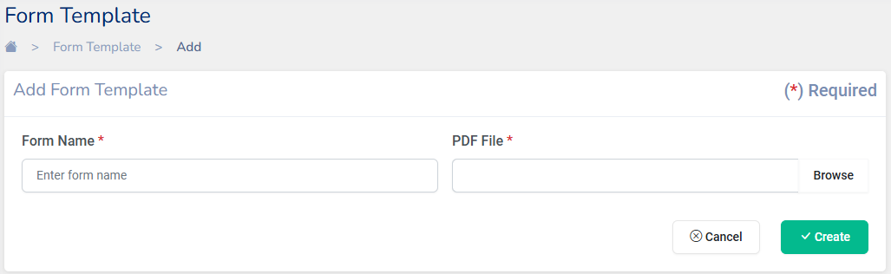

## **Add, fill out, and submit Forms**

1. Navigate to the Forms tool under Projects.
2. Select the template you'd like to use, here we are choosing “Covid1 Safety Checklist” template

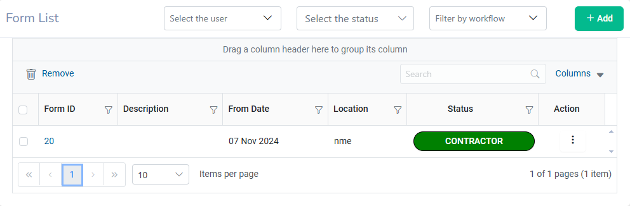

1. After you select the template click on . The form dialog in the show up where you can fill the form as per the instructions
2. All form will have the basic details to be filled like:

* Form Date
* Due Date
* Location
* Workflow
* Description

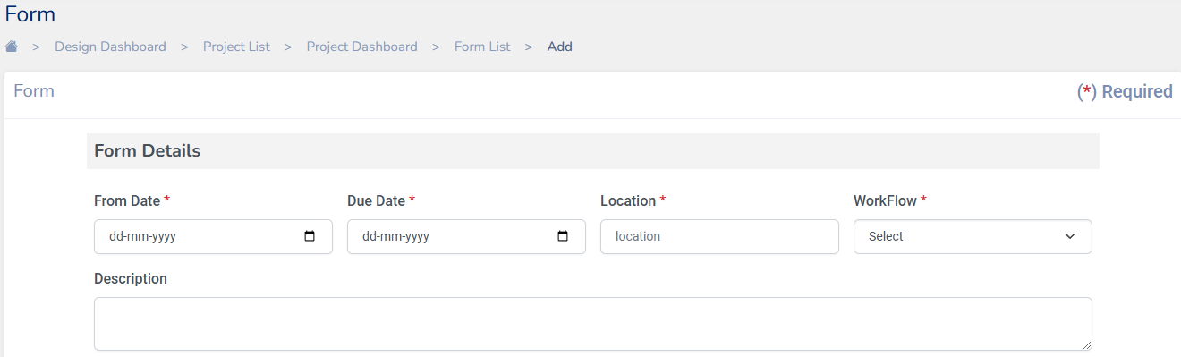

1. The form dialog for “Covid19 Checklist” here has radio buttons to fill

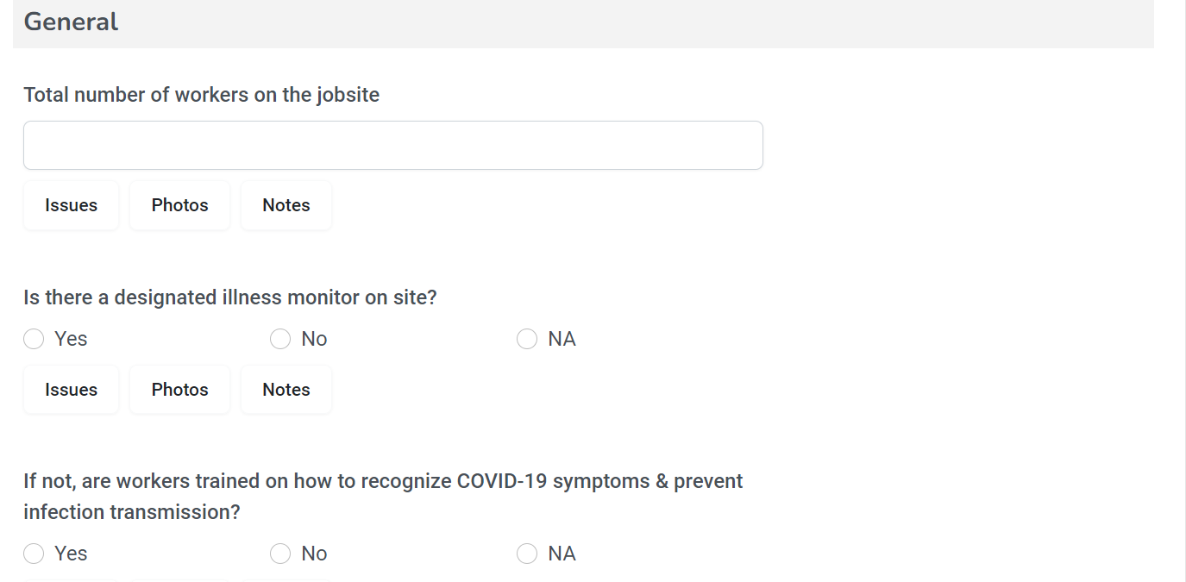

1. Fill out all the sections in the form and click on Submit

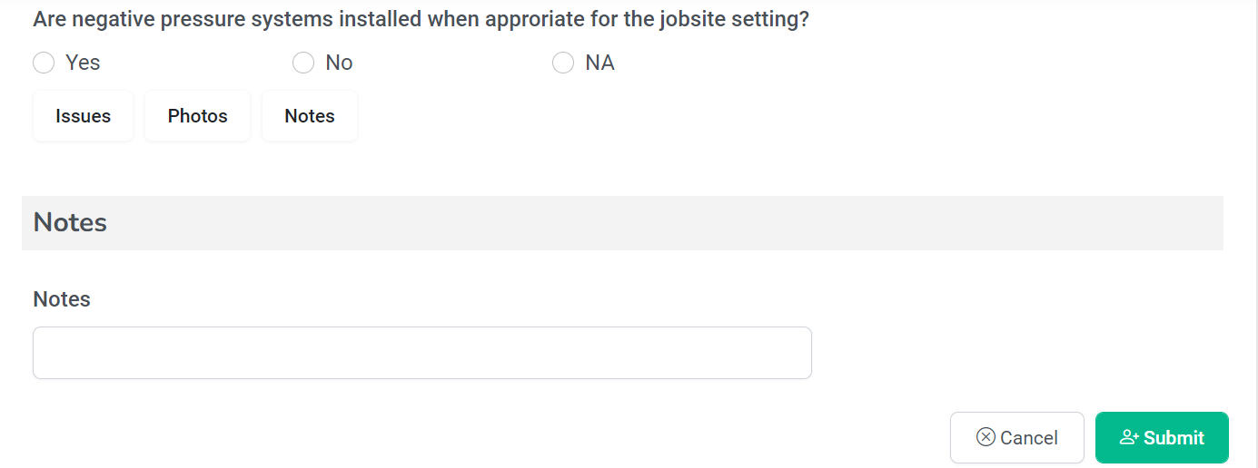

1. Form templates can also have fillable PDFs like the Drywell RFI shown below

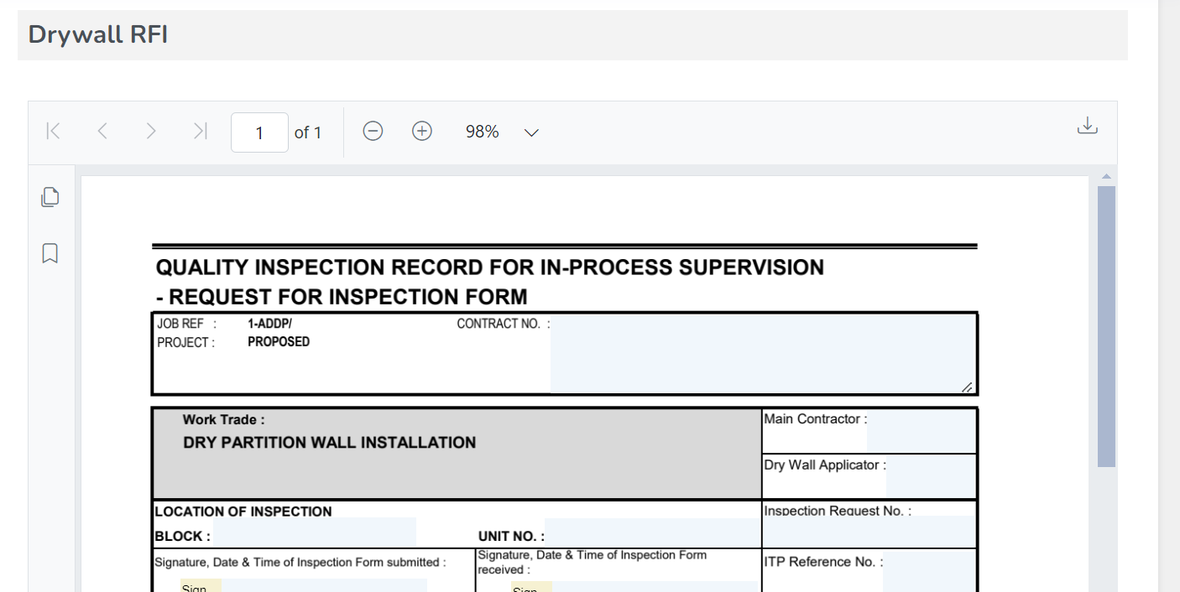

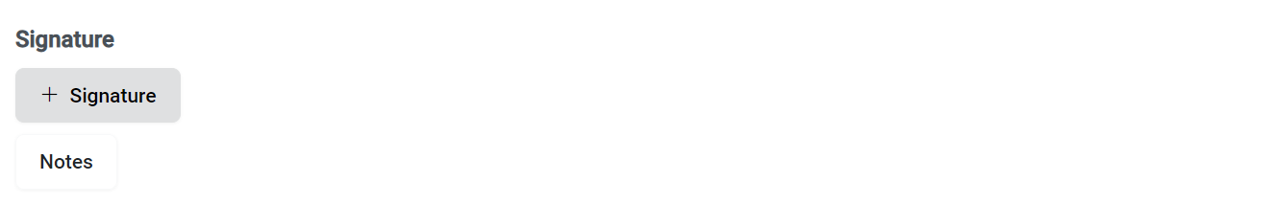**Note:** Forms allow to add of signatures and notes at the end of each section

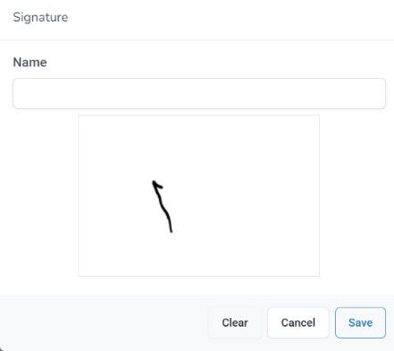Signature Dialog allows you to enter your name and signature

**Chats**

Chat tool in Krion6D application helps instantly connect with your organization's team members. Chat tool can be found in the navigation pane above the Administration tools

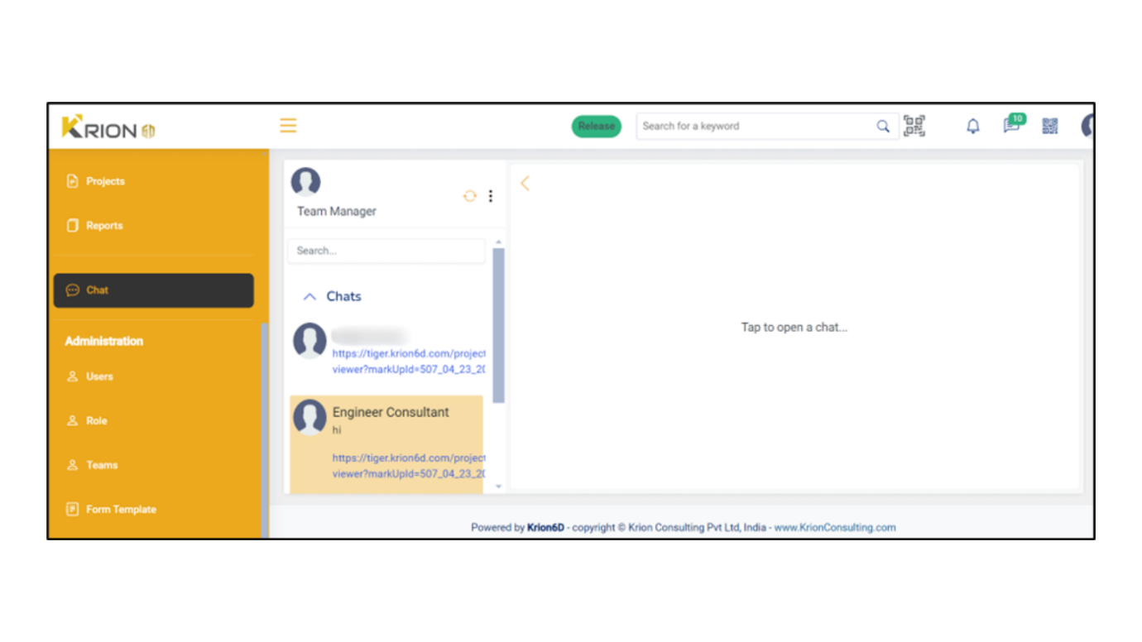

Chat tool in Krion 6D enables you to Chat with individual users or with a group of users. Clicking on the shows options to open existing **Chat(s)** or start a **New Chat.**

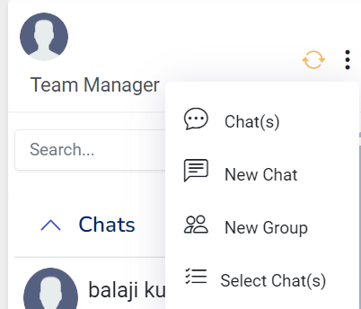



 : Shows all the previous chats of the user

Start a new chat with a user

 To Create a new Chat Group

A new chat group can be created by selecting **New Group**. Enter a Group Name for the chat group and select the users to be added from the list or use the search tool.

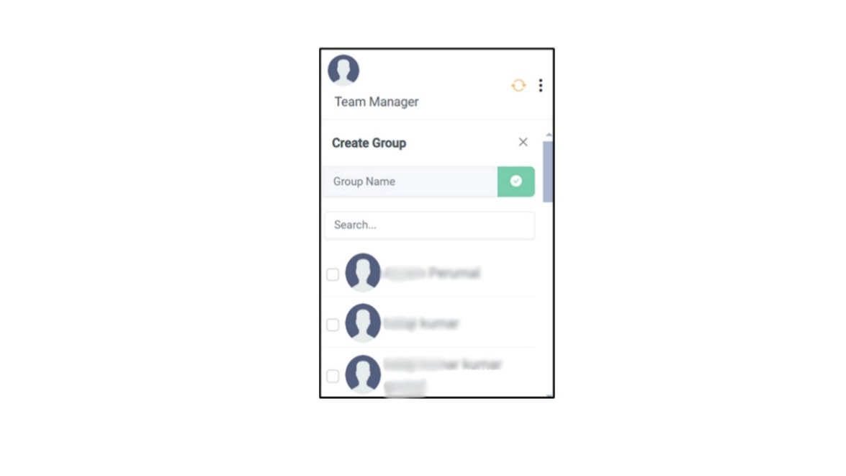

Select chats shows the list of previous chats to be selected and start a chat

# **Reports**

Krion6D application lets you create various reports in the **Reports** tool. The tool provides a central location for project members to [view](https://beehive.autodesk.com/community/service/rest/cloudhelp/resource/cloudhelpchannel/guidcrossbook/?p=DOCS&l=ENU&accessmode=live&guid=View_Filter_Search_Reports)  and [share](https://help.autodesk.com/view/DOCS/ENU/?guid=Download_Share_Void_Reports#share-reports) reports. With **Reports**, project members can communicate important project data and distribute this data among the people who need it most.

The reports tool can be accessed under the Design section from the navigation pane.

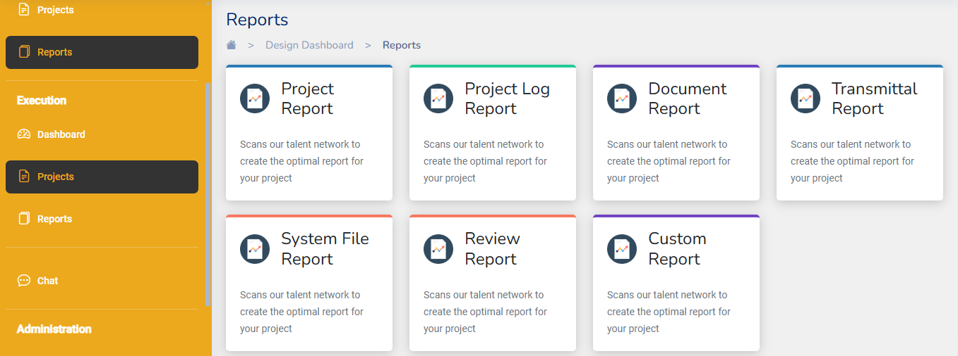

**Project Report**:

This report lists the list of various projects under your organization.

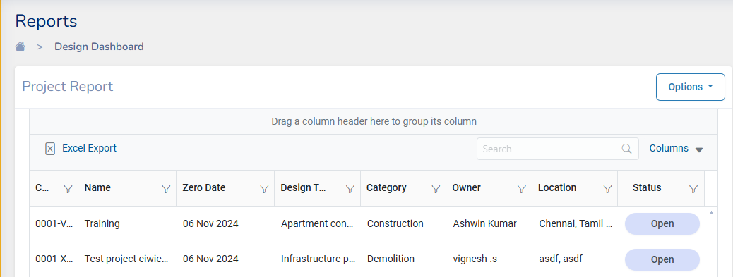

**Project Log Report**

Project log report references to each project’ s log details.

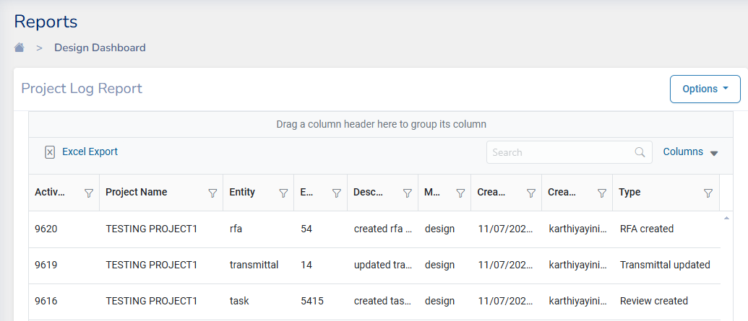

**Document Report**

This report contains a list of all documents like Drawings, model files, and other PDFs related to all the projects.

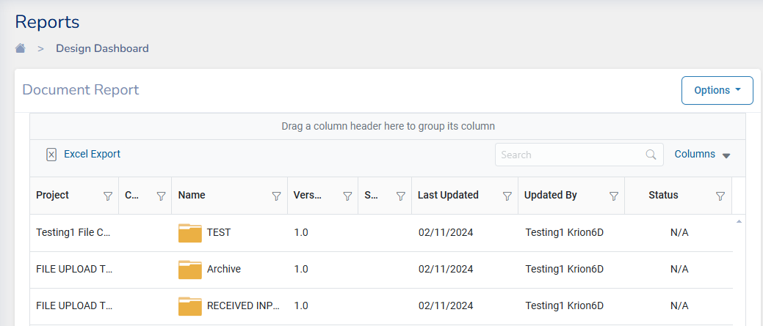

**Transmittals Report**

Displays a list of all transmittals under all the projects in your organization

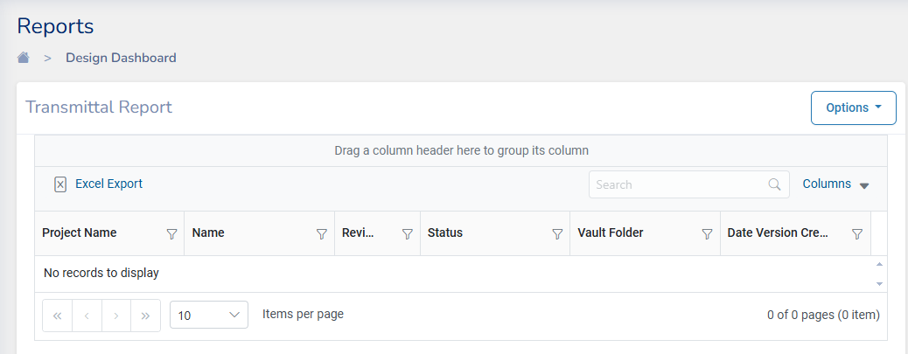

**System File report**

This report displays a list of all drawing files of all the projects

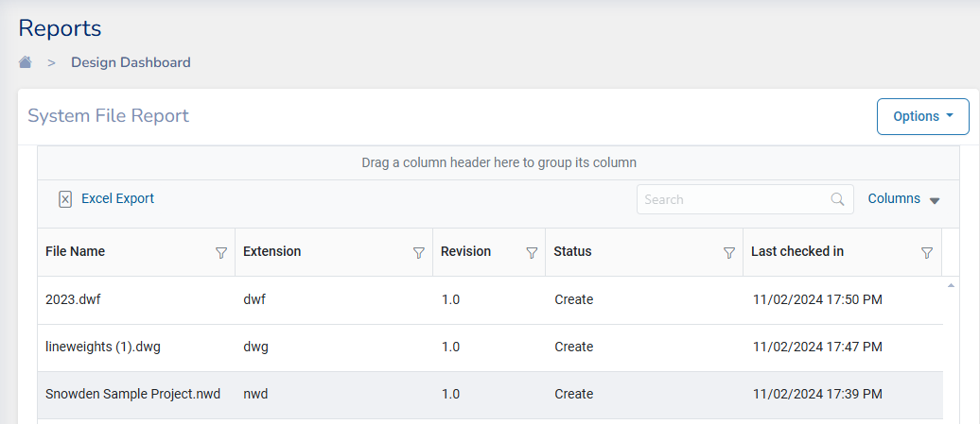

**Review Report**

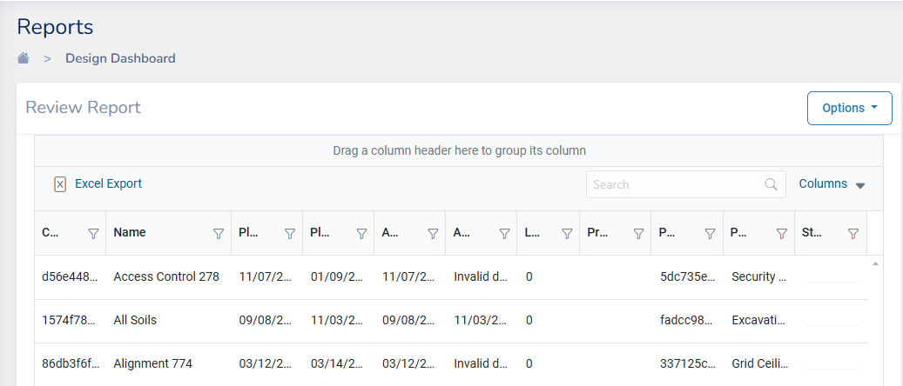

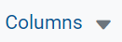**Note:**

* Columns displayed in the report can be customized by clicking on
* Report list can be filtered by clicking on

For example, if you want to filter .rvt files (Revit Files), click on the filter button of the Extension column and check on rvt.

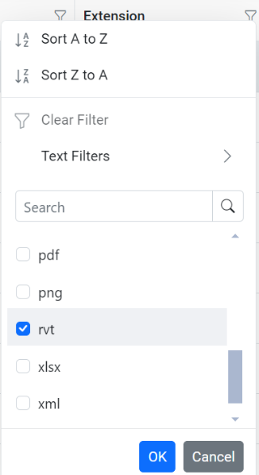

* Report entries can also be grouped by dragging and a column to the space provided, as shown below

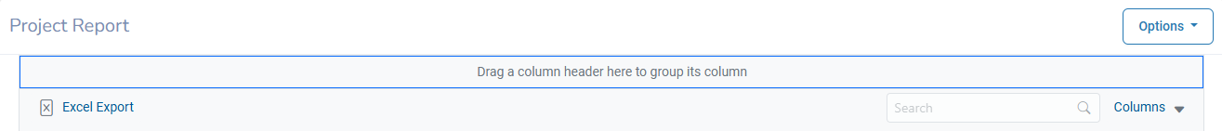

## **Create a Custom Report Template**

Custom Report tool lets you create customized reports to generate data relevant to your project. Custom Report can be accessed from the reports list

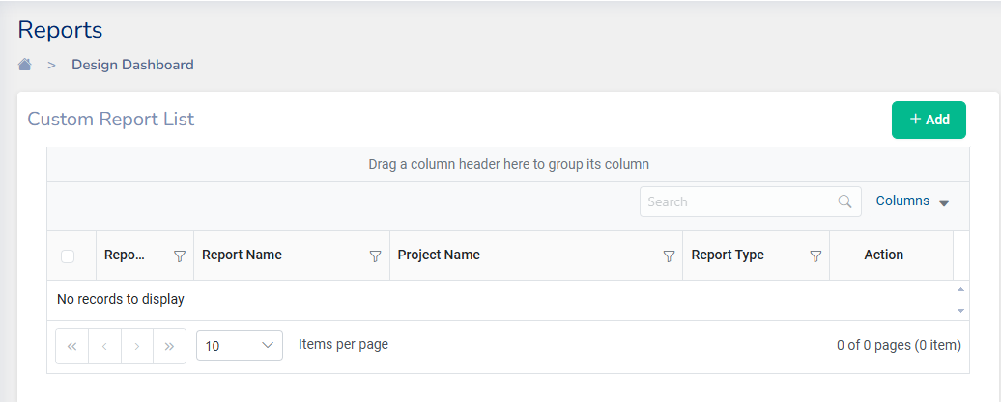

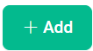To create a new custom report, click on , the custom report dialog will open

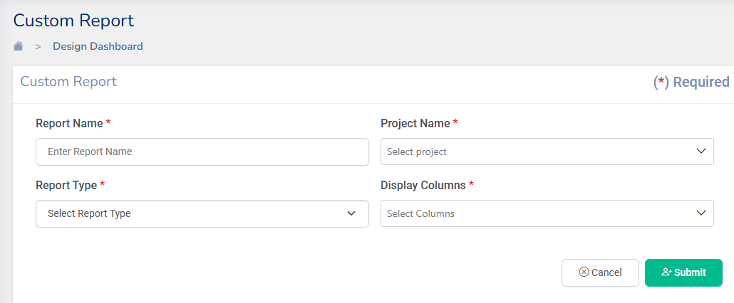

1. **Report Name**: Enter a report name
2. **Project Name**: This field can be selected from the list of projects that your organization is working on
3. **Report Type**: Choose a report type from the available list of reports

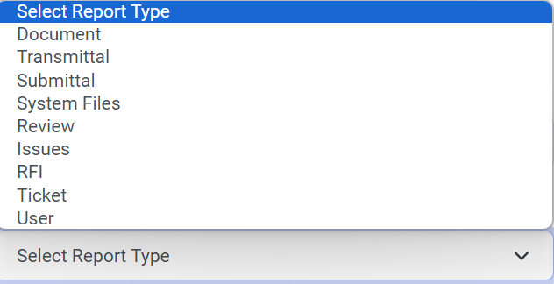

1. **Display Columns**: Once a report is selected from report type all the fields from that report will populate in the display column. Choose the fields that you want in your report. Repeat this by selecting another report from where more columns of data for your reports need to be taken.

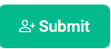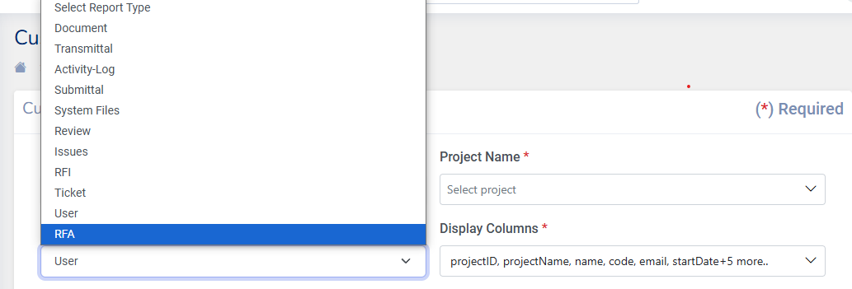

1. After selecting all the necessary columns click on to finish creating a template for a custom report.

**Generate Report**

To Generate a report for the custom report created click on the designed template from the Reports list.



Click on either or the Options tool to download the report as an Excel file

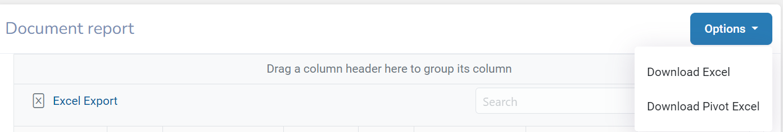

# **3D Viewer Interactive tools**

There are many tools available in the Krion 6D application to interact with the 3D Model/drawings.



****Details of the tools:

* 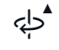 **Select:** Choose specific elements or areas within the drawing for closer inspection or manipulation.
* **Orbit:** Rotate the viewpoint around the drawing to view it from different angles and perspectives.
* ** Pan:** Move the view horizontally or vertically to explore different parts of the drawing without altering the zoom level.
* ** Zoom:** Magnify or reduce your view of the drawing to focus on details or see the bigger picture.
* **First Person:** Navigate the drawing from a first-person perspective, simulating walking through the model. When we click on first person view various options to use along with shortcut keys will be displayed
* **Camera Interactions:** Manipulate the camera settings to change viewing angles and perspectives dynamically. This tool has various options:
  +  Roll: Adjusts the orientation of the camera view by rotating it around its axis. This feature is useful for achieving precise angles or for aligning the view with specific elements in the model.
  +  Focal Length: Changes the focal length of the camera, altering the perspective of the view. Increasing the focal length narrows the field of view, resulting in a zoomed-in appearance, while decreasing it widens the field of view, providing a broader perspective.
  + Fit to View: Automatically adjusts the camera settings to fit the entire model within the current view window. This feature ensures that the entire model is visible without the need for manual adjustments, making it easier to navigate and work with large or complex models.
* ** Measure:** Calculate distances and dimensions within the drawing to verify accuracy and scale.
*  **Section Analysis:** Cut through the drawing at specified planes to examine internal structures and layouts. The various options in section analysis are:
  +  Add Box: Defines a rectangular box within the model to create a section cut, allowing users to analyze specific areas in detail.
  + Add Z Plane: Inserts a vertical plane across the model, enabling users to create a section cut perpendicular to the Z-axis, revealing internal details along that plane.
  +  Add Y Plane: Inserts a horizontal plane across the model, facilitating the creation of a section cut perpendicular to the Y-axis, exposing internal components along that plane.
  + Add X Plane: Inserts a vertical plane across the model, facilitating the creation of a section cut perpendicular to the X-axis, revealing internal features along that plane.
* ** Markup:** Annotate the drawings with notes, symbols, or sketches to provide feedback or highlight important features. Various Markup Options are as below:
*  Arrow Markup
* Cloud Markup
*  Dimensions Markup
*  Ellipse Markup
* Freehand Markup
*  Label Markup
*  Polyline Markup
*  Rectangle Markup
* Close

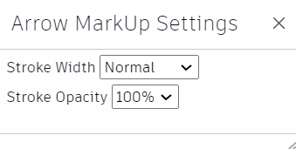

All the markups have settings for changing the Stroke Width and Stroke Opacity

* 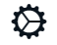 **External Data:** Incorporate additional data from external sources into the drawing for enhanced analysis and comparison.
* 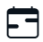 **Timeline:** Review the progression of the project stages and changes over time through a chronological display.
* 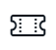 **RFI/Issues:** Track and manage Requests for Information and other issues directly within the project environment. While analysing and viewing models if there are any issue found, Issue or RFI can be created by marking the item in the model itself.
* 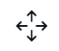 **Ticket Creation:** Generate and assign tickets for tasks or issues that need attention, facilitating project management.
* **Model Placement:** Position and orient models within the project environment to ensure they fit into the overall design.
* ** Explode Model:** Break down the model into its constituent parts for a detailed examination of its construction.

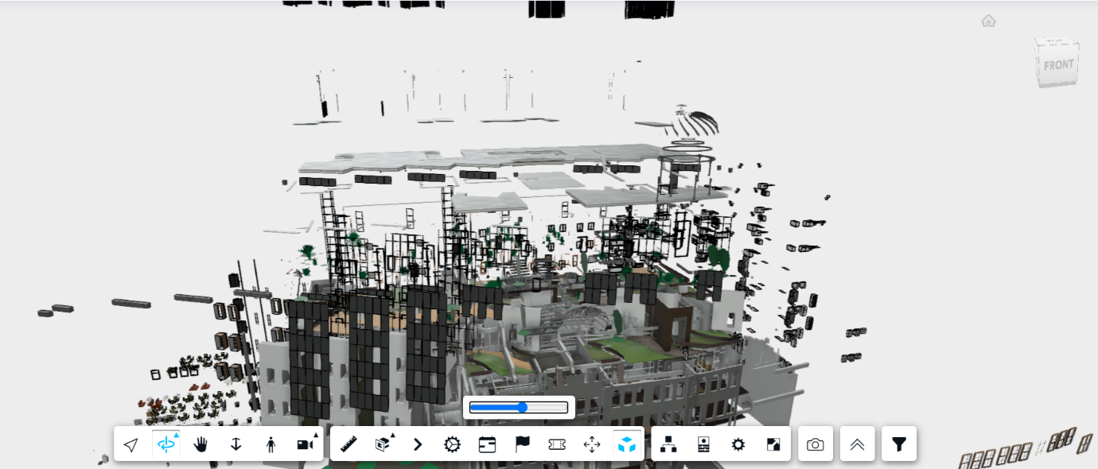

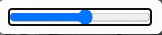**Note:** This button can used to increase/decrease the exposure level of each item.

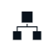

* **Model Browser:** Navigate through a list or hierarchy of all model elements, making it easier to locate specific components.

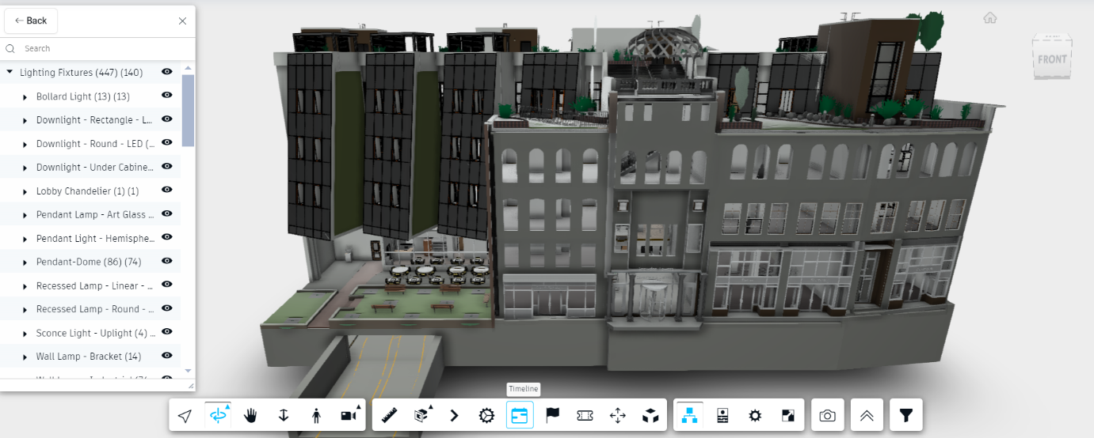

Model Browser dialog box lists down all the elements of the 3D model which can be viewed individually by clicking on button.

* 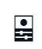 **Properties:** View and edit properties and metadata of selected elements or the overall drawing.

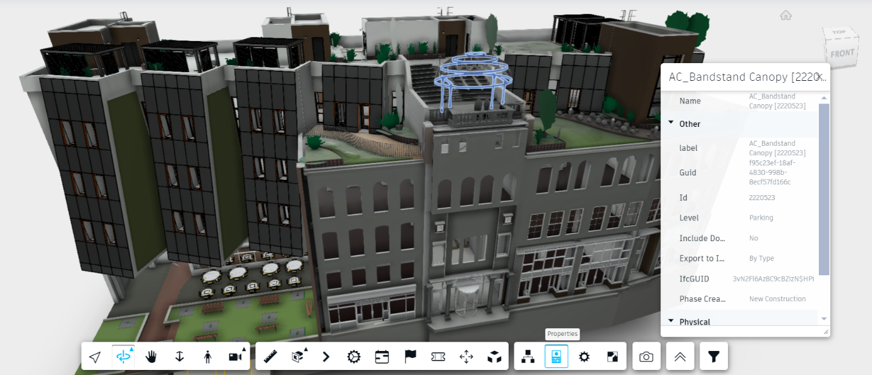

* ** Settings:** Adjust the configuration of the 3D viewer tool to suit project needs or user preferences.

There are various settings available in the tool for Viewing the 3D model

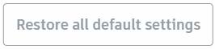**Note:**

* Settings can be restored to default by clicking on
* Settings dialog can be resized to view all the options.
* **Configuration Settings** Customize various parameters and preferences within the 3D viewer to tailor the user experience according to specific requirements or preferences including Performance Optimization, Display, and Selection.

Various options under Configuration settings are:

* **Performance Optimization**: The various options under these settings can be toggled on/off. 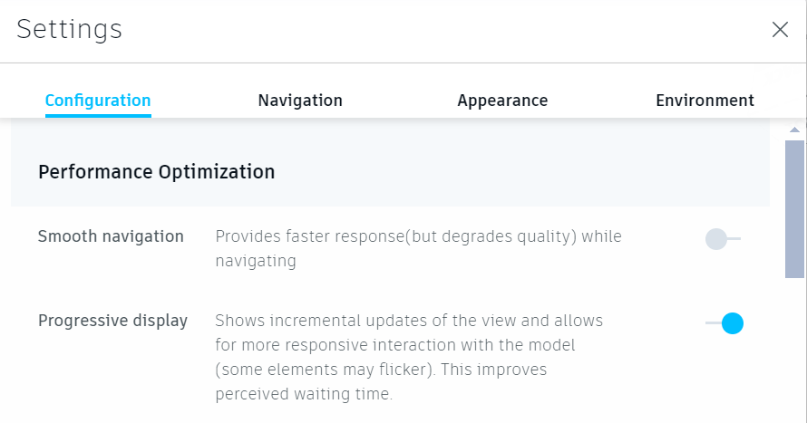
* **Smooth Navigation**: Provides faster response (but degrades quality while navigating)
* **Progressive display**: Shows Incremental updates of the view and allows for more responsive interaction with the model (some elements may flicker). This improves perceived waiting time
* **Display**
* Ghost hidden objects: Leave hidden objects slightly visible
* Display lines: Toggle display of objects
* Display Points: Toggle display of point object

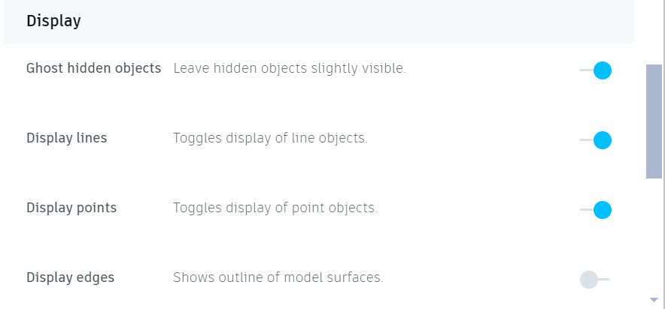

* Display Edges : Show outline of model surfaces
* Display section Hatches:

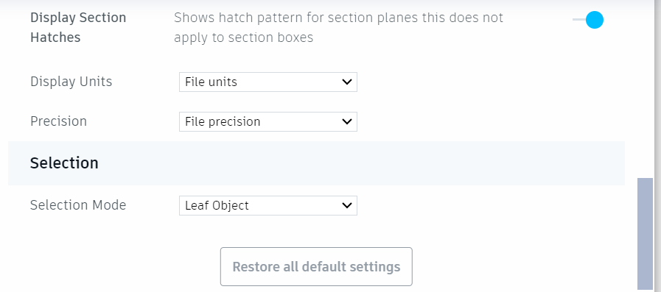

* Display units: Can be selected from the drop down

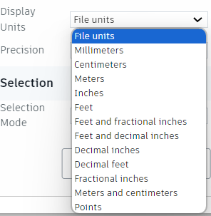

* Precision: Display precision can also be selected from the options

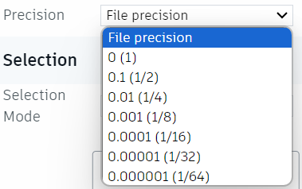

* Selection Mode can be selected from the list

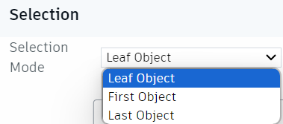

* **Navigation Settings** Adjust the controls and options related to navigating through the model or drawing, such as mouse sensitivity, keyboard shortcuts, or navigation modes.

**View Cube**

* Show view Cube: Toggles the availability of the view cube navigation control
* View Cube acts on Pivot: When enabled, the View Cube Orbits the view around the active pivot point. When disabled, it orbits around the center of the view.

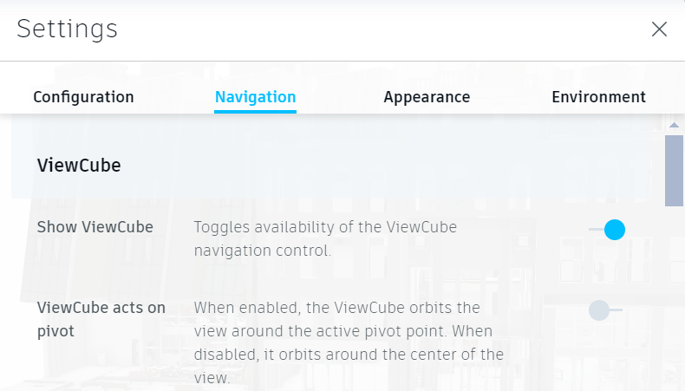

**Orbit**

* Fusion-Style Orbit: Enables Fusion-Style orbit overlay and gives the ability to lock orbit axis
* Orbit past world poles: Allows view rotation to continue past the model’s North Pole

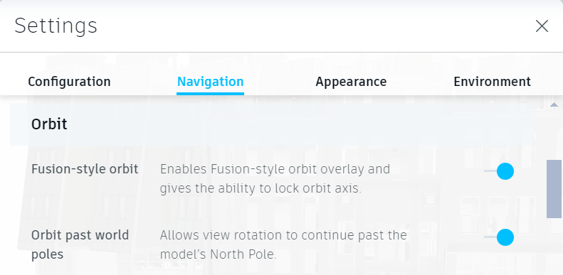

**Zoom**

* Zoom toward pivot: When disabled, zooming operations are centered at the current cursor location
* Reverse Mouse zoom direction: Toggles direction of zooming in and out
* Scroll Speed: Changes the sensitivity of the mouse scroll wheel when zooming
* Drag Speed: Changes sensitivity of mouse movement with the Zoom tool

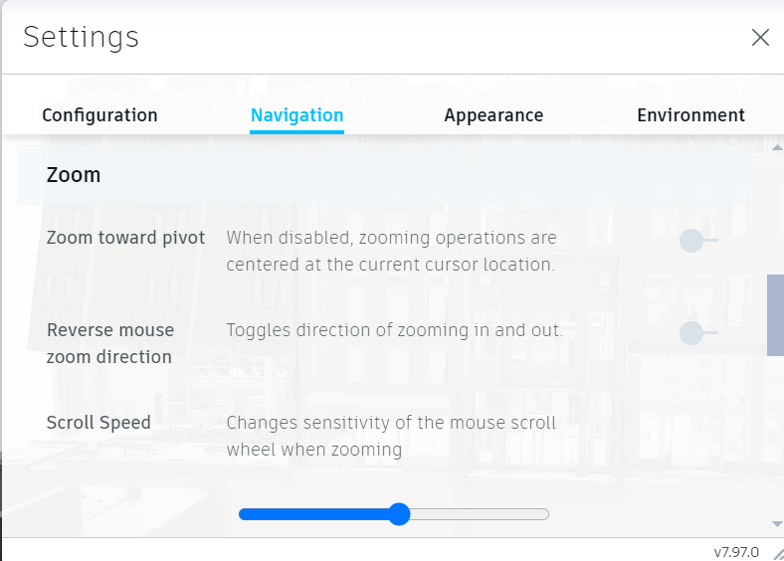

**Mouse**

* Left-handed mouse setup: Swaps the buttons on the mouse setup
* Set Pivot with left mouse button: Change left-click behaviour to set new pivot point (Overrides select output)
* Open Properties on Select: Always show properties upon selecting an object
* Enable Gravity: Toggles gravity while in first-person mode

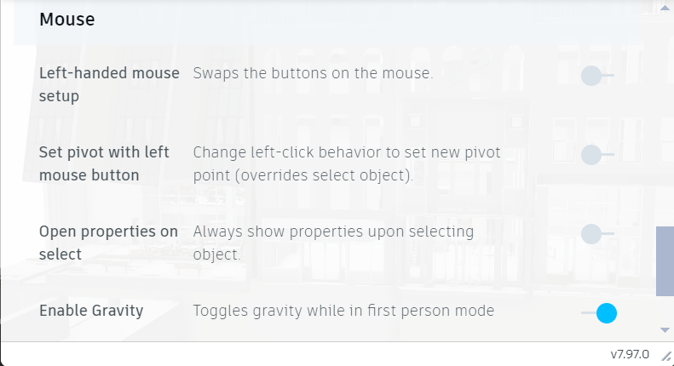

* **Appearance settings** Modify the visual presentation of the model or drawing, including options for Shadows, rendering quality, and display settings to optimize visualization.

**Visual Quality Optimization**

* Anti-Aliasing: Remove jagged edges from the lines
* Ambient Shadows: Improve Shading of Occluded surfaces
* Ground Shadow: Add simulated ground surface shadows
* Ground Reflection: Add simulated ground surface reflections

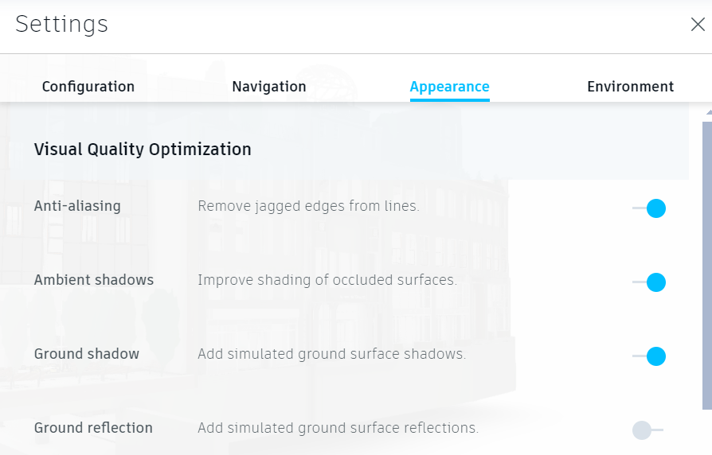

* **Environment settings C**onfigure environmental factors affecting the model, such as lighting conditions, background settings, ambient effects, and other environmental elements to simulate real-world conditions or enhance visualization.

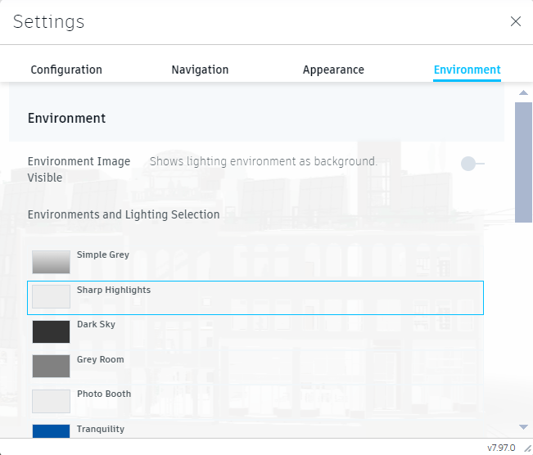

* Environment Image Visible: Shows lighting environment as a background
* Environment and Lighting selection: Enables to choose from a range of color options for lightening.
* ** Full Screen:** Expand the viewing area to fill the entire screen, eliminating distractions and focusing on the drawing.
* **View State:** Save or restore a particular view setup, including camera angle, zoom level, and visible layers.

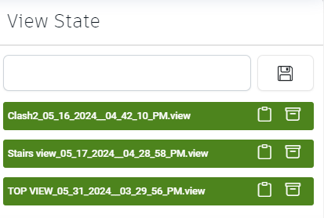

* View can be saved and later retrieved
* Saved state can be copied to be used in Issues/RFI creation.
*  View State can also be deleted.
* **Navigation Viewer:** Use interactive tools to smoothly navigate through the drawing, enhancing user control and orientation.
* ** Filter:** Apply criteria to display only those parts of the drawing that meet specific conditions or attributes. By clicking on this tool Filter options will be displayed. You can add necessary filters by selecting from the options listed.

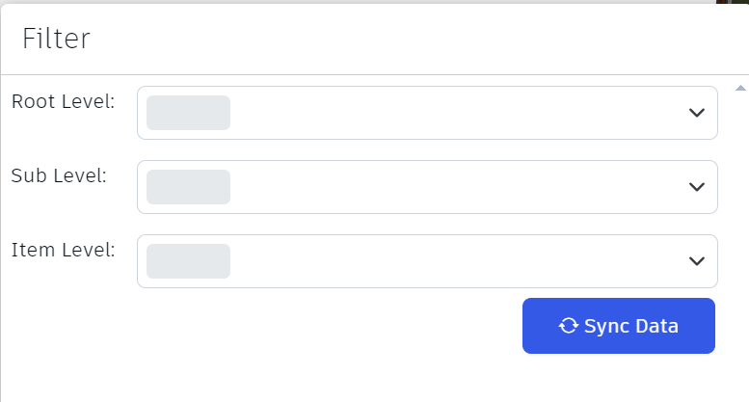

Items can be filtered by root level, Sublevel and item level by selecting from the drop-down menu.

# **Changing Views**

The Views can also be changed by clicking on the below 3D view tool

A brief description of the various options under this view is given below:

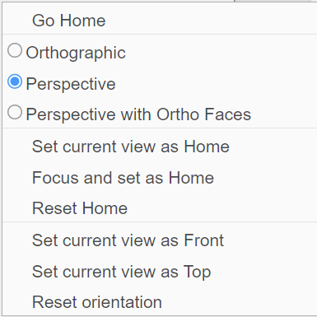

* **Go Home**: Return to the default or previously defined "home" view of the drawing for a familiar orientation point.
* **Orthographic**: Switch to a 2D view where all the elements are uniformly scaled, eliminating perspective to allow for accurate measurements.
* **Perspective**: View the model in a 3D perspective where elements are scaled relative to their distance from the viewpoint, enhancing depth perception.
* **Perspective with Ortho Faces**: View the model in perspective, but flatten specific faces to orthographic view to combine depth with measurable accuracy on key surfaces.
* **Set Current View as Home**: Define the current view as the "home" view, allowing you to quickly return to this perspective at any time.
* **Focus and Set as Home**: Center the view on a selected element and define this focused view as the new "home" view.
* **Reset Home**: Revert the "home" view to the default or the last saved view state, discarding any changes made since.
* **Set Current View as Front**: Designate the current view as the front view, standardizing the orientation for future reference.
* **Set Current View as Top**: Establish the current view as the top view, providing a consistent overhead perspective for accessing the model.
* **Reset Orientation**: Return the view to the original or default orientation, disregarding any rotational changes made during the session.

# **Clash**

Clash tool in Krion 6D helps in analyzing intersections between models. When the supported documents are added and then viewed in the 3D viewing space, they are automatically analyzed and a clash data report is shown in a dialog. Each item in the Clash Data can be individually viewed on the 3D model and analysed.

To Visualise Clash of drawings following two documents are required

* Navisworks Document (file extension: .nwd)
* XML file corresponding to the respective Navisworks document (file extension: . xml)

## **Prepare documents for Clash Detection**

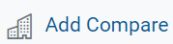The .xml file and the .nwd file of the project should be already available under the same folder in the Documents section of a project. Select the required files and click on

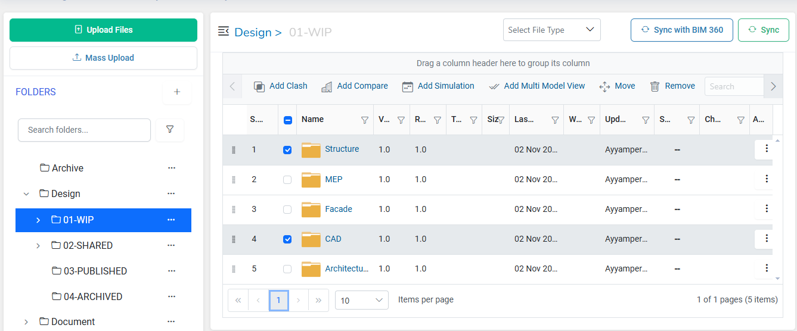

Enter a **Document name** for the Clash View and click update

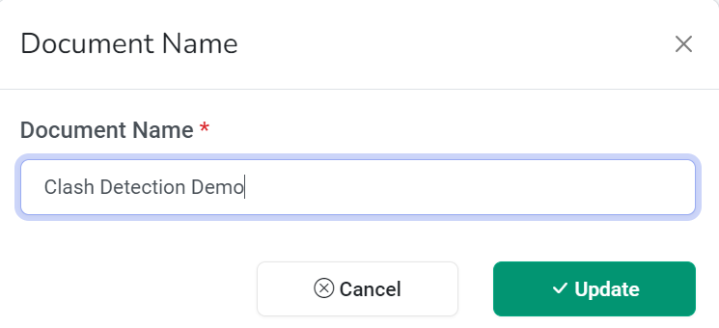

Once the Clash Document is created successfully a message will be displayed

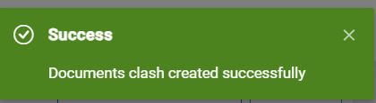

## **Clash List**

Navigate to Views under Projects and Click on . The Clash List shows the list of documents created for Clash view.

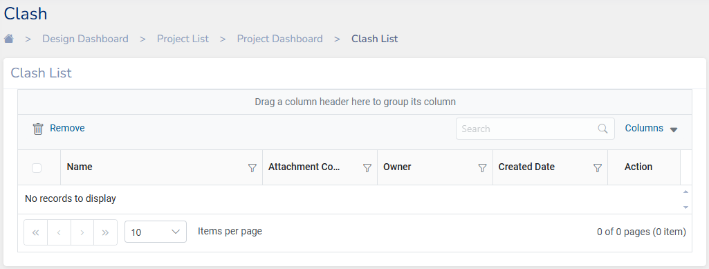

Clash List displays the following data:

* **Name**: Displays the document file created for viewing the clash
* **Attachment Count**: Displays the number of documents added for the class check
* **Owner**: Displays the User who created the clash check file
* **Created Date**: Shows the date on which the clash document file was created

**Note:**

* Clash documents can be removed by selecting and clicking on
* Clash list columns can be customized by selecting the Columns from drop down

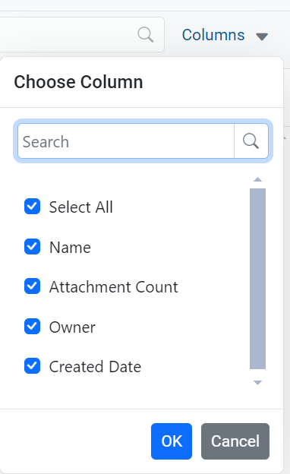

## **View Clash**

To view a Clash document select the document from the Clash List.

Here “Clash Detection Demo” document is Selected



The tool will detect the clashes and show a **Clash Data** Report in a dialog box as shown below along with the 3D viewer

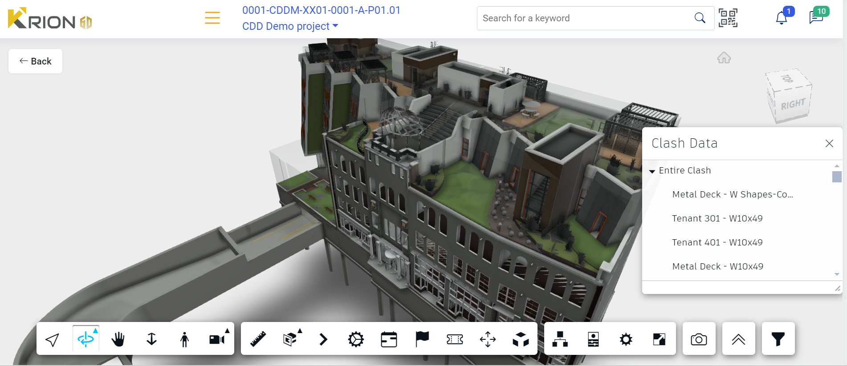

The Clash elements are highlighted below:

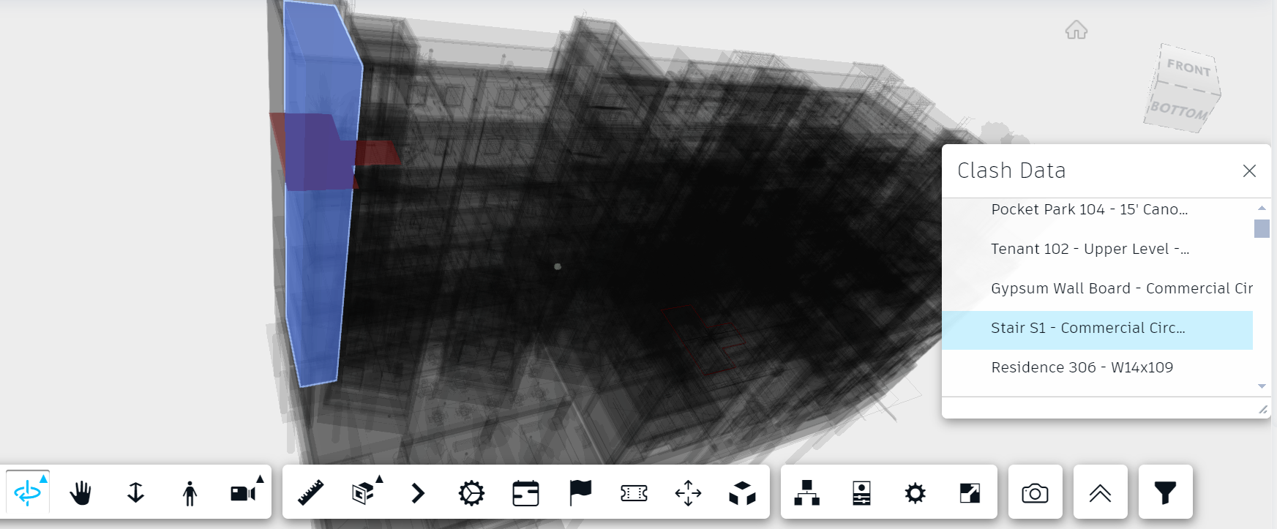

**Note:** To view only the Clash elements in the display Settings toggle off **Ghost Hidden Objects**

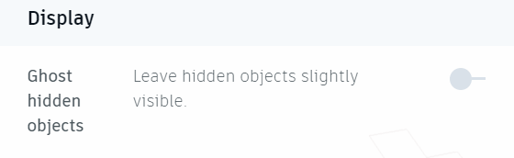

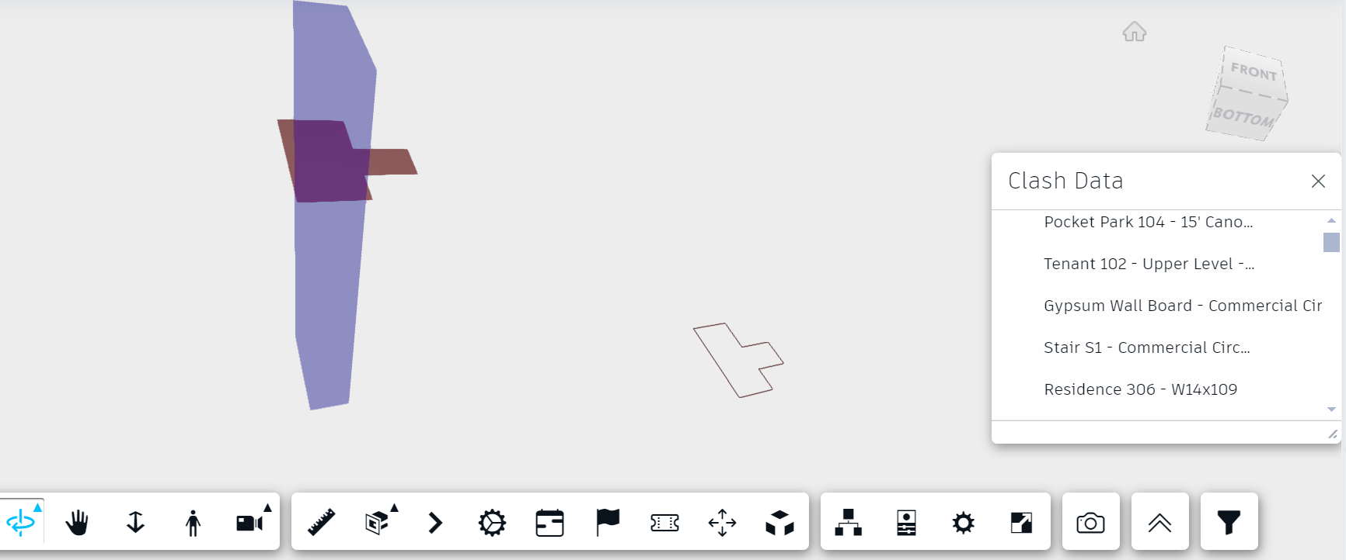

**Clash data** report lists all the items in which clashes have been detected.

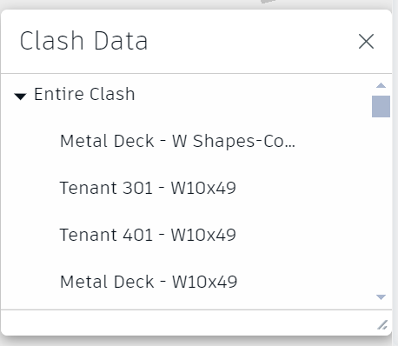

You can click on each item and view its location of the clash on the 3D model Viewer.

# **Multi Model View**

A multi-model view in Krion 6D application is a comprehensive visual representation that integrates 2D multiple drawings and 3D models into a single view. Federating a multi model view integrates or combines multiple individual discipline-specific models into a single, cohesive model. The federated model encompasses all the different aspects of the building project, such as architectural, structural, mechanical, electrical, and plumbing systems etc.,.

## **Prepare documents for Multi-Model View**

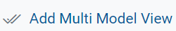The required drawings for federating the model should be already available under the same folder in the Documents section of a project.

Select two or more documents to federate and click on

* rvt + .rvt
* .dwf + .dwf
* .rvt + .dwf + .dwf or any other combinations as required or applicable.

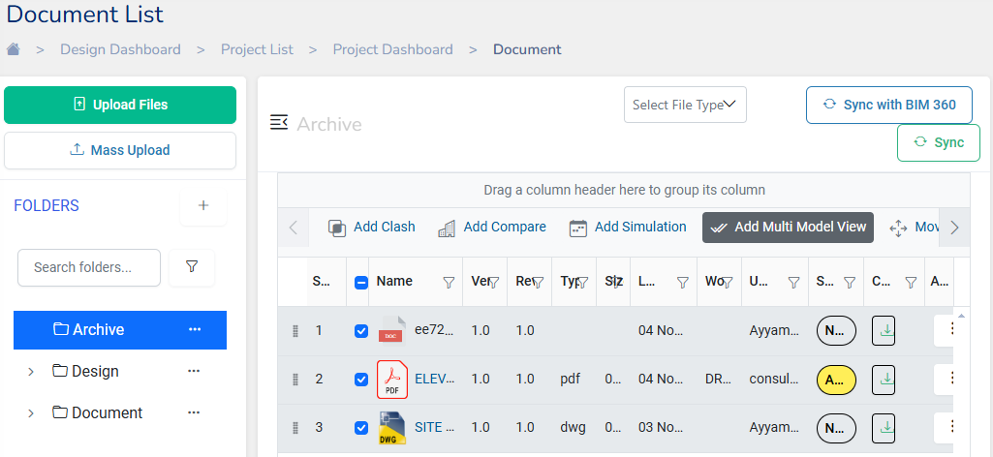

Enter a **Document name** for the Multi-Model View and click update

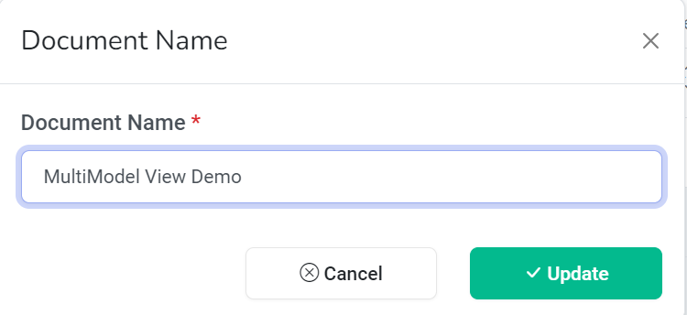

## **View Multi-Model**

Navigate to Views under Projects and Click on Multi Model View . The “Multi Model Demo” document will be in the Multi-model View List. Select the file to view the comparison.

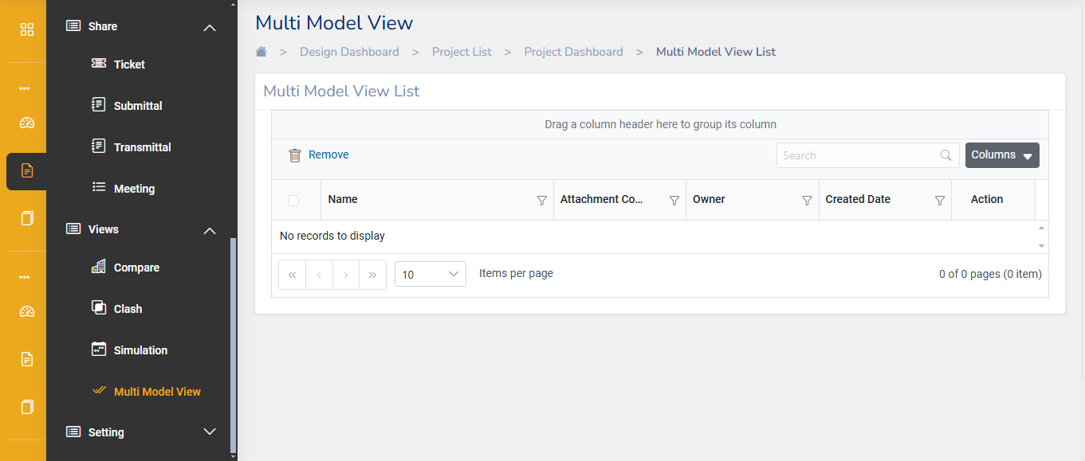

The multi model view will open in the viewer. Use the 3D interactive tools to analyze the model.

# **Compare**

Compare Tool is an important feature of Krion 6D, designed to enhance collaboration and accuracy in construction projects. It enables project members to thoroughly compare multiple drawings, ensuring consistency and precision in project execution.

To utilize the Compare Tool, users must first upload the drawings as documents within the project in Krion 6D. The tool supports detailed comparison for the following types of files:

* 3D Revit drawings (file extensions: . rvt)
* 2D CAD drawings (file extensions: .dwg)

This capability allows users to analyse and compare two or more project drawings simultaneously, facilitating effective decision-making and project management.

## **Prepare documents to Compare**

Drawings to be compared should be already available under the same folder in the Documents section of a project.

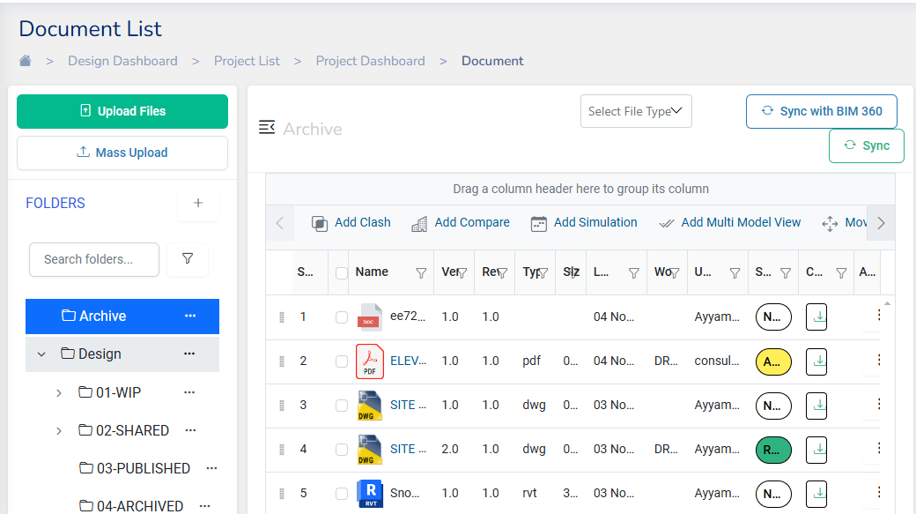Top of Form

* Select the Drawings for comparison and click on
* A dialog will open prompting to enter the **Document name** and finish by clicking

update

* Click on Update to finish creating a compare file

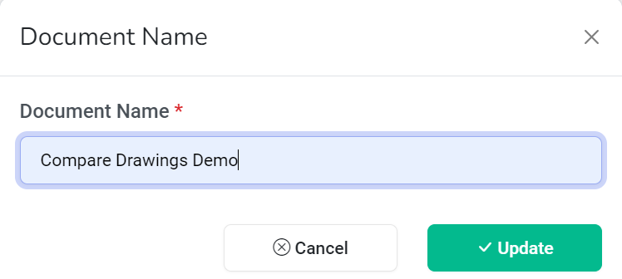

## **View Model Compare**

Navigate to Views under Projects and Click on Compare. The “Compare Drawings Demo” document will be in the compare list. Select the file to view the comparison.

1. Click on the Compare file that you created to check the details. This will open a 3D visualization of the building drawing that was added for the comparison.

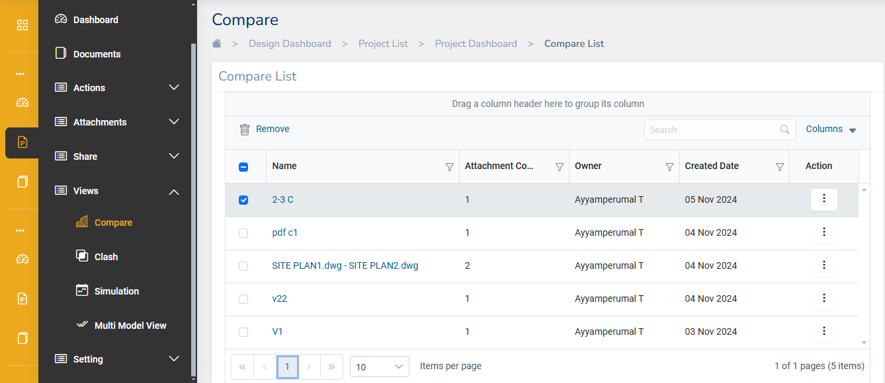

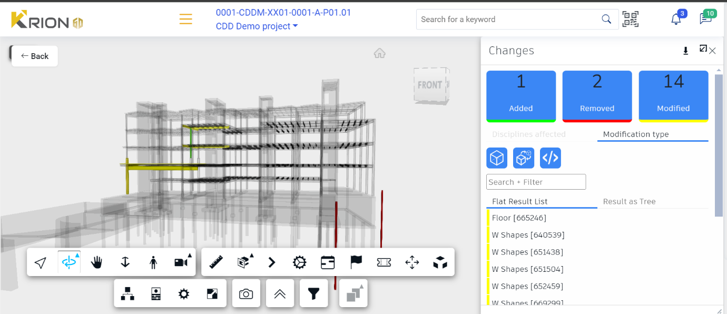

## **Change List Toolbar**

When comparing two versions of a 3D model, you can identify object-level information about what has been **Added** (green), **Removed** (red), or **Modified** (yellow) between the two versions. The color-coding is displayed on the model, and against the elements in the Changes and Information dialogs. As you select items from the change list, their position on the model is highlighted.

**Note:**

The Change List can also be downloaded as an Excel file by clicking on

Change results are displayed in 2 different ways in the

1. **Flat result List**

When we click on an item under the flat result list it shows the details of the items on the model view pane

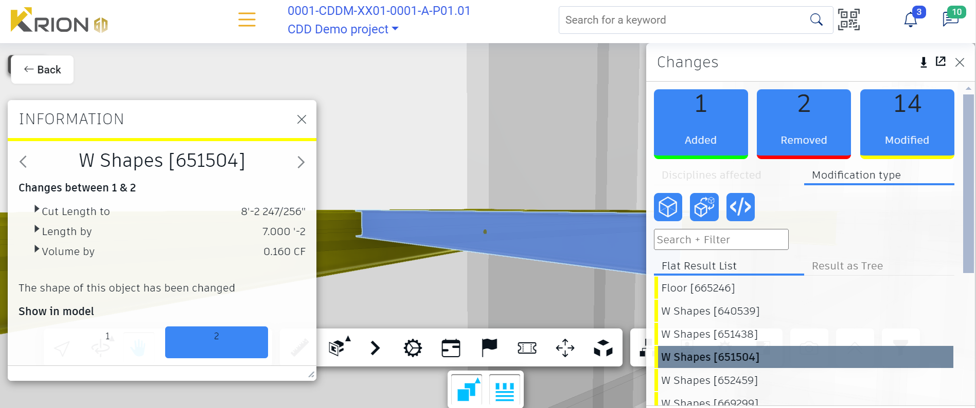

1. **Result as Trees**

This list shows items in stepwise (Tree) view

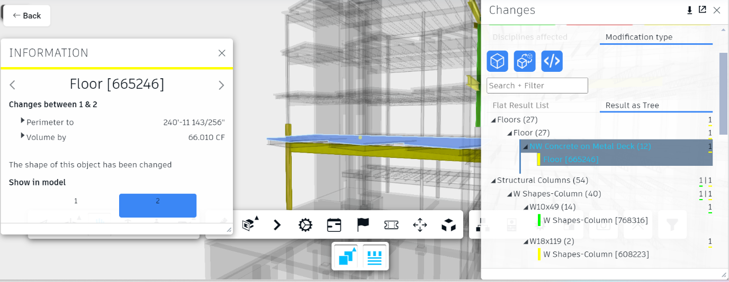

**Note:** Toggle the following icons to view/hide changes

: Hide Shape changes

 : Hide Transformations

: Hide Property changes

# **Simulation**

The simulation tool in Krion 6d is a valuable tool which enables visualization of the projects drawings along with its timeline of completion.

The simulation tool in Krion 6d, provides a dynamic visualization of the project construction process over time. This simulation tool integrates 3D models with schedules and timelines to create a simulation that shows how a project will evolve from start to finish.

Users must first upload the drawings as documents within the project in Krion 6D to utilize the Simulation Tool. To view the simulation of drawings, the following two documents are required

* Navisworks Document (file extension: .nwd)
* XML file corresponding to the respective Navisworks document (file extension: . xml)

## **Prepare documents to run simulation**

The .xml file and the .nwd file of the project should be already available under the same folder in the Documents section of a project.

Select the required file and click on

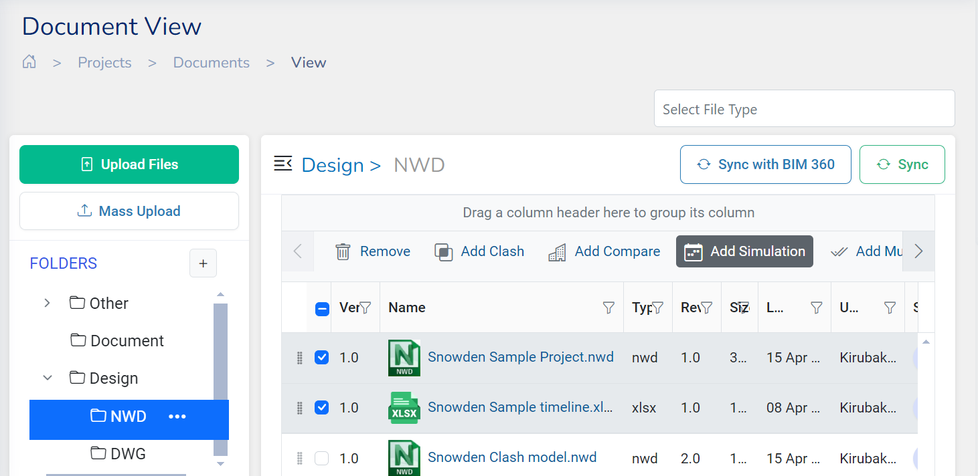

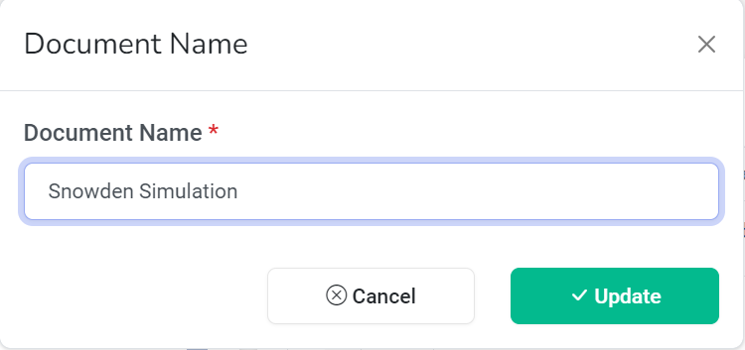Enter a **Document name** for the simulation will in the dialog and click **Update**

## **View Simulation**

Navigate to Views under Projects and Click on Simulation. The “Snowden Simulation” document will be listed under the Simulation list. Select the file to view the Simulation.

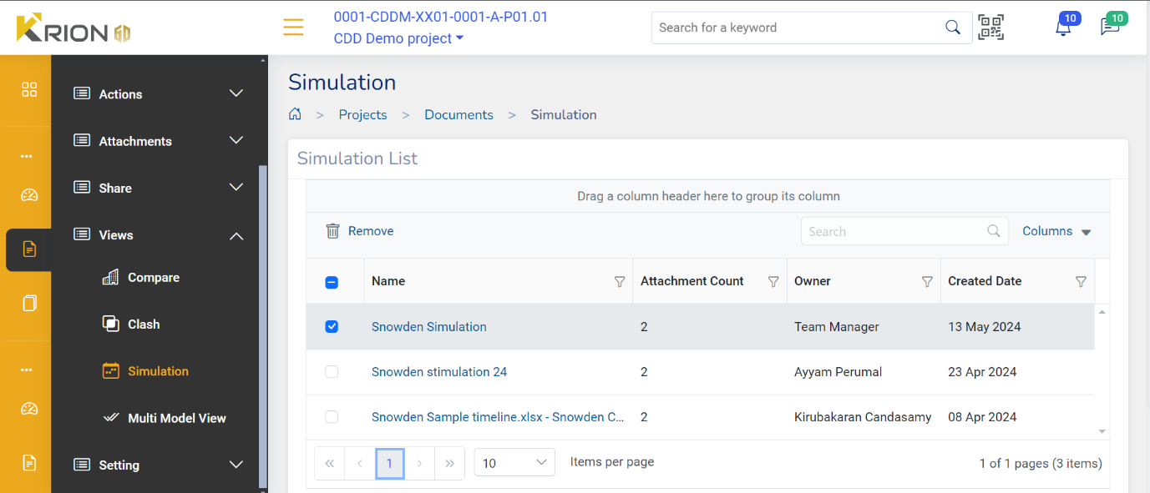

The simulation view along with the timeline will open

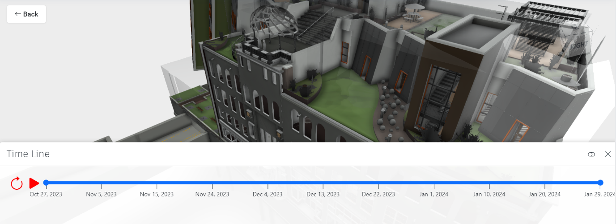

**Note:**



* Click on to play and view the simulation of the drawing
* Click on button will toggle the timeline view to a more details about the project

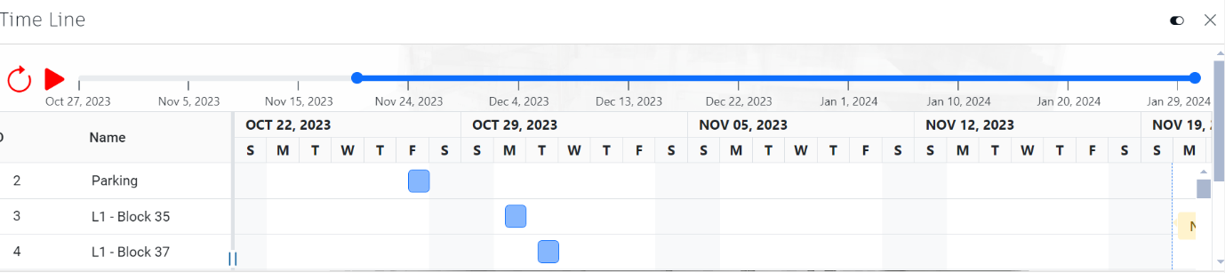

* The simulation can be paused and the details of the activity can be read from the Gantt chart below along with the item
* The scroll bar can be adjusted to view the activity planned for a particular time frame

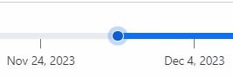

* Timeline view can be also be closed by clicking on and the 3D model can be viewed without it.

# **IoT Data Connection**

The IoT data connection feature in Krion 6D enables the analysis of all data related to the 3D structural model of a project. This tool allows users to connect any data in spreadsheets (XLS, CSV, DB) with the 3D model. The spreadsheet data is mapped through a unique ID, such as the IfcGUID. Once the data connection is established, users can use charts to slice and dice the data for further analysis.

## **Setting up the Data Connection**

Open the 3D model to be analysed from the Documents list. Once the Drawing/Model opens in the 3D viewer, Click on the **External Data** Tool.

**Connection Settings** Dialog Open up

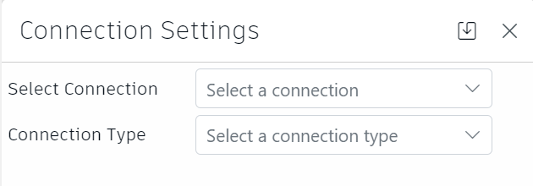

* **Select Connection**: This lets you select the connections that has already being made.
* **Connection Type**: Select the Connection type from XLS, CSV, or DB based on the file format of the Data file.

Once the Connection type is selected an Icon to upload the Data file will show up



Select the file to upload the Excel Data file and click **Attach**.

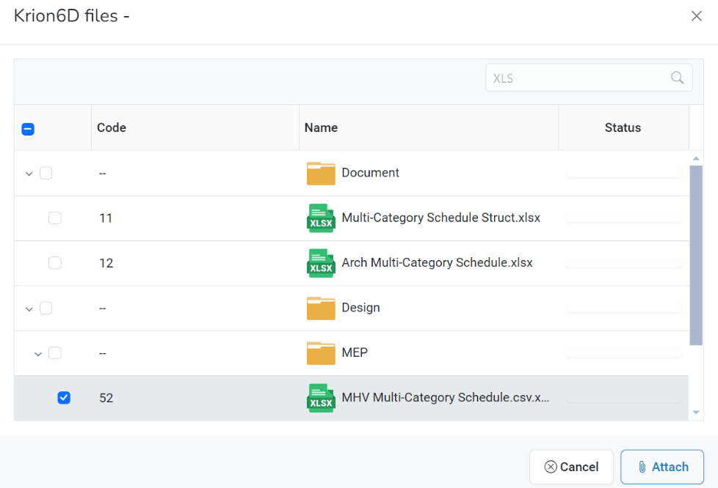

Once the file is uploaded other options will populate for selection.

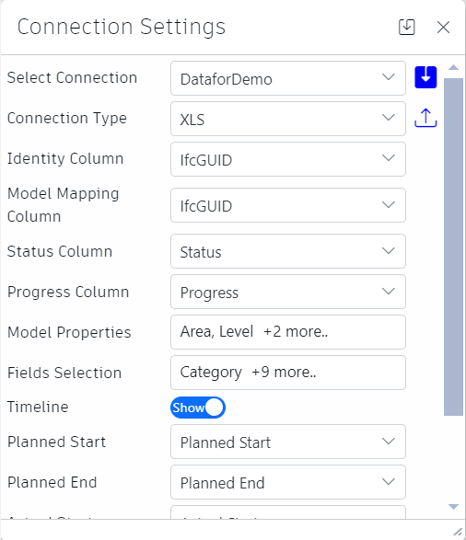

**Identity Column**: Select the specific column in a database table that uniquely identifies each Record like the IfcGUID (Industry Foundation Classes Global Unique Identifier)

**Model Mapping Column**: Model mapping column refers to aligning columns from the source data with the corresponding columns in your data model or schema. This ensures that data from the source fits correctly into the target structure.

**Status Column**: The status column is used to indicate the current state of a record, such as 'active', 'inactive', 'pending', etc. This is useful for tracking the lifecycle or workflow status of each record

**Progress Column**: The progress column is used to track the progress of a process related to each record. This could be a percentage, a completion status, or some form of milestone tracking, indicating how far along a record is in a given process

**Model Properties**: Model properties refer to the metadata and configuration settings of the data model. This can include attributes like data types, constraints, relationships, and other settings that define how the data should be structured and validated

**Field Selection**: Fields selection allows you to specify which fields (columns) from the data source should be included in the connection or operation. This is useful for filtering out unnecessary data and focusing only on the relevant fields

**Timeline:** The timeline feature, is typically used to display or conceal a timeline view of data or events. It is a chronological display of records, changes, or activities related to the data. The toggle button allows users to expand or collapse this view for better clarity or focus on other aspects of the interface. When we Click on Show Timeline, Timeline related fields will show up like Planned Start, Planned End, Actual Start, Actual End.

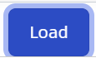After selecting all the fields, the click on to save the configuration settings.

Click on the to see the data. The Data Dialog will open.

## **Data Visualization Chart**

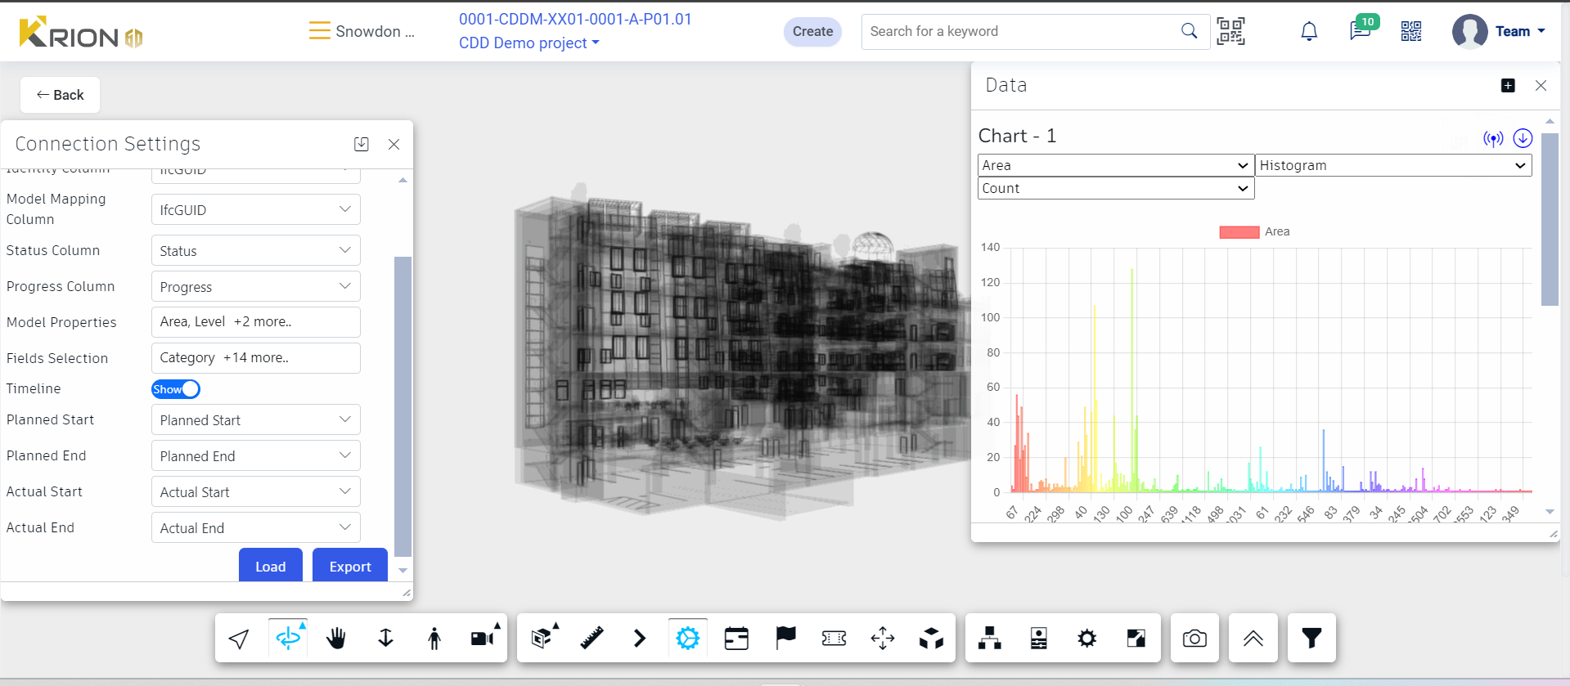

* The **Data** Dialog window will display the **Charts** where Model properties can be selected and viewed.
* ****The Model Items to be displayed in the 3D Viewer can be also Filtered from the Chart Elements or by using the Filter tool
* For the **Model Properties** (Viz Area, Level, Length) that we have selected either **Sum** or **Count** of the elements can be shown in the Chart Data

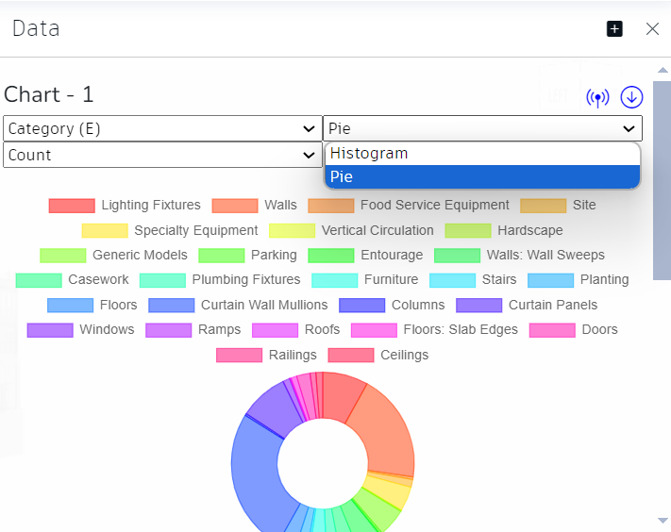

* Chart Type can be switched between **Histogram** and **Pie Chart**

## **Child chart**

When we choose any Element in Chart 1 (Parent), A Child Chart is shown below for further data analysis on the selected element.

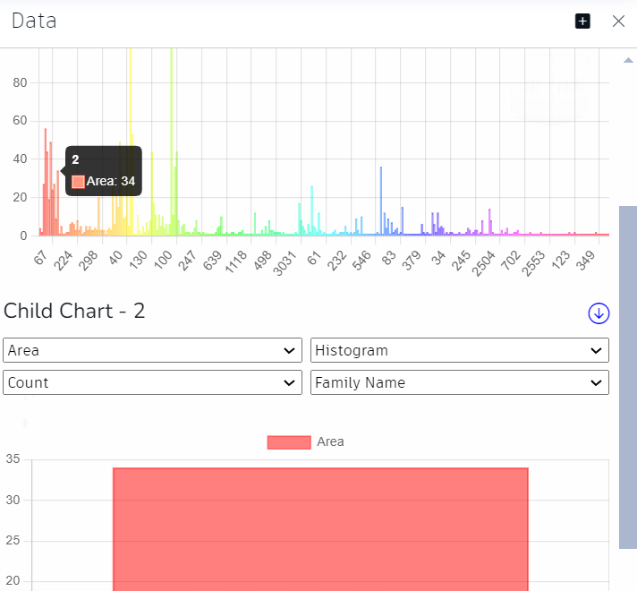

Multiple Child Charts can be generated based on the data we want to analyse.

 Note: The tool available in the top right corner of the Data Dialog visualizes the data. Along with the timeline tool, it enables the user to view the project's progress at each instant of time. The Icon turns green when the timeline view begins

tool enables users to view or hide a chart.